cj| solartron
instruments
7081
Precision Digital Voltmeter
OPERATING MANUAL
Parti
Solartron Instruments Ltd is a division of the Solartron Group Ltd. Any reference to Schlumberger or Schlumberger Instruments (the name of the company until November 1993) implies no liability on the part of Schlumberger.
Solartron Instruments Ltd
Victoria Road, Famborough, Issue 6 : January 1989
Hampshire GU14 7PW. UK. Solartron Part No. : 70810010
19©93
Solartron Instruments Ltd
Victoria Road, Farnborough Hampshire GU14 7PW England. Telephone 0252 376666. Fax: 0252 544981
Solartron Instruments
WittekindstraBe 12
45470 Mulheim/Ruhr, Germany
Tel: 0208 31026
Fax: 0208 31441
Solartron Instruments
12 Lorong Bakar Batu #07-07/11 Singapore 1334, Republic of Singapore Telephone: 7466344. Fax: 7475186 Telex: RS 25315 SLBSYS
For details of our agents in other countries, pleas»
Solartron Instruments
11321 Richmond Avenue, Suite M102 Houston, Texas, 77082-2615 USA Tel: (713) 558 2587 Fax:(713)558 8954
Solartron Instruments
50 Ave Jean Jaures
BP 620-06, 92542 Montrouge, Cedex, France
Telephone: (1) 47 46 67 00
Fax: (1)47 46 67 27
Solartron Instruments Liaison Office
Room 58357, Jin Jiang Club
191 Chang Le Road, Shanghai 200020
Peoples Republic of China
Telephone: 21 4728753 Fax: 21 4728753
Telex: 33012 BTHJC CN (Room 58357)
contact our Farnborough, UK, office.
Solartron Instruments pursue a policy of continuous development and product improvement. The specification in this document may therefore be changed without notice.
GENERAL SAFETY PRECAUTIONS
The equipment described in this manual has been designed in accordance with IEC publication 348 (Class 1) Safety Requirements for Electronic Measuring Apparatus, and has been supplied in a safe condition. To avoid injury to an operator or service technician the safety precautions given below, and throughout the manual, must be strictly adhered to, whenever the equipment is operated, serviced or repaired. For specific safety details, please refer to the relevant sections within the manual.
The equipment is designed solely for electronic measurement and should be used for no other purpose. Solartron Instruments Ltd accept no responsibility for accidents or damage resulting from any failure to comply with these precautions.
GROUNDING
To minimize the hazard of electrical shock it is essential that the equipment is connected to a protective ground whenever the power supply, measurement or control circuits are connected, even if the equipment is switched off. The protective ground for ac and dc supplies is connected separately.
AC GROUND is connected via the ac supply cord. The cord must be plugged into an ac line outlet with a protective ground contact. When an extension lead is used, this must also contain a ground conductor. Always connect the ac supply cord to the supply outlet before connecting the control and signal cables; and, conversely, always disconnect control and signal cables before disconnecting the ac supply cord. The ac ground connection must have a continuous current rating of 6A.
DC GROUND is connected via a ground stud on the equipment power supply unit (PSU). The dc ground connection must have a continuous current rating of 35A.
Where both protective grounds are used it must be ensured that these grounds are, and will remain, at the same potential.
AC SUPPLY VOLTAGE
Never operate the equipment from a line voltage or frequency in excess of that specified. Otherwise, the insulation of internal components may break down and cause excessive leakage currents.
FUSES
Before switching on the equipment check that the fuses accessible from the exterior of the equipment are of the correct rating. The rating of the ac line fuse must be in accordance with the voltage of the ac supply.
Should any fuse continually blow, do not insert a fuse of a higher rating. Switch the equipment off, clearly label it "unserviceable" and inform a service technician.
EXPLOSIVE ATMOSPHERES
NEVER OPERATE the equipment, or any sensors connected to the equipment, in a potentially explosive atmosphere. It is NOT intrinsically safe and could possibly cause an explosion.
Continued overleaf.
SAFETY PRECAUTIONS (continued from previous page)
SAFETY SYMBOLS
For the guidance and protection of the user, the following safety symbols appear on the equipment:
MEANING
Refer to operating manual for detailed instructions of use.
Hazardous voltages.
Protective conductor terminal. This must be connected to ground before operating the equipment.
NOTES, CAUTIONS AND WARNINGS
For the guidance and protection of the user, Notes, Cautions and Warnings appear throughout the manual. The significance of these is as follows:
NOTES highlight important information for the reader's special attention.
CAUTIONS guide the reader in avoiding damage to the equipment. WARNINGS guide the reader in avoiding a hazard that could cause injury or death.
AVOID UNSAFE EQUIPMENT
The equipment may be unsafe if any of the following statements apply:
• Equipment shows visible damage.
• Equipment has failed to perform an intended operation.
• Equipment has been subjected to prolonged storage under unfavorable conditions.
• Equipment has been subjected to severe physical stress.
If in any doubt as to the serviceability of the equipment, don't use it. Get it properly checked out by a qualified service technician.
LIVE CONDUCTORS
When the equipment is connected to its measurement inputs or supply, the opening of covers or removal of parts could expose live conductors. The equipment must be disconnected from all power and signal sources before it is opened for any adjustment, replacement, maintenance or repair. Adjustments, maintenance or repair, must be done only by qualified personnel, who should refer to the Maintenance Manual.
EQUIPMENT MODIFICATION
To avoid introducing safety hazards, never install non-standard parts in the equipment, or make any unauthorized modification. To maintain safety, always return the equipment to Solartron Instruments Ltd for service and repair.
SYMBOL
A A
SAFETY
The instrument has been designed and tested in accordance with the recommendations of IEC 348 Class 1. It is primarily intended for indoor use, and for such use it is supplied in a safe condition. However, no degradation of its safety will be caused if it is occasionally subjected to temperatures below normal room temperature (see Specification).
This manual contains information and warnings which the user should follow to ensure his own safety and the continued safe operation of the instrument. 7081 has been engineered with ease of use as one of the primary considerations. Attention has also been given to making the instrument immune to most inadvertent overloads. It should be appreciated, however, that even the most sophisticated measuring instrument can be dangerous when connected to high voltages, unless elementary safety precautions are observed.
The voltage limits of lkV on AC and DC mean that no damage will be caused to the instrument at this level of input. Other than the displayed reading, however, no indication is given to the user that a voltage of such a magnitude is present at the input terminals. Care should therefore be exercised whenever the dvm input leads are being connected to/removed from live circuits, especially where high voltages are known to exist, or high transients could occur.
Similarly, when using the instrument on mains operated equipment capable of delivering high voltage outputs, it is strongly recommended that the equipment under test is NOT switched off with the dvm still connected. For example, consider 7081 connected across the secondary winding of a large mains transformer. The instruments very high input resistance is such that, in the event of the mains supply being interrupted, the resultant back emf induced in the undamped secondary could be in the order of lOOkV. This is obviously hazardous to the user and would certainly harm the voltmeter.
When measuring high voltages, always ensure that the 7081 Hi and Lo inputs are connected correctly, i.e. Hi to the largest potential with respect to earth, Lo to the lowest. Once the measurement has been taken, disconnect 7081 from the high voltage equipment before switching the equipment off. User safety can be improved in these circumstances by the inclusion of a switch between the 7081 and the high voltage equipment; the switch could then be turned on, and off, whilst the equipment remained powered.
Whenever it is likely that the safety of the instrument has been impaired, e.g. if it shows visible signs of damage, if it fails to perform correctly, or if the specifications have been exceeded in any way, it should be made inoperative and referred to a suitable repair organisation.
Any adjustment, maintenance or repair of this instrument should be carried out only by a skilled person who is aware of the hazards associated with mains operated equipment. Such adjustment, maintenance or repair should be carried out in accordance with the procedures, and observing the precautions, detailed in the Maintenance Manual.
GAM/7081/Part 1/2
INTRODUCTION
The 7081 operating manual is arranged in two separate parts, covering local and systems (remote) use. Each part contains all the information necessary for operating the instrument in that particular role.
Included in Part 1 is the specification applicable to the functions described, the tables showing the expected instrument performance relative to time since calibration. A further section of Part 1 is devoted to the unit's processing capabilities and front panel operations. Part 2 describes the use of the instrument in a systems environment.
GAM/7081/Part 1/2
Contents Parti
Chapter 1 General Information
1 | Introduction
2 | Facilities
3 | Measurement Capability
4 | Ratio
5 | History File
6 | Processing
7 | Interfaces
8 | Unit Calibration
9 | Multi-Channel Capability
10 | Accessories
11 | Specification
Chapter 2 | Installation
l | Voltage Selection
2 | Fuses
3 | Warm-up Procedure
4 | Rack Mounting
Chapter 3 | Controls and Displays
l | The Voltmeter Controls
2 | Front Panel Controls
3 | Shifted Level Controls
4 | Rear Panel Controls
5 | Displays
Chapter 4 | Local Operation
1 | Power-Up
-> | Calibration Transfer
3 | Self Test
4 | Operation
5 | Nulling
6 | Processing
7 | Help Control
8 | Clearing Programs
9 | Computing History
Appendix 1 | Operating System Error h/
Page No. 1.2
2.2 2.2 2.3 2.4
3.2 3.2 3.5 3.6 3.6
4.2
4.3
4.3
4.4
4.5
4.5
4.19
4.20
4.20
Al-1
AMK/7081/Part 1/4
Index
Chapter 1 General Information
Contents
 |  | Page No.
1 | Introduction | 1.2
2 | Facilities | 1.2
3 | Measurement Capability | 1.2
4 | Ratio | 1.2
5 | History File | 1.3
6 | Processing | 1.3
7 | Interfaces | 1.3
8 | Unit Calibration | 1.4
9 | Multi-Channel Capability | 1.4
10 | Accessories | 1.5
11 | Specification | 1.9
1.1
1 Introduction
The 7081 voltmeter is a high quality instrument designed for calibration, laboratory and systems applications. It combines superb measurement performance with data storage facilities and processing power. The unit has no internal options having all facilities as standard.
2 Facilities
The instrument provides the following facilities:
• DC voltage and resistance measurements to a scale length of 140 000 000 and true rms volts ac, or volts ac + dc, to a scale length of 1 400 000.
• The ability to ratio any of the above inputs to a dc voltage or to a constant.
• Automatic storage of results (History file).
• Processing of measurements to provide additional results.
• Remote control using either RS232C or IEEE-488 (GP-IB) interfaces.
• Calibration, via either of the two interfaces, without the need to remove covers.
• Interface for Minate analogue scanner, providing a multi-channel measurement capability.
3 Measurement Capability
DC voltage measurements can be made using scale lengths of 3,4,5,6,7 and 8x9; the 3 and 4x9 scales are available only by remote control. Each scale length provides a different integration time and can be used over all ranges, i.e. 0.1 to 1000V.
Two types of ac voltage measurement are possible; a true rms value of the ac component only of an input or the rms of the total signal (ac + dc). Scale lengths of 3,4,5, and 6 x 9 and ranges of 0.1 to 1000V are available for both types of measurement.
Ranges of 0.1Ш to lOOOMft are provided for resistance measurement; the 0.1,1,10,100 and ЮООкП ranges use a 4 terminal technique whereas the 10 to 1000МП ranges use a special ratio method. The 7081 also offers a 'True ohms' facility, i.e. the unit measures the resistance with the current source off and then with it on. Subtracting the former measurement from the latter removes any errors caused by thermal emfs or external currents. The 7081 'True ohms' facility can deal with emfs of up to 10V.
All measurements taken by the 7081 are averaged readings over the selected integration time.
4 Ratio
Eight types of ratio measurement are possible using either a reference input or a constant. The latter may be a measurement result accessed from the voltmeter memory or a number entered from the front panel controls. The ratios can be presented in linear or logarithmic (dB) form.
1.2
GAM/7081/Part 1/2
5 History File
The voltmeter has a separate memory, the history file, for storing readings. These may be straightforward measurements or processed results.
The value displayed on the voltmeter, which is subsequently stored, is not necessarily displayed or printed in the identical format on recall. Up to 1500 unformatted readings (numeric value only) can be stored or 500 fully formatted readings.
6 Processing
The unit provides the following programs:-
Ratio
Digital Filter
Scale
Statistics
Limits and max/min
The programs may be used together or individually and are listed in their chaining order, i.e. the input data to one program may be the result of the previous program.
Access to the programs can be made either from the front panel or over the interfaces.
For further details on processing, refer to Chapter 4.
7 Interfaces
Two interfaces, the RS232C V24 and the IEEE 488/1978, are fitted as standard.
7.1 RS232 Interface
Access to this interface is via a 25-way Cannon socket on the rear of the instrument. Baud rates from 110 to 9600 are available, which are selected from three internal switches, the normal factory setting being 300 baud.
7.2 IEEE 488 Interface (GP-IB)
The unit fully implements the requirements of the IEEE 488/1978 standard, access to the interface being provided via a connector on the rear panel of the instrument. The instrument address is set up via the GP-IB Selector switches also mounted on the rear panel.
7.3 Interface Language
A common language, which is based on English, is used over both interfaces.
Comprehensive error reporting is available giving the exact position in a command where the mistake lies. A HELP command is available, if required.
For further details, refer to Part 2 of the Operating Manual.
GAM/7081/Part 1/2
8 Unit Calibration
Calibration is enabled via a front panel key operated switch. This allows the unit to be calibrated without removal of the covers or disturbance of the analogue circuitry.
Unit calibration is based on the equation:-
y = mx + с
where у = calibrated reading
x = uncalibrated reading m = range/mode multiplier с = zero offset
Every range/mode combination has its own set of constants {m and c), which are stored in a non-volatile memory with a predicted life of ten years.
Calibration can only be carried out over the IEEE or RS232C Interfaces.
Multi-Channel Capability
A Minate (7010) interface is also fitted to the unit. This interface is capable of driving 127 channels and provides programmable pull-in and drop-out delays, if required.
The connector has the pin/signal assignment shown in Table 1.1 Table 1.1 Multi-Channel Connector Pin/Signal Assignment
Pin No. | Signal
1 | 1 л
2 | 2
3 | 4
4 5 | 8 10 | ► Device control
6 | 20
7 | 40
8 | 80 J
9 | Contact closure remote trigger (connect to 0V)
10 | Out of limit high (Logic 1 = True)
11 | Out of limit low (Logic 1 = True)
12 | 0 Volts
13 | +5 Volts (100mA max. load)
14-23 | Not Used
24 | TTL compatible measurement complete signal (Logic 1 = True)
25 | 1 к V probe enable (connect to 0V)
Figure 1.1 shows the relative positions of the pins.
13
ooooooooooooo oooooooooooo
Fig 1.1 Multi-Channel Connector
1.4
GAM/708I/Part 1/2
10 Accessories
The items listed below are supplied with 7081: Input lead Power lead Crocodile clips (2) Rack ears (2) and fixing screws Operating manual
5-way DIN plug (for connection to the rear panel reference/ratio socket) Spare fuses: 2 X 200mA slo-blo and 2 X 400mA slo-blo Calibration key 25-way socket kit
The following optional accessories are available for use with 7081:
3 Terminal Input Lead 3193
5 Terminal Input Lead 3183
Kelvin Clip Lead 70758E
Telescopic Rack Sliders 70759A
Low Thermal Lead 70758D
High Voltage Probe 7075A
Maintenance Manual 7071 & 7081 70810014
10.1 2 Terminal Input Lead
This input lead, supplied with 7081, may be used for all standard measurements. The RED lead should be connected to Hi, normally the largest potential with respect to earth. The BLACK lead should be connected to Lo and provides the return path (see Figure 1.2). The cores are enclosed in a braided screen which is connected to Guard. At the free-end of the cable, this screen is connected to the black lead thus effectively preserving the guard right up to the signal source. This prevents the measurement being affected in any way by common mode current flowing in the screen and via leakage to earth. The input may be floated above mains earth by up to 350V; the use of higher common mode voltages is not recommended purely to ensure safety for equipment and the user. The guard is not made available as a separate termination.
The two D. source leads are connected within the cable to the Hi and Lo leads and are not available as separate terminations.
The input lead can be connected to either the front or rear panel input socket. Before initiating measurements, ensure that the front panel Input Select switch is in the correct position. Refer to Chapter 3 for the switch positions.
-O
Red
\
Hi П (Yellow)
— DVM
Lo $1 (Blue)
1k
-O
Black
Z
Guard (Green)
Fig 1.2 2 Terminal Input Lead
JWS/7081/Part 1/4
1.5
10.2 Reference/Ratio Plug
Three lines from this 5-way plug are used: Ratio Hi, Ratio Lo and OV. The Ratio Hi and Lo lines must not have more than ± 14V, with respect to OV, connected to them, the voltage measured being the difference between these two lines.
Ratio Hi should be connected to the higher reference potential, Ratio Lo to the lower reference potential. Ratio Lo can be connected to OV only if Ratio Lo is connected to the main input Lo.
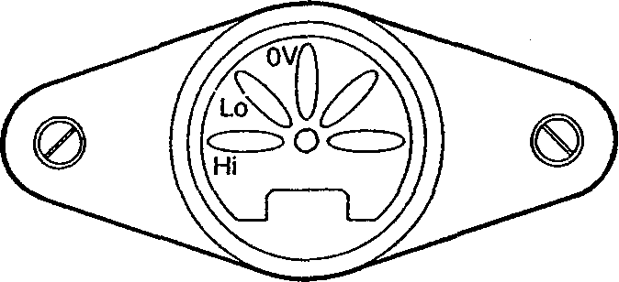
Fig 1.3 Rear Panel Reference Socket
10.3 3 Terminal Input Lead
The 3 Terminal Input Lead, Part No. 3193, can be used to eliminate sources of interference in the circuit under measurement.
Within the instrument the cable screen is connected to the guard 'box' (a screening compartment which encloses the input circuits) and at the free end the screen is connected directly to the source of interference thus isolating common mode current from the input leads. (See Figure 1.4).
Red (Hi)
' ------------------ DVM -----------------
-O
©
Guard
\L
Hi П (Yellow)
-O
Black (Lo)
\
Lo П (Blue)
О
Guard (Green) |
Fig 1.4 3 Terminal Input Lead
PD/7()8l/Part 1/3
Using this arrangement, even if the interference was the permitted maximum, it is most unlikely that there would be any discernable error, even at the most sensitive range.
If 'Guard' can not be connected directly to an interference source, it should be connected to the Lo line, i.e. not left unconnected.
10.4 5 Terminal Input Lead
The 5 Terminal Input Lead, Part No. 3183, can be used for resistance measurements and has the four cores and guard screen terminated separately as shown in Figure 1.5.
Hi Q (Yellow)
Resistor
Hi (Red)
Lo (Black)
Lo Cl (Blue)
Guard (Green)
Fig 1.5 5 Terminal Input Lead
•To DVM
When measuring low values of resistance, the voltage dropped along the leads can sometimes introduce errors. This effect may be eliminated by employing the 4 wire technique in which two wires supply the current to the resistor and two others sense the potential developed across it. The guard screen can be used to reduce any errors due to common mode interference.
10.5 High Voltage Probe (70757A)
The High Voltage (H. V.) probe effectively increases the dc voltage range of the voltmeter, to a maximum of 20kV.
Safety Precautions: When using the H. V. probe, the following safety precautions should be observed.
Do not use the instrument in the Autorange mode as damage might occur.
The 50 way cannon plug supplied with the probe must be inserted into the minate interface at the rear of the instrument. This secures the instrument for this mode of operation. The display reads in kV.
Know the equipment under test: locate all high voltage points before commencing work.
Do not work alone.
Do not depend on the insulation of high voltage cables for protection.
Remember that high voltages may appear at unexpected points in defective equipment. Note that even though equipment may be switched off, bleeder resistors may be open circuited and capacitors charged to high voltages.
PD/7081/Part 1/3
High voltages can discharge from point to point or point to air (corona). Keep hand closed on the handle of the probe and away from high voltage points.
Keep hands and shoes and test area absolutely dry.
Ensure that the surface of the probe is clean and moisture free.
BEFORE MAKING ANY MEASUREMENT, ENSURE THAT THE GROUND LEAD OF THE PROBE IS CONNECTED TO THE LOW POTENTIAL OR GROUND SIDE OF THE HIGH VOLTAGE SUPPLY BEING MEASURED.
8
PD/7081/Part 1/1
11 SPECIFICATION
ROOT-YEAR RELATIONSHIP
Realistic specifications should not be based on speculation. They require a real knowledge of components, their behaviour under stress, and their drift with time.
Long term assessment of precision components has enabled Schlumberger to specify performance from 90 days to 9 years using a simple square-root-year relationship for calibration drift with time. Tests conducted over several years using precision resistors and zeners from many leading manufacturers indicate that drift reduces with time and the change is proportional to the square root of time. Using pre-aged, hermetically encapsulated components, the drift is reduced to extremely low levels and can be predicted accurately for short or long periods. Accuracy specified for one year can be used with a multiplier to provide all additional information, as shown below:
ACCURACY
The following apply to the Accuracy sections:
Required. Spec Time
3 months £ months lyear
2 years
4 years 9 years
One Year Multiplier
0.5
0.7
1.0
1.4
2.0
3.0
Limits of Error:
apply after 24 hours warm-up* with ac inputs >2% of range and dc resistance with null in use.
Temperature Coefficient: expressed as ±ppm rdg/°C and valid from 10"C to 30°C.
Calibration temperature T„ is the temperature of the calibration room. Calibration occurs at 20°C (23°C for the USA) and is directly traceable to International Standards via the National Physical Laboratory or the National Bureau of Standards. Recalibration is valid at T. from 18°C to 25°C.
Factory traceability to NPL is luV for standard cells, 1.5ppm for lOVdc reference, 5ppm for resistors and 60ppm for AC/DC transfer.
Temperature coefficient need be applied only outside the temperature span quoted with T_{e}.
♦Instruments are usable within minutes after switch-on but for ultimate precision a long warm-up in a stable thermal environment is recommended.
If an instrument has been stored at below 5"C for long, follow the special warm-up procedure given in Chapter 2, Section 3.
CALIBRATED FOR LIFE
Beyond nine years the drift becomes insignificant such that three times the one year figure will predict the performance of the 7081 for the life of the voltmeter -however long that may be. Traceabiliy to International Standards can be maintained for long periods.
The square-root-year relationship applies to the 7081. The voltmeter will retain its predicted long term specification, even if subjected to rigorous working conditions. However, the best stabilty, and minimum long term drift, will be obtained by maintaining the voltmeter in a reasonable environment. The user should consider leaving the voltmeter switched on and avoid extreme environmental conditions. In these circumstances the long term performance can be expected to be even better than that which is predicted.
Calibration for life, introduced for the first time by Schlumberger, gives important savings in time and money, thus making a significant reduction in cost of ownership.
RATIO
Differential measurement of Hi_{ref} and Lo_{ref}, with respect to input Lo on a fixed 10 V dc range to establish V„[.
V_{re}f, maximum permitted input: V_{n[}, error: Ratio error
±14Vdc ± 2 X error on 10 V range ± [ V_{m} error+V_{ref} error]
7081 ACCURACY WITHOUT RECALIBRATION
H-----r-t-
3 4 5 6
INSTRUMENT AG6 IN YEARS
JWS/7081/Part 1/6
1.9
DC VOLTAGE
Stability
24hrs, T_{e} ± 1°C, 8У2 digits, ± [ppm rdg + ppm fs]
Range Sensitivity Full Scale Guaranteed Transfer
0.1V
1V
10V
100V
1000V
10nV
10nV
100nV
1uV
10uV
0.140 000 00 1.400 000 00 14.000 000 0 140.000 000 1000.000 00
2.0 + 0.8 1.0 + 0.4 0.5 + 0.3 1.0 + 0.4 2.0 + 0.3
0 + 0.8 0 + 0.4 0 + 0.3 0 + 0.4 0 + 0.3
Limits of error
8У2 digits, T_{e} ± 3°C, ± [ppm rdg + ppm fs]
Range 90 Day 1 Year 2nd Year* Temp. Coeff
1.2 1.0 0.5 1.3 1.3
0.1V | 6 + 0.8 | 9 + 0.8 | 6 + 0.8
1V | 5 + 0.4 | 7 + 0.4 | 5 + 0.4
10V | 4 + 0.3 | 6 + 0.3 | 4 + 0.3
100V | 5 + 0.4 | 8 + 0.4 | 5 + 0.4
1000V | 6 + 0.3 | 9 + 0.3 | 6 + 0.3
Scale length, integration time, tracking speed Scale Digits Integration Speed
Add Error
8x9 7x9 6x9 5x9 4x9 3x9
8'/2 7'/2
6У2
5'/2
4У2
ЗУ2
51.2s
3.2s
0.4s
0.1s
6.25ms
1.56ms
Input Resistance: 0.1,1,10V range: 100,1000V range: Input Current, at T_{e}°C: Range of Null: Sample settling time:
Overload Protection
Autorange:
Commanded range: 0.1.1,10V: 100, 1000V: Linearity:
1/51.2s | —
1/3.2s | ±2 digits
2.5/s | ±1 digit
10/s | ±1 digit
85/s | ±1 digit
100/s | ±1 digit
 | >10GQ
 | 10MQ
 | <20pA
 | ±10% of range
13ms x (digits selected)
 | 1kVpk
 | 350V pk
 | 1kVpk
 | <0.2ppmoffs
RESISTANCE
Stability 24hrs, T_{e} Range
± ГС, 8У2 digits, ± [ppm rdg + ppm fs] Sensitivity Full Scale Guaranteed Transfer
0.1 kQ | 10uO | 0.140 000 00 | 2.0 + 0.8 | 0 + 0.8
1kO | 10u0 | 1.400 000 00 | 1.5 + 0.4 | 0 + 0.4
10k0 | 100uQ | 14.000 000 0 | 1.5 + 0.3 | 0 + 0.3
100kO | ImO | 140.000 000 | 1.5 + 0.4 | 0 + 0.4
1000k0 | ЮтП | 1400.000 00 | 2.0 + 0.3 | 0 + 0.3
10MO | 100mQ | 14.000 000 0 | 8.0 + 0.5 | 0 + 0.5
1000M0 | 1 ppm rdg | > 1400.000 | 1ррт/МП | --
Limits of error
8У2 digits, T_{e} ± 3°C, ± [ppm rdg + ppm fs]
Range 90 Day 1 Year 2nd Year*
Temp. Coeff
0.1kQ
7+ 1.0
10+ 1.0
7+1.0 1.2
1kO | 6 + 0.5 | 9 + 0.5 | 6 + 0.5 | 1.2
10kO | 6 + 0.5 | 9 + 0.5 | 6 + 0.5 | 1.0
100k0 | 8 + 0.5 | 12 + 0.5 | 8 + 0.5 | 1.3
1000kD | 8 + 0.5 | 12 + 0.5 | 8 + 0.5 | 1.2
10M0 | 20 + 0.5 | 30 + 0.5 | 20 + 0.5 | 4.0
1000M0 бррт/МО Юррт/МО Юррт/МО Ippm/MO
Scale length, integration time, tracking speed Scale Digits Integration Speed
Add Error
8x9 | 8У2 | 51.2s | 1/51.2 | —
7x9 | 7У₂ | 3.2s | 1/3.2 | ±2 digits
6x9 | 6У2 | 0.4s | 2.5/s | ±1 digit
5x9 | 5'/2 | 0.1s | 10/s | ±1 digit
4x9 | 4Уг | 6.25ms | 85/s | ±1 digit
3x9 | ЗУ2 | 1.56ms | 100/s | ±1 digit
Measurement configuration: Current source, fully floating:
Overload protection: Open circuit voltage: Range of Null:
Maximum total lead resistance: Sample settling time:
* After first year recalibration
4-wire, 0.1 kfito 10OOkO ranges
2-wire, 10M0 and 1000M0 range
0.1,1, 10k0 1mA
100k0, 1000кЛ 10uA
10MQ, 1000M0 1uAmax
350V pk
17V dc
±10% of range
1кО
13ms x (digits selected)
Add lOms/MO
Traceability
The ability to relate individual measurements to International Standards through an unbroken chain ofcoinpansons.
Transfer Accuracy
Transfer accuracy is the short-term limit of error for measurements of similar value.
Stability
The ability to remain га thin predefined error hunts for a short time. The reading at the beginning oj the time peiiod is the datum for the limits.
1.10
JWS/7081/Part 1/6
AC VOLTAGE True rms of ac or ac+dc
Stability
24 hrs, 90 day, T_{e} + 1°C, ± [% reading + % full scale]
Range Sensitivity Full Scale 10to40Hz 40Hz to 10kHz
10k to 30kHz 30k to 100kHz 100k to 200kHz 200k to 1 MHz
0.1V | 1uV | 0.140 000 | 0.05 + 0.006 | 0.005 + 0.005 | 0.015 + 0.015 | 0.02 + 0.03 | 0.2 + 0.2 | 1 + 1
1V | 1pV | 1.400 000 | 0.05+0.006 | 0.005 + 0.005 | 0.015 + 0.015 | 0.02 + 0.03 | 0.2 + 0.2 | 1 + 1
10V | 10uV | 14.000 00 | 0.05 + 0.006 | 0.012 + 0.005 | 0.03 +0.02 | 0.05 + 0.03 | 0.3 + 0.2 | 1 + 1
100V | 100uV | 140.000 0 | 0.06 + 0.006 | 0.017 + 0.005 | 0.08 +0.02 | 0.20 + 0.03 | 0.3 + 0.2 | —
1000V | 1mV | 1000.000 | 0.08 + 0.01 | 0.035 + 0.007 | 0.1 + 0.03 | -- | — | —
Limits of error
1 Year, 2 Years, T_{e} ± 5°C, ± [ppm rdg + ppm fs]
Range Full Scale 10to40Hz 40Hz to 10kHz
10k to 30kHz 30k to 100kHz 100k to 200kHz 200k to 1 MHz
0.1V
1V
10V
100V
1000V
0.140 000 1.400 000 14.000 00 140.000 0 1000.000
0.06 + 0.006 0.06 + 0.006 0.06 + 0.006 0.07 + 0.006 0.09 + 0.01
0.015 + 0.005 0.015 + 0.005 0.022 + 0.005 0.027 + 0.005 0.045 + 0.007
0.02 + 0.02 0.02 + 0.02 0.04 + 0.03 0.1 +0.03 0.15 + 0.04
0.03 + 0.04 0.03 + 0.04 0.06 + 0.04 0.21 + 0.04
0.2 + 0.2 0.2 + 0.2 0.3 + 0.2 0.3 + 0.2
1 + 1 1 + 1 1 + 1
Scale length, integration time, tracking speed Digits Display Integration Speed
Add Error
8x9 | 6У2 | 51.2s | 1/51.2 | —
7x9 | 6У2 | 3.2s | 1/3.2 | —
6x9 | 5У₂ | 0.4s | 2.5/s | —
5x9 | 4У₂ | 0.1s | 10/s | ±1 digit
4x9 | ЗУ2 | 6.25ms | 85/s | ±1 digit
3x9 | ЗУ2 | 1,56ms | 100/s | ±2 digits
Low Frequency Error
below 1 kHz
5to10Hz
3to5Hz
2to3Hz
1.5to2Hz
DC
Input Impedance: Temp, Coeff. up to 10kHz: Sample settling time: ~ Filter selected:
use ~ Fill add 0.25% rdg add 0.3% rdg add 0.6% rdg add 1.0% rdg add 0.1% rdg
1MO||l50pF
±30 ppm rdg/°C
20ms x (digits selected)
400ms x (digits selected)
Maximum Inputs
Autorange:
Commanded range: 0.1,1V:
10,100,1000V: Maximum V x Hz: Crest Factor at fs:
20
1kVpk 350V pk
1kVpk 10⁷ 5:1
JWS/7081/Part 1/6
1.11
FUNCTIONS
Modes:
Ranging: Scale length:
Additional:
Programs:
History File:
Vdc, Vac, Vac + dc, Filter (ac). Ohms,
True Ohms, Ratio
Auto or manual
7081: 3'/2*, 4'/2*, 5'/2, 6'/>, 7>/₂, 8'/2
•through remote control.
Local, Null, Null On, SRQ, Self Test,
History forward, History reverse,
Compute On/Off, Compute History,
History clear, Help, clear results.
Ratio 8 subsets
Digital Filter 3 subsets
Scale and offset
Statistics 6 subsets
Limits 8 subsets
Time, real or elapsed
1500 readings numeric only
500 Readings with time, channel mode,
History number recircultating or fixed
Selectable dump facility
SYSTEMS USE
The following interfaces are provided as standard.
IEEE 488 (1978)
Provides full talker/listener facilities and remote control of all
functions.
Subset: SHI, AHI, T5, TEO, L3, LEO, El, SRI, RLI, DCl
CO, DT1.PP1
RS232C
Provides full remote control of all functions.
Speed, user selectable:
Scanner
Interface provided for Minate (7010)
Channels:
Pull in and drop out delays:
Additional control lines
External Sample:
Sample complete:
Out of limit High:
Out of limit Low:
110to9600bits/s
16 to 128 programmable
contact closure
. TTL level
open collector 40mA
open collector 40mA
SYSTEMS LANGUAGE
The 7081 is programmed by use of ENGLISH words. These may be of a full or shortened form, and conform to recommended practices set out in 1981 draft 'Code and format conventions for use with IEEE standard 488 (1978)'. A 'HELP' facility is available for ease of programming.
INTERFERENCE REJECTION
Normal Mode Rejection, dc measurement. 8'/2 to 5'/2 digits at 50(60) or 4001 Iz, ± 3% Effective Common Mode Rejection
With Ikfl imbalance.
DC measurement
8У2 to 5'/2digits, at 50(60)Hz, + 3%:
8 Vz to 5 Vz digits, at 40011/. ± 3%:
AC measurement
Rejection of 50/60H/. ± 3%:
Maximum permitted common mode:
>70dB
>140dB >120dB
>40dB 500V dc or pk
GENERAL
Power Supply
Voltage: 100/120/220/240V +\S% - 10%
Frequency, automatic sensing: 48 to 521 Iz,
57 to 63Hz, 384 to 416Hz Consumption: 40 VA
Safety
Designed in accordance with IEC 348, BS4743 and I ."LI 244 Environment Operating: Storage:
Relative Humidity Dimensions
Height: Width: Depth: Weight :
0°C to 4-45°C -2()°Cto+7()°C 9()'/<- at 4()°C (non condensing)
88111m (3.5ins)
432mm (17ins)
4l9nim (I6.5ins)
8.25kg(191bs)
1.12
PD/708 I/Part 1/1
Chapter 2 Installation
Contents
Page No.
1 Voltage Selection 2.2
2 Fuses 2.2
3 Warm-up Procedure After Prolonged Low-Temperature Storage 2.3
4 Rack Mounting 2.4
BDRP/7081/Part 1/2 2.1
1 Voltage Selection
The 7081 is fitted with a multi-purpose mains input unit on the rear panel which contains the mains input socket, fuses, voltage selector and filter. Before applying mains power, ensure that the voltage selector is correctly set; 100V, 120V, 200V, or 240V will appear in the small aperture.
The voltage selector must be set as follows:
100V for 90 V to 115 V ac input 120V for 110V to 135V ac input 200V for 190V to 215V ac input 240V for 230V to 255V ac input
To change the selector:
1. Remove the mains plug from the input socket.
2. Lift the hinged flap.
3. Turn the voltage selector roller block so that the desired voltage shows through the aperture.
4. Check fuses as described below.
5. Close flap.
2 Fuses
There are two fuses mounted below the voltage selector. Both LINE and NEUTRAL are fused with the following fuse values depending upon the voltage selected:
100 and 120V 400mA slo-blo 200 and 240V 200mA slo-blo
To change the fuses, press the arrow in the direction indicated and pull the fuse out.
2.2
GAM/7081/Part 1/2
3 Warm-up Procedure After Prolonged Low-Temperature Storage
For optimum calibration performance the instrument should normally be warmed up for 24 hours in a stable thermal environment. However, if it has been stored below 5°C for long (e.g. during initial shipment or outside in cold weather), use the following special warm-up procedure:
1. Unpack the instrument, but leave the middle box located within the outer box by the foam 'corners' (Fig. 2.1)
2. Set aside the inner box, expanded polystyrene packings, and thermal inertia bottles. These are not used in this procedure
3. Connect a mains lead, and stand the instrument directly inside the middle box
4. Plug in the mains lead, switch on the instrument, and close both middle and outer box covers to form an 'oven' enclosure
5. Leave to stand for 24 hours in this high temperature (~35°C) environment
6. Remove the instrument, place in a stable room temperature environment, and allow to stand powered up a further 24 hours.
The instrument is now ready for accurate use.
Expanded polystyrene Outer box packings Foam 'corners'
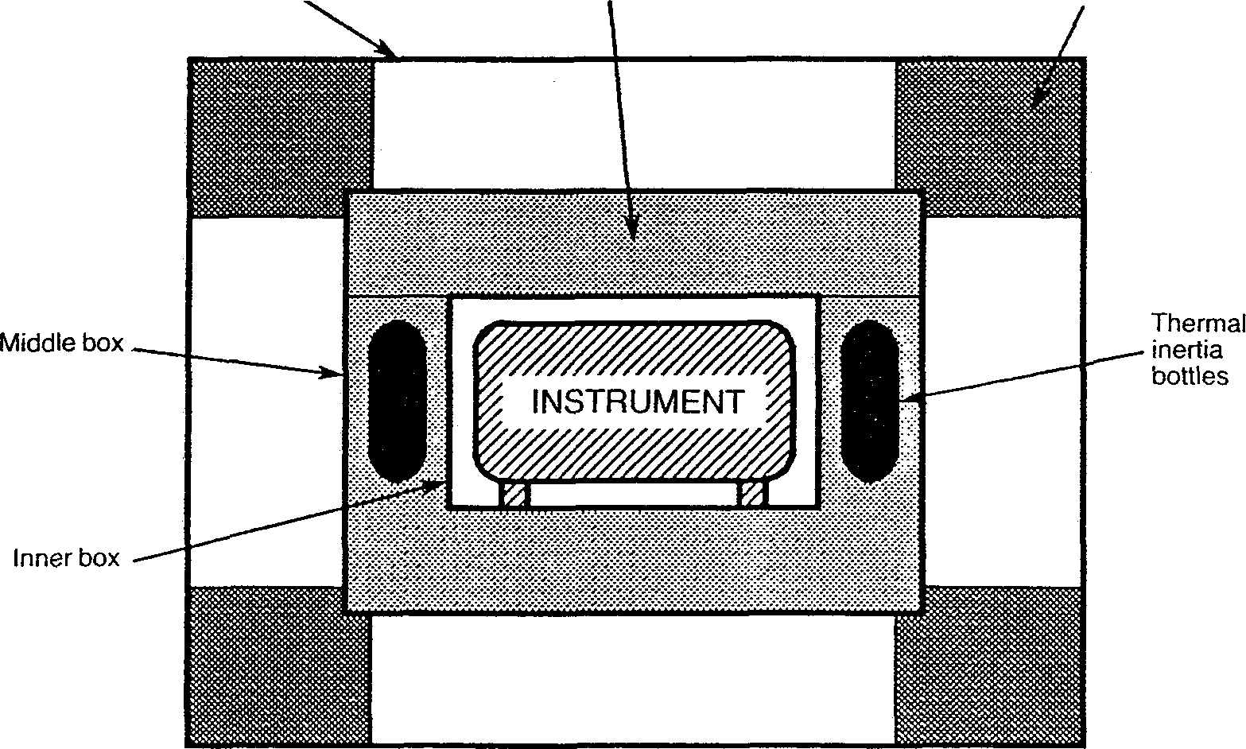
Fig 2.1 Instrument packaged for shipment (side view)
AMK/7()81/Part 1/1
4 Rack Mounting
The 7081 can be rack mounted in two ways: either by using fixed rails in the rack to support the underside of the case, or by using telescopic slides to support the 7081 and allow easy withdrawal for servicing.
With either method, the pair of rack mounting brackets included in the accessory kit is substituted for the finisher trims on the 7081. Screws inserted through the brackets and into the rack keep the unit in place.
Note 1: The rack mounting brackets must be used only to prevent the 7081 sliding out of the rack. They are not designed to support the whole weight of the instrument.
Note 2: When the 7081 is rack mounted on telescopic slides, ensure that the rack will not tip over when the sides are fully extended.
4.1 Telescopic Slide Mounting Kit 70759
This slide mounting kit is available from Solartron as an optional accessory, and contains:
a. 1 telescopic slide kit, plus fixings
b. 12 screws, M4x6 panhead, to fix slide inner members to the mounting bars с 12 washers, M4 crinkle
d. 2 screws, M6 satin chrome, to fix front panel to rack
e. 2 washers, M6 plain
f. 2 caged nuts, M6, to fix front panel to rack
The kit is suitable only for 30 inch deep IMHOF IMRAK Series 80 or dimensionallv similar cabinets.
4.2 Rack Dimensions
The internal rack dimensions required for fitting the 7081 are:
610mm (24ins) deep x 485mm (19 ins) wide for fixed rail mounting, and 760mm (30 ins) deep x 485mm (19 ins) wide for telescopic slide mounting.
BDRP/7081/Part 1/2
2.4
4.3
Fitting the Telescopic Slide Mounting Kit
4.3.1 Remove the following items from the unit, as shown in Fig. 2.1:
a. Finisher Trim (two off)
Keep the four M4xl6 panhead screws and M4 crinkle washers for securing the rack brackets.
b. Handle and Handle Trim
с Side Trim
Located on the opposite side to the handle, it is normally secured by a pip on the finisher trim, and slides out backwards.
d. Feet (four off) and Tilt Bar
The tilt bar is secured by the two front feet.
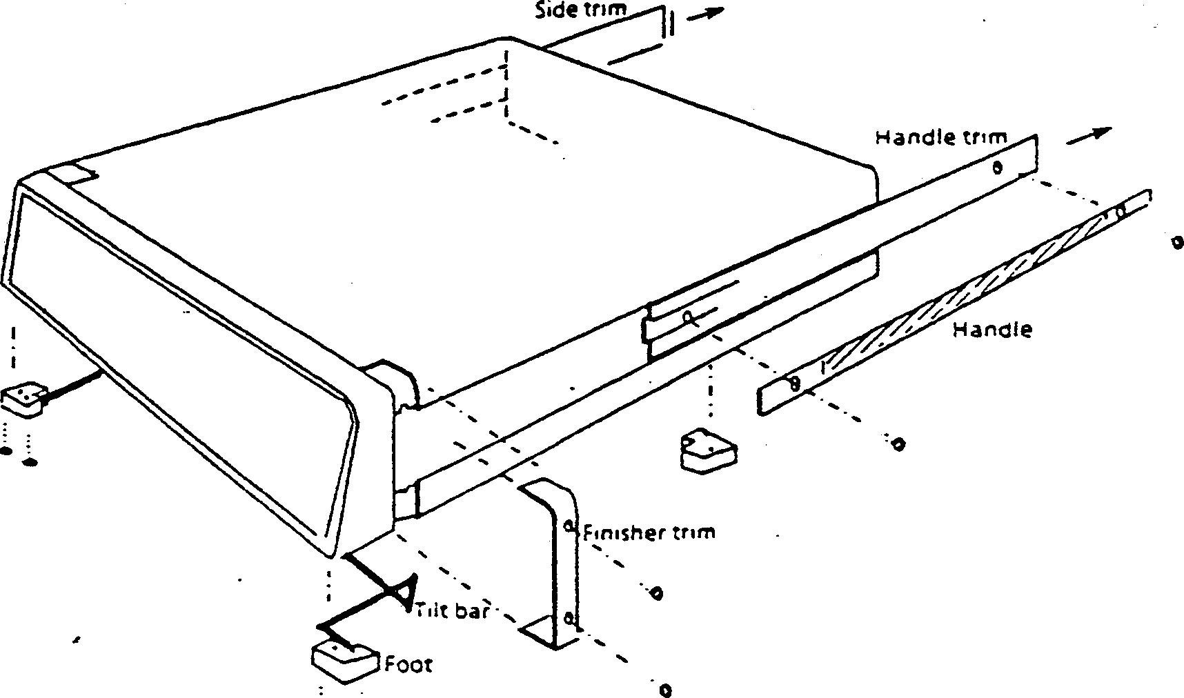
Fig. 2.1 Removal of trims, handle, feet and tilt bar
2.5
BDRP'T081/Part 1/2
4.3.2
Fit the following items to the unit, as shown in Fig. 2.2:
Rack Mounting Brackets (two )
Fit rack mounting brackets in place of the finisher trim, using the same fixings.
The brackets, may be fitted as illustrated, or with their flanges facing the rear of the 7081, which causes the unit to stand out further in the rack, allowing use of racks too shallow for normal mounting.
Slide Mounting Bar
The slide mounting bar and fittings are provided with the 7081 accessories. Screw the bar to the chassis in the former position of the handle, using the four M4xl2 countersunk screws provided. The bar fits correctly only one way round, with threaded holes nearest the front.
The corresponding mounting bar on the left-hand side of the unit is supplied already fitted behind the side trim: it is slightly narrower than the right-hand bar.
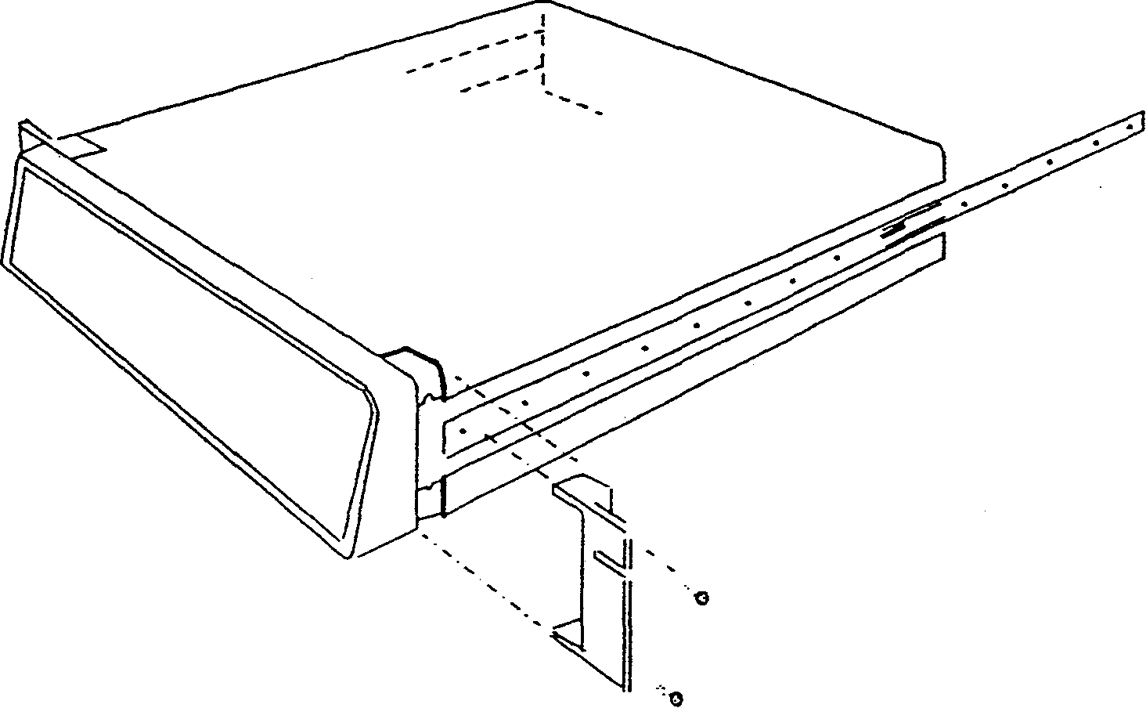
Fig. 2.2 Fitting mounting brackets and telescopic slide inner members
BDRP/7081/Part 1/2
2.6
с. Telescopic Slide Inner Members (two)
The telescopic slides are supplied with inner and outer members slotted together. Slide out the inner member as shown in Fig. 2.3, depressing the locking catch at the halfway point.
Locking catch
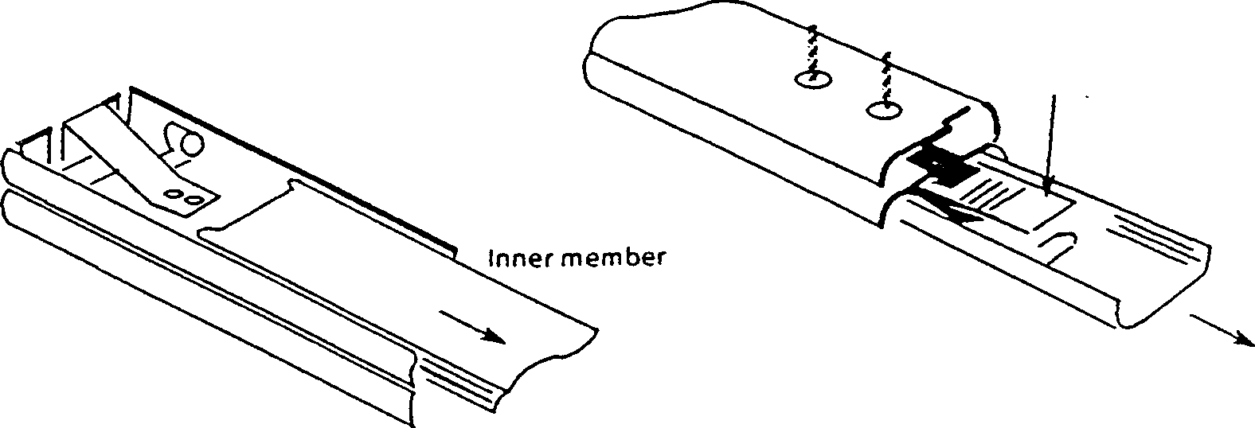
Fig. 2.i Separating the inner and outer slide members, prior to fixing
Screw the slide inner members to the mounting bars, using the 12 M4 x 6 panhead screws supplied, 6 each side.
Fit the following items to the telescopic slide outer members, as shown in Figs. 2.4 and 2.5:
a. Adjustable Rear Brackets (two)
Fit one rear bracket to each outer member, but do not fully tighten the screws until the 7081 is fitted into the rack (Section 4.3.6).
8-32 UNCx 5/16 pan head screws and crinkle washers
Adjustable rear bracket
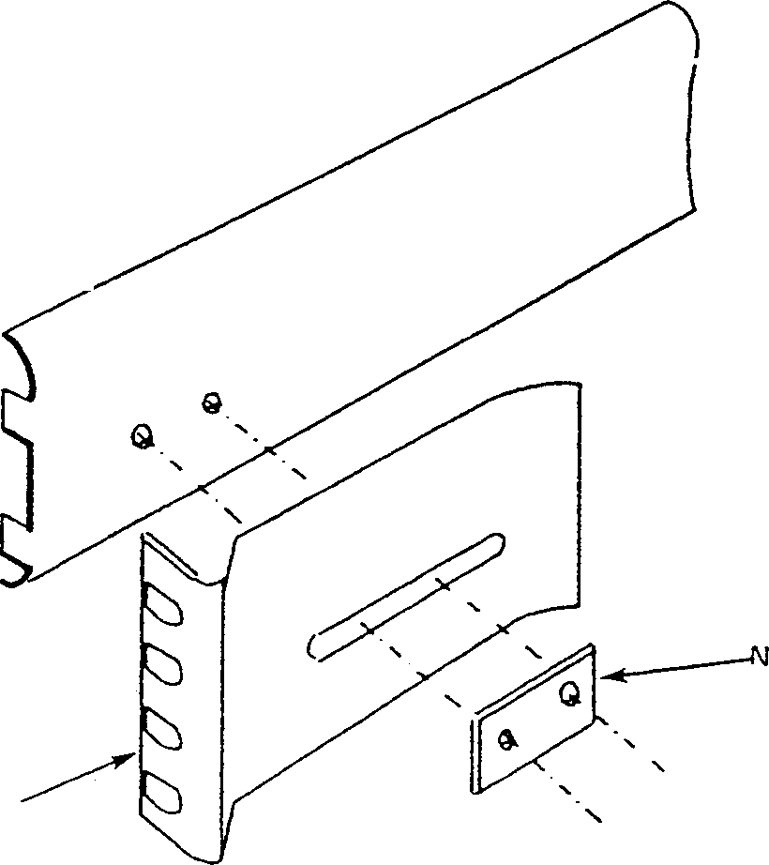
ut plate
Fig. 2.4 Fitting a rear bracket
2.7
BDRP/7081/Part 1/2
b.
Fixed Front Brackets together with Support Brackets (two of each).
Support Bracket
M4 nuts and crinkle washers
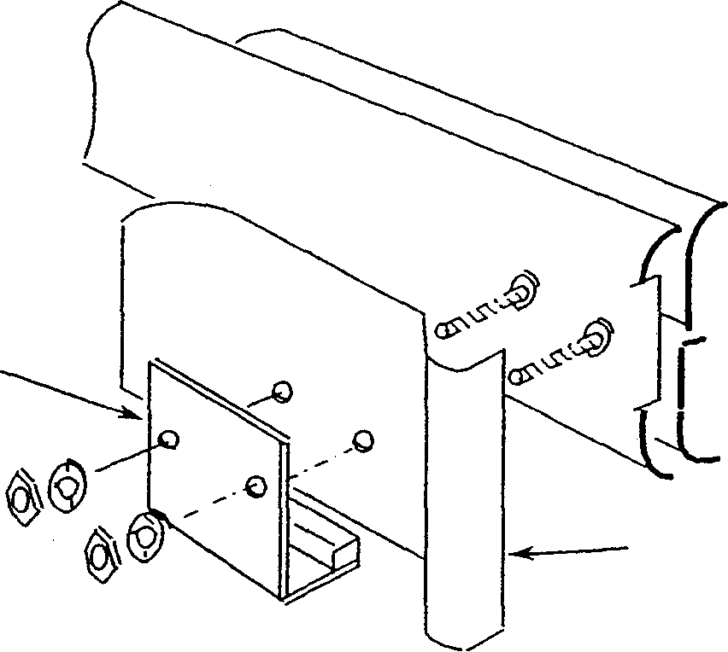
Fixed front bracket
Fig. 2.5 Fitting a front bracket and support bracket
4.3.4 Fit the M6 caged nuts for outer slide member and rack slide member and rack mounting
bracket fixing into the rack, in the positions shown in Fig. 2.6 How to insert and remove caged nuts is shown in the figure detail.
Rack bracket fixing (left hand side)
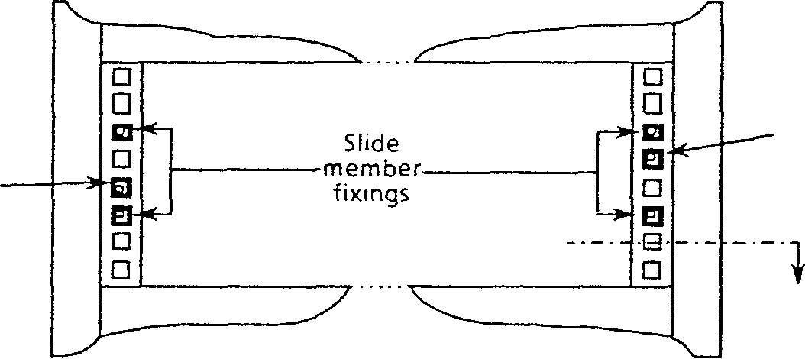
Rack bracket fixing (right hand side)
SECTION 'A'
CAGED NUT INSERTION:
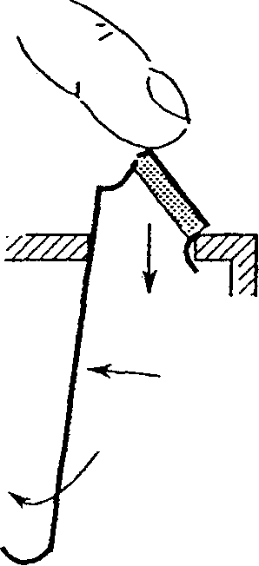
SECTION 'A'
DZUSDP-134-9
CAGED NUT REMOVAL:
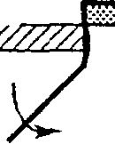
^
Fig. 2.6 Caged nut insertion in Imrak Series 80 (and similar) cabinets
BDRP/7081/Part 1/2 2.8
4.3.5
Fit the Outer Slide Members (two) to the гаек as shown in Fig. 2.7
Note that the tapped holes in the nut plate are positioned off-centre in order to provide maximum lateral adjustment. Fit the plates, as shown, with the holes offset towards the rack exterior.
Fitting one end of an outer member is made easier if the other end is supported, by hooking the bracket at the other end over an M5 screw pushed into the top caged nut.
Tighten the M5 screws securing each member until it is held moderately firmly in the rack, approximately in the centre of its travel. The members must, however, be free enough to take up any adjustment when the 7081 is first fitted into the rack.
Special M5x 10 Ch. HD. screws
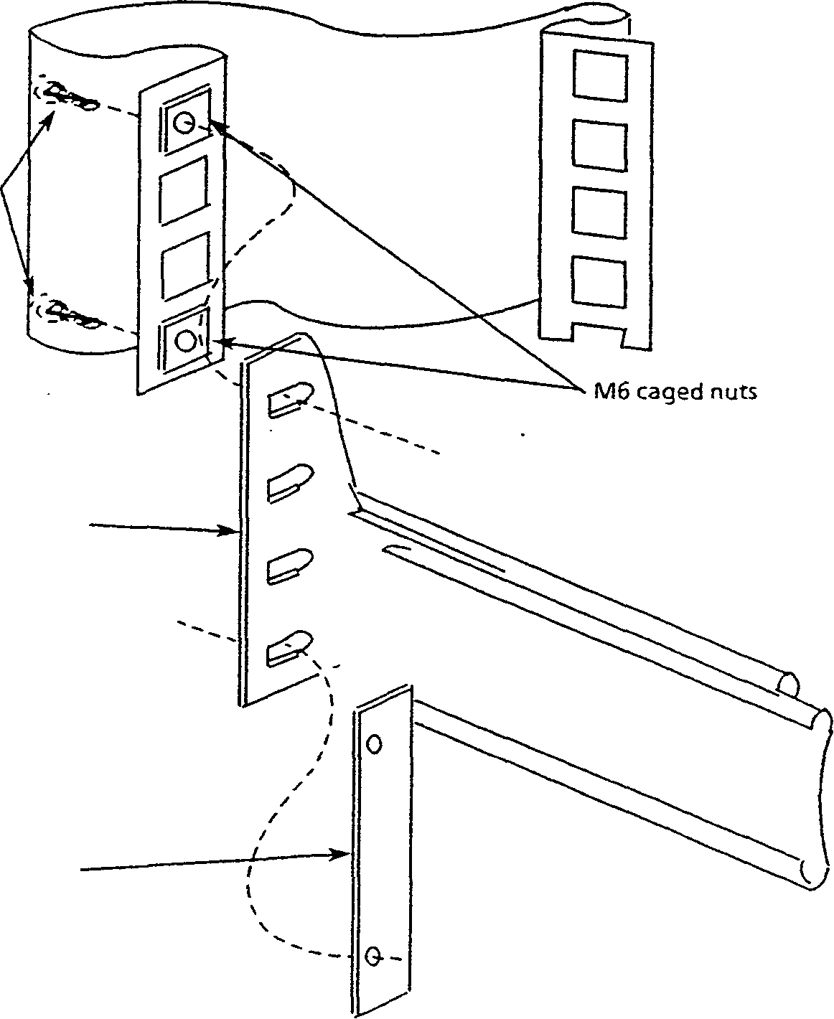
Outer slide member
Nut plate
Fig. 2.7 Fitting the outer slide members into the rack
2.9
BDRP/7081/Part 1/2
4.3.6 Finally, fit the 7081 into the rack, as follows:
a. Offer the 7081 up to the rack and feed the inner telescopic slide members into the outer members, pushing the unit into the rack until the locking catches engage and lock.
b. Depress both catches and push the unit fully into the rack, ensuring that no cables are trapped.
с Tighten the screws on the outer slide members in the following order:
1. the M5 screws securing the rear bracket to the rack,
2. the M5 screws securing the front bracket to the rack,
3. the 8-32 UNC screws securing the rear bracket to the outer slide member.
BDRP/7081/Part 1/2
2.10
Chapter 3 Controls & Displays
Contents
Page No.
1 The Voltmeter Controls 3.2
2 Front Panel Controls 3.2
3 Shifted Level Controls 3.5
4 Rear Panel Controls 3.6
5 Displays 3.6
GAM/7081/Part 1/2
3.1
This chapter is intended to familiarise the user with those voltmeter controls and displays which are associated with its operation as a bench instrument.
Some controls have additional functions, for processing. Also some displays are only concerned with the remote control of 7081. Although mentioned here for continuity, more detailed information on remote control can be found in Part 2 of the manual.
The Voltmeter Controls
All of the voltmeter controls, with the exception of the mains ON/OFF switch, RS232 Baud rate switches and the GP-IB selector switches, are located on the unit front panel. An audible tone accompanies each control selection; a short tone for a valid selection and a long tone for an invalid selection. An invalid signal results, if, for example, the NULL control is selected with the voltmeter set to measure an ac function as nulling is a dc facility. Similarly, a long tone resulting from a keyboard selection (other than by pressing local) indicates that the voltmeter may be under REMOTE control.
Front Panel Controls
The front panel controls are used to select the following unit operations:
1. Measurement
2. Ranging
3. Scale length
4. Trigger
5. Special functions
6. Input select
| ScNumberger |  | 7081 PRECISION VOLTMETER
 |  | ■ .1-33455189 | vsc ■
— fasten nwnuv
— SRQ «utilise
• compute о'оунп
^5; fz=r (g=f f=rT, |gf? p⁵^ p=f p=£ p=fr p=^ pS* p^ f=^ ^Ш
Vrr. ( VO. Ivb*"*' J -^fUJ I П IT«* (I | RATIO ■ I AUTO I T I * I S>3 | «■» I '" I | 8 « 9
p=------ 1 | pi.
1 ГИАСК : | 1 sample :
■•-HIST 1 | |hiST-»i
f-n^e | tn u~'
l"""- ; | [MULL ON ■
P..... !
fa.» 1 | |o*Gfu.r;
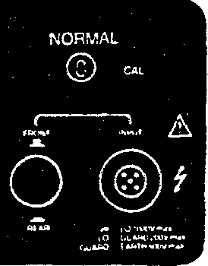
Rg3.1 Front Panel
2.1
Measurement
V= DC Volts
Measures the average dc input over the selected integration time.
V~ AC Volts
Measures the true rms of the ac component of the input over the selected integration time.
V~ + —AC + DC Volts
Measures the true rms of the total (ac + dc) input over the selected integration time. i.e.
-J(Va<r + Vdc²).
-FILT
Selects ac filter. This control can only be used in conjunction with the V~ + — and V— controls and should be selected for full accuracy below 1kHz.
3.2
GAM/7081/Part 1/2
П Resistance
Measures the average resistance over the selected integration time.
Truefl
Measures the resistance eliminating any spurious emfs.
RATIO
Measures the ratio of the unknown input against a reference. (For further details refer to Chapter 4.) The default setting is main/reference.
2.2 Ranging
AUTO
Selects automatic ranging. The unit will select the required range for each measurement taken. Deselection causes the existing range to be held.
▲
Ranges down to a more sensitive range. The unit is therefore set to a specific range.
T
Ranges up to a less sensitive range. The unit is therefore set to a specific range.
2.3 Scale Length
Control | Example Outputs | Approximate | Integration
 |  | Maximum Output | Time
5x9 | 0.54833,2.5491 | 1.40000 | 0.1s
6x9 | 0.548488,2.54883 | 1.400000 | 0.4s
7x9 | 0.5485005,2.548854 | 1.4000000 | 3.2s
8x9 | 0.54850758,2.5488129 | 1.40000000 | 51.2s
2.4 Trigger
TRACK
Causes continuously updated measurements. Press again to stop measurements.
SAMPLE
Causes a single measurement.
2.5 Special Functions
«-HIST
Recalls the last displayed reading. Press again to recall the last but one reading and so on. Up to 1500 readings may be recalled, if the file is set to compressed, or 500 readings, if the file is set to expanded format.
HIST—
Operates as «—HIST but recalls the readings in reverse order, i.e. starting from the first reading in the file.
Note: Holding either of the above two controls ON scrolls through the stored values until the control is released at the required value. This facility provides fast access to records.
NULL
Commands the unit to NULL on any selected dc or ohms range. If the AUTO control is in use, all ranges for the chosen measurement function are nulled.
GAM/7081/Part 1/2
NULL ON
Disables/re-enables a NULL. This control can be used to provide a comparison check on previously nulled ranges. If NULL is in use, the NULL ON annunciator is illuminated.
Note: The unit remembers any nulled range. It is not therefore necessary to re-null after returning from another function.
DIG FILT
Provides digital filtering of the measurements. (For further details, refer to Chapter 4.) The default setting is Walking Window averaging with a sample size of 10.
memory
Places the last displayed numeric value into a specific single slot memory location. The value can be accessed directly and used during program set-up, e.g. as the value N in Ratio. To place a display in the memory or to recall a result from the memory, press the memory control. A result will remain in the memory until over-written or until the 7081 is initialised.
initialise
Returns the unit to the initialised state, i.e. vdc, autorange, 6x9, local, with all programs off. The Ratio and Digital Filter programs adopt their default settings and both interfaces and the nulling facility are disabled.
self test
Initiates a sequence of tests on the voltmeter internal measuring circuits using known inputs. Checks the ohms drive generator, ac amplifier, dc input amplifier and a-to-d converter. A fail display, e.g. FAIL, TEST 0V, appears if a circuit is faulty. Self test stops at a failure, or displays «PASS* if successful.
program
Causes the program status to be displayed and introduces the keyboard shifted level for program selection and definition. After program definition the control must be pressed again to activate the program. (See Shifted Level Controls).
compute
Enables already defined programs to be turned on or off without the need to clear them from the memory.
Note: If compute is pressed to turn the programs off, the RATIO and DIG FILT annunciators may remain on. Under these circumstances, the results will not be processed by these two programs as the compute control overrides the other controls.
SRQ
Permits the user to generate a service request. This control can be used, for example, to indicate to the controller that some local operation has been carried out and that control can now be returned to the controller. Local use of SRQ (usually an automatic voltmeter function) must be enabled via remote control.
local
Returns the voltmeter to local control (from remote), provided that Local Lockout has not been enabled from the controller.
3.4
GAM/7081/Part 1/2
2.6 Input Select
FRONT
1
INPUT
A

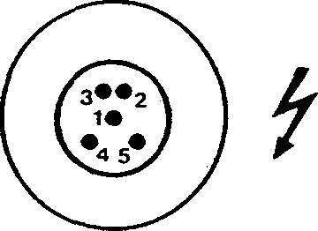
Input pins have the following signal assignment:
1. Guard
2. Lo
3. ft source Lo
4. Hi
5. ft source Hi
REAR
Hi-Lo 1000V max Lo - Guard 200V max GUARD-EARTH 500V
x JS£)
Selects inputs to be routed either via the front panel connector (push button out) or the rear
panel connector (push button in).
Shifted Level Controls
UMGi"
irW«L.
For processing, some of the front panel controls lose their face value meanings and assume different functions. These second, or shifted-level, functions become available after the program key has been pressed. Programs, which may be used individually or combined, can be selected from the following using the adjacent controls:
ratio digfilt scale stats limits time
After selection, programs may be entered then defined.
For program definition, the numeric, the «/EXP and the +/— controls are used. Pressing the above (from left to right) will either select the required program option or enable any numeric value plus sign and exponent to be selected as the constant in a program. The invalid tone will advise when no further options are available for the chosen program.
The remaining shifted-level controls are:
ENTER
Enters program(s), options and constants into memory prior to program execution.
CLEAR
Clears either one program or all programs in preparation for a new program definition or run. This control also clears the program constants.
RECALL
Recalls processed results to the display. Applies to Stats, Limits and, in one case only, to Digital Filter programs.
CLR HIST
Clears the contents of the history file.
COMP HIST
Passes the contents of the history file through any activated programs in the chaining order.
CLR RSLTS
Clears any processed results from the program memory.
HELP
Displays the program options available. Refer to Chapter 4 for a list of the messages displayed.
BRS/708I/Parl 1/3
3.
Rear Panel Controls
The rear panel controls have the following functions:
MAINS ON/OFF
When ON, applies mains power to the unit, initiates a power-up test sequence and causes trickle charge of the RAM back-up batteries.
GP-IB Interface Selectors
Only applicable when the unit is under remote control via the GP-IB interface. (See Part 2).
Displays
When under local control, the voltmeter conveys visual information to the user via the front panel annunciators and the main 14-segment display windows. The audible tone, with its valid or invalid "beep", complements the above two facilities.
Annunciators
When lit, the push button annunciators indicate some active state, e.g. the ft annunciator indicates that the voltmeter is primed to measure resistance.
The HIST (history file) and range (A and T) controls require no annunciation since a change is clearly visible on the main display as it is occurring.
The two nulling controls (NULL and NULL ON) have only one annunciator. When NULL is pressed, the NULL ON annunciator lights after the nulling sequence is completed. Thereafter, NULL ON acts as a switch to either remove the null offset (light off) or to activate it (light on).
The program control has two distinct functions:
1. To introduce shifted-level controls for program selection.
2. To return from programming to ordinary measurement mode.
Executing operation 2 above will cause the 'compute' annunciator to light indicating that programs are defined for use.
Two other annunciators on the front panel are associated only with remote control and have the following functions when lit:
TALK - indicates that the voltmeter is primed to send, or is sending data via the GP-IB interface.
LISTEN - indicates that the voltmeter is primed to receive or is receiving data via the GP-IB interface.
It is possible for the two remaining annunciators, 'SRQ' and 'local' to be activated either by front panel operation or by remote control.
The reasons why a service request (SRQ) is raised are varied but, usually, SRQ is raised automatically as a result of some action (or inaction) over the interface. It is possible for the user to raise an SRQ by pressing the SRQ control.
When the 'local' annunciator is lit, the voltmeter may be controlled fully via the front panel; otherwise ('local' annunciator out) only remote control is possible. Under certain conditions, local control may be re-asserted by pressing local.
GAM/7081/Part 1/2
5.2 Display
A 20-character, alpha-numeric display is used to indicate measurement values, program results and messages. A fixed minus sign appears in the left-hand window if the display quantity is negative.
Table 3.1 lists the 7081 display messages that may appear when the unit is being operated via the front panel.
Table 3.1 Local Messages
Message | Reason for display
WAIT@F | Appears during 7081 power-up or initialise sequence. If message remains displayed, a fault exists.
*RESUMED* | 7081 has been successfully powered-up.
INITIALISED* | 7081 has been initialised either by power-up or by pressing the initialise control.
MAINS FAULT DUMP FAIL NVM FAIL CAL INCOMPLETE | >A fault has occured at power-up.
*PASS* | Self test has been successful.
FAIL, TEST OVDC FAIL, TEST 10VDC FAIL, TEST OHMS FAIL, TEST AC | >7081 has failed part of the self test.
COMPLETE | Nulling or history compute successfully completed.
NULL TOO HIGH | Nulling unsuccessful.
NULLING n | Nulling of range n in operation.
*ARMED* | Time program ready for use.
*READY* | Program(s) ready for use.
COMPUTING | History compute in operation.
INSUFFICIENT HISTORY | Not enough history in the file to complete a history compute operation.
NO PROGRAMS ON | There are no programs enabled and, therefore, history
 | compute has no meaning.
Note: A full list of the responses displayed when the HELP control is pressed is given in Chapter 4.
GAM/7081/Part 1/2
3 Overload Indications
An overload condition is indicated by a flashing display. Usually this occurs when the value at the voltmeter's input terminals becomes too large for a given selected range. Selecting a higher (less sensitive) range, or changing to Autorange, will cause a normal display to return as the instrument automatically protects itself up to the specified maximum input, i.e. 350V if range is fixed on 0.1, 1 or 10V.
Overload may be indicated even when a measurement has not been requested, since the a-to-d converter is always assessing the input.
GAM/7081/Part 1/2
Chapter 4 Local Operation
Contents
 | Page No.
Power-Up | 4.2
Calibration Transfer | 4.3
Self Test | 4.3
Operation | 4.4
Nulling | 4.5
Processing | 4.5
Help Control | 4.19
Clearing Programs | 4.20
Computing History | 4.20
GAM/7081/Part 1/2
This chapter covers the basic operation techniques for the unit including program initiation and use.
1 Power-Up
When the voltmeter is switched ON, a power-up test sequence automatically commences. This checks the voltmeter's two microprocessors and also its battery back-up (for internal calibration memory (RAM) ).
The full sequence should conclude with the display:
RESUMED
indicating that the test sequence has been concluded satisfactorily and that the voltmeter may resume normal operation, i.e. any program constants or history file contents entered before the unit was switched off are retained in the memory.
During the test sequence, the display:
WAIT @ F
should appear momentarily then clear. A failure to clear indicates that the "floating" microprocessor (hence "F") has failed to come out of the reset condition and thus a fault exists. The microprocessor is said to be "floating" because the supply voltages to that side of the unit are tied to the input and therefore subject to some variation.
If, instead of RESUMED, the following appears in the display:
INITIALISED
battery back-up has been unsatisfactory, i.e. the unit has been switched off for too long to retain any history file contents, programs etc.
If
DISPLAY OFF
appears, the display has been turned off via remote control. In order to receive any results, messages, etc. via the front panel, the 7081 must be initialised by pressing the front panel initialise control or the display must be turned on again using a remote control device.
If the unit has a fault, one of the following messages may appear in the display after WAIT @ F:
MAINS FAULT, DUMP FAIL, NVM FAIL, CAL INCOMPLETE
The first of these messages indicates that the "floating" microprocessor has been unable to identify the mains frequency. The second, third and fourth messages relate to the calibration constants as described in the following section.
Once the power-up sequence is complete, the unit adopts the volts dc, auto range, 6x9 mode.
4.2
GAM/7()81/Part 1/2
2 Calibration Transfer
The calibration constants are stored in a Non-Volatile Memory (NVM) situated on the "floating" side of the voltmeter. There are two identical pages of constants in the NVM so that, if a fault occurs on one page, the other can still be used.
At power-up or initialise, the calibration constants are transferred from the NVM into battery-backed RAM on the "earthy" side. This transfer is performed to reduce the access required to the NVM and hence decrease the possibility of corruption of the constants. When the constants are read out of the NVM, a checksum character is computed and compared to the character in the NVM. Each page has its own checksum and, if the page is correct, the result of the comparison will be zero. The NVM checksum has an offset value so that it can distinguish between a valid result and an "all zeros" result produced when the page is empty.
If page one of the NVM is incorrect, page two is checked and the message NVM FAIL displayed. If page two is incorrect, it will still be transferred to the RAM. The microprocessor checks that the RAM has been given the correct number of constants and, if there is an error, DUMP FAIL is displayed. If any of the constants are incorrect, the microprocessor substitutes the default values and the message CAL INCOMPLETE is displayed.
The voltmeter can still be used, if any of these calibration messages appear, but recalibration is required for precision work.
3 Self Test
A unit self test can be initiated by pressing the self test control. During the self test, the voltmeter internal measuring circuits are checked using known inputs. The test sequence is as follows:
1. Press self test.
2. Observe the following displays:
TESTOV TEST 10V TEST OHMS TEST VAC
3. The sequence is completed with: ***** PASS *****
if all the circuits are functioning correctly.
In the event of a failure, one of the displays listed below will appear.
FAIL, TEST OV - indicates a failure in the OV circuitry.
FAIL, TEST 10V- indicates a failure in the dc measurement circuitry.
FAIL, TEST OHMS - indicates a failure in the circuitry used to measure resistance.
FAIL, TEST VAC-indicates a failure in the ac measurement circuitry.
Ail self testing stops at a failure.
If the voltmeter fails theOVor 10V test, it should not be used but, if it fails the ohms or ac test, it can be used, if absolutely necessary, for dc measurement only.
PD/708 I/Part 1/3
Operation
Normal measurement flow is presented in Figure 4.1
RS232 iGPIB |  |  |  |  |  |  |  | NO |  |  |  | G | RS232  PIB  A J
м | 1 |  |  |  |  | w /ТОМИГГрЧ |  | YES |  |  |  | G
м |  | COMMANO INTERPRETER |  | MEASUREMENT CONTROL |  |  |  | YES | PROCESSING |  |  | OUTPUT MANAGER
 |  | COMMANO INTERPRETER |  |  |  | ^\y |  | r~  4 | PROCESSING | ~~1  t l |  | OUTPUT MANAGER
 |  |  |  |  |  |  |  |  |  |  |  |  | 1
 |  |  |  | 1 |  |  |  | r~  4 |  |  |  | t | 1 | '
A |  |  |  |  |  |  |  |  | t | i 1 l_  1  _l |  | 1 |  | '
 |  | KEYBOARD |  | A-0  CONVERTER  CONTROL |  |  |  | r~  4 | DISPLAY |  |  | HISTORY FILE
Fig 4.1 Normal Measurement Flo w
If the unit is to be used, via the front panel, to take individual measurements, the following procedures should be used.
1. Once the unit has been powered-up and a power-up test completed, press the relevant measurement control, e.g. V=, V~ etc. (It is not necessary to press the dc control ,(V='), if the unit is in the powered-up or initialised state).
2. Select the required scale length, i.e. 5, 6, 7 or 8 x 9.
3. Select manual range, if required, using the A or T controls.
4. Connect the test source to either the front or rear panel connector, ensuring that the Input Select switch is in the correct position, i.e. Out for front panel connector, In for rear panel connector.
5. Press SAMPLE for each reading required or select TRACK for repetitive readings.
For any measurement function the user may select Digital Filter.
Before generating a new command into the system, the front panel keyboard checks on the pressure of work and amount of pending inputs, returning an invalid tone if conditions are unsatisfactory, e.g. if repeated samples are requested on 6 x 9 or higher, the 7081 cannot generate results as fast as they are requested and a backlog of trigger commands builds up until, eventually, the invalid tone is heard.
Under certain conditions, controls are rendered invalid to prevent potential confusion, e.g.
1. When measuring under clock control, most of the controls are disabled. This is because new measurement setting commands cannot be actioned until the present measurement command has been completed and so there would be no status display/annunciator feedback or change to the new setting for what could be a very long time.
GAM/7081/Part 1/2
2. When computing history, the prompting mechanism (on error or completion) requires that no further input is generated until the process is complete. To ensure this, most controls are disabled whilst the computing process is being carried out.
5 Nulling
The NULL facility allows offsets during a measurement sequence to be removed from the result. For example, the resistance of test probes could affect the accuracy of a measurement but, by using the NULL facility, this can be allowed for.
When the NULL control is pressed, the message:
NULLING n appears, where n=0.1,1.0,10,100,1000, 10 f 4 depending upon the range being nulled. Upon completion of the null sequence, the message:
COMPLETE appears in the display.
If the NULL is unsuccessful, NULL TOO HIGH appears.
6 Processing
The programs available for the 7081 are:
Ratio
Digital Filter
Scale
Statistics
Limits
Time
The programs have a specific "chaining" order, i.e. result flow order. Therefore a result input into a program may be a result derived from a previous program as shown in Figure 4.2.
If programs are required in a different order to the fixed order, the COMP HIST facility should be used, as shown below.
To calculate the current in a circuit for multiple values of fixed resistances:
1. Clear the history file by pressing theCLR HIST control.
2. Set up the Scale program for m=3, c=0 and activate the program.
3. Set the voltmeter to measure True il.
GAM/7081/Part 1/2
т. г ress the SAMPLE control to measure and process the required number of results.
5. When the measurements are completed, clear the Scale program by pressing program, scale, CLEAR.
6. Set up and activate the Ratio program for MMain with N equal to the known circuit voltage.
7. Press the COMP HIST control.
8. The results displayed will be equal to: known voltage / 3 x measured resistances.
T
INPUT
 | 1 |  |  | 2 |  | 3
 | RATIO |  |  | DIGITAL FILTER |  | SCALE& OFFSET
i |  |  |  |  |  | 6
 |  |  |  |  |  | ЛМЕ PROGRAM
RESULT
Fig 4.2 Program Chaining Order
Ratio Program
Ratio has a front panel control, which has the effect of turning the program on or off. Its mode of operation, however, may be changed via the program control. The modes available are:
Main/reference dB, i.e. x/Ref.dB Reference/main dB, Ref./jrdB Main/reference, i.e. x/Ref. Reference/main, i.e. Ref./дг Main/NdB,i.e..r//VdB N/maindB.i.e. MrdB Main/N, i.e.xW N/main, i.e. Nix where x is the input value.
'Main' refers to the input terminals (front or rear panel) and 'Reference' to the reference or ratio terminals (rear panel). N is a user defined constant. The default setting for the program is main/reference, which is adopted on initialise.
The maximum permitted input for the reference terminals is ± 14V dc but, using the memory, the unit can be used to ratio volts ac and resistance.
GAM/7081/Part 1/2
To ratio resistance values, for example, the following sequence could be used.
1. Measure resistance 1 (Rl) and store the result in the unit memory.
2. Set up the Ratio program using the memory contents as the value N in the program.
3. Measure resistance 2 (R2) using the Ratio program. Results of R2/R1, or R1/R2 can be obtained.
This program can also be used to enable the instrument to measure current, for example in a resistive circuit:
1. Measure the resistance (R) in the circuit, using the True П control, and store the result in the 7081 memory.
2. Set up the Ratio program for MainW with the unit memory contents as N.
3. Measure the voltage (V) in the circuit using the Ratio program. This will give the result V/R, i.e. current (I).
Program Definition
To access the Ratio program, press program, ratio, ENTER.
The program mode is set by pressing one of the controls shown below followed by ENTER.
main _{dB} ref
default
1
main ref
ref
dB
main _{dB}
ref main
main
N
N main
dB
N main
i—tI ^nnnr^i
The value for N is keyed in or obtained from memory.
If required, define the value for N and press ENTER.
To activate the program, press the program control.
READY appears in the display and the compute annunciator lights.
Readings can be taken by pressing the SAMPLE or TRACK control.
To deactivate the program, press compute.
GAM/7081/Part 1/2
Digital Filter Program
The Digital Filter averaging program has three modes of operation:
Continuous averaging Simple averaging Walking window averaging
In continuous averaging, an updated average is output for every input.
UH^kH
H-h-1
о о
205
210
215 RESULTS (л)
-г-Ч—r—I—г—i—I—I—г—I—I—I—r-H—I—r-H—I—h
220
H-----1-----1----1-----1-----H
225
Fig 4.3 Continuous averaging
Readings can be taken using either the SAMPLE or TRACK controls, the difference being that the TRACK control takes measurements at fixed time intervals, whereas the SAMPLE control can be pressed at varying time intervals depending upon the user's requirements. If the TRACK control is used, the program has the capability of producing a continuously updated average for up to 1.37 years before the unit runs out of computing ability owing to the increasing size of the numbers involved.
n measurements
♦
t
♦ ♦ +
♦
RESULT
+
♦

-t-r-H—V
H-------Г-Г-
TIME
3 4
t i t t t
nSAMPLES
8. 9
♦ H t
10
Fig 4.4 Simple A verage of n Measurements (Sample Control Used)
GAM/7081/Part 1/2
In simple averaging, one average result is produced for each sample size (л). The sample size is user definable and has a maximum value of 1E18. A result does not appear on the display until n readings have been taken, therefore, after each reading, (as a result of pressing the SAMPLE control) the number of samples to go is displayed, finally replacing n = 1 with the result. The procedure then repeats itself for another n readings. When using the TRACK control the number of samples to go is not displayed.
n measurements
n measurements
^{T} • •

RESULT
X
4
RESULT
4—I—I—h
4—r—I—r-
10 1
H-----1-----1-----1-----I-----r-
TIME
-----►
TRACK
10
Fig 4.5 Simple Average ofn Measurements (Track Control Used)
In walking window averaging, the sample window used to produce the average result consists of the last n readings where n is the user defined sample size. Therefore, Once the sample size has been fulfilled, an average result is produced for every new input. The maximum sample size for this mode is 16. If a sample size > 16 is set, the program will default to a sample size of 16.
~*— |  |  |  | - '1ST WINDOW --------------- | ---*-
 |  |  |  |  | I |  | »
 |  |  |  |  | < | » | - | > | ( | » | •
 |  | + |  | • •  • | * |  | * |  | * |  | *
< | > |  |  |  |  | 1 |  | 2 | ; | 3 | 4
*
H------h
н—i-
TIME
12 3 4
WALKING WINDOW, n = 7
6 7
MEASUREMENTS
10
11
Fig 4.6 Walking Window A veraging
GAM/7081/Part 1/2
A result does not appear on the display until n readings have been taken. Therefore, after each reading taken using the SAMPLE control, the number of samples to go is displayed until the window is full. The result is then displayed. The sample count down does not appear again, as the window is always full, unless the window is reset or cleared.
Digital Filter has a front panel control, which enables the user to directly turn the program on and off. The mode of operation and, if applicable, the sample size may be changed via the program control. The program default setting, which is adopted on initialise, is walking window averaging with a sample size of 10.
Program Definition
To access the Digital Filter program, press program, dig filt, ENTER.
The program mode is set by pressing one of the controls shown below followed by ENTER.
Continuous Average
Simple Average
default n = 10
Walking Window Average
I M M Л\ 1ПП
V— I W. VV= "VFILT МП ITrue П
LZ
Define the sample or window size and press ENTER, if required. To activate the program, press the program control. READY appears in the display and the compute annunciator lights. Readings can be taken by pressing the SAMPLE or TRACK control. To deactivate the program, press compute.
4.10
GAM/7081/Part 1/2
6.3 Scale Program
The Scale program provides:
у — mx + с where у is the processed result, x the input, and m and с user defined constants.
slope = m
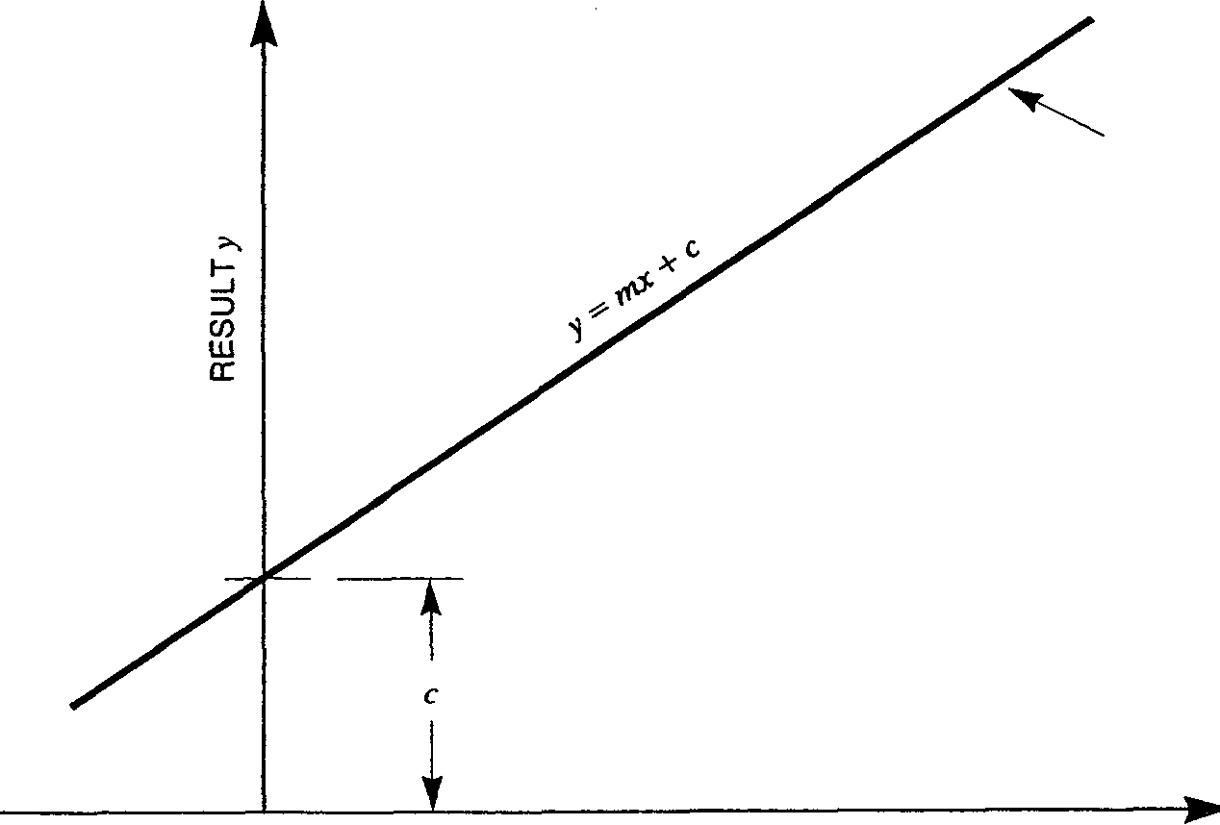
MEASUREMENT x Fig 4.7 Scale and Offset
Both m and с may be taken from memory thus enabling a measured value (e.g. of an offset) to be used.
Readings can be taken using either the SAMPLE or TRACK controls.
Program Definition
To access the Scale program, press program, scale, ENTER.
Set the required value for m. Press ENTER.
Set the required value for c. Press ENTER.
To activate the program, press the program control.
READY appears in the display and the compute annunciator lights.
Readings can be taken by pressing the SAMPLE or TRACK control.
To deactivate the program, press compute.
GAM/7081/Part 1/2
4.11
6.4 Statistics Program
The Statistics program can be used in either continuous or window mode.
In continuous mode, the running variables are constantly updated and a result is output for every input.
In window mode, the result is derived from a user defined sample size up to a maximum of 1E18. After the result has been produced, the variables are reset and a new sample collected.
Both modes may be configured to pass on any of the following outputs:
Normal, i.e. x (reading passed on unaltered)
Number so far, i.e. n (number of samples collected so far)
1 ^{n} Average, i.e. x= — s jc,
i = l
Variance, i.e.
1 " — Z (Xj-x)
i = l
Standard Deviation, i.e.
Д!
(x,-x)
Root mean square, i.e.
M
X/
All of the outputs, with the exception of 'Normal', are stored in the unit's program memory and can be recalled at any time during the program's life by pressing the RECALL control.
Readings can be taken for this program using either the SAMPLE or TRACK controls. However, when in window mode, a number of samples are required before a result is produced. Therefore, a sample count down is displayed to give the user an indication of how many more readings are required to produce a result.
■ continuous -
-O
-window (л)-
<^^[
CALCULATE
STORE
normal -
no. of samples ■
■ average---------
■ variance--------
std. dev.---------
rms---------------
- no. of samples -■ average --------
- variance---------
• std. dev.---------
О
A
"^
-O
_P
]
-o
-o
\
-O
OUTPUT RESULT
RECALL
Fig 4.8 Statistics Program
4.12
GAM/7081/Part 1/2
Note: The standard deviation and variance given in the Statistics program are the standard deviation and variance of the actual sample taken. If a predicted variance of a much larger sample is required, the equation:
1 n _₂
Variance = — £ (xj - x)
/i-l / = i
should be used. This can be calculated using both the Statistics and Ratio programs in the following way:
1. Clear the history file by pressing the CLR HIST control.
2. Set up the Statistics program for a variance output and activate the program.
3. Take the required number of measurements.
4. Clear the Statistics program by pressing program, stats, CLEAR.
5. Set up and activate the Ratio program for Main//V with N = (n — \)ln where n is the sample size used in the Statistics program.
6. Press the COMP HIST control.
7. The reading displayed will be equal to:
1 ^{n} 2
—, X (x,-xf n-\ i=i
i.e. the variance of the total population. Program Definition
To access the Statistics program, press program, stats, ENTER.
The program mode is set by pressing one of the controls shown below followed by ENTER.
Continuous Sampling
Window Sampling
| П | ^f Г]( Г|| П I Г|| 7]
I W. Ivb-f— -\,FILT МП (ТгиеП I RATIO I AUTO
GAM/7081/Part 1/2
4.13
To define the output, press one of the controls shown beiow followed by ENTER.
Normal
No. of Samples
Average
Variance
Std. Deviation rms I I
I ^li 11 ^i ^ii ^f—ni—^i—^
[ V~ j I V<\, I Iw.*—J l-VFILT I I П I True П RATIO I AUTO |
ratk) diofih «<-_ab> stale b.^ **™.
To activate the program, press the program control.
READY appears in the display and the compute annunciator lights.
Readings can be taken by pressing the SAMPLE or TRACK control.
To deactivate the program, press compute.
Recall
To recall the results stored in the program memory, press program, stats, RECALL.
Press the RECALL control to scoll through the results, which are displayed in the following orden-
Number of samples Average Variance
Standard Deviation Root Mean Square
To return to the normal measurement mode, press program.
14
GAM/7081/Part 1/2
6.5 Limits Program
This program can be used in both continuous and window mode.
In continuous mode, the results are constantly updated and an output result is displayed for every input.
In window mode, one result is produced for each sample size. The sample size is user definable up to a maximum of 1E18.
The output of the program may be configured to be any of the following:
Normal, i.e. x (reading passed on unaltered)
Number high, i.e. n> Hi limit (number above high limit)
Number low, i.e. n< Lo limit (number below low limit)
Number no go, i.e. Hi < n < Lo (number out of limits)
Number go, i.e. Lo ^ n =£ Hi (number within limits)
Max.value, i.e. Max. x found
Min. value, i.e. Min. x found
Peak to Peak value, i.e. Max. x - Min. x
High results, i.e. x > Hi (only high results output)
Low results, i.e. x < Lo (only low results output)
No Go results, i.e. Hi < x < Lo (only out of limits results output)
Go results, i.e. Lo <д: ^ Hi (only within limits results output)
The unit stores the number of high, low, go and no go results, the max., min. and peak to peak values in the program memory. These results can be recalled at any time during the program's life by pressing the RECALL control.
-X*
continuous
■ window (n) ■
^^
CALCULATE
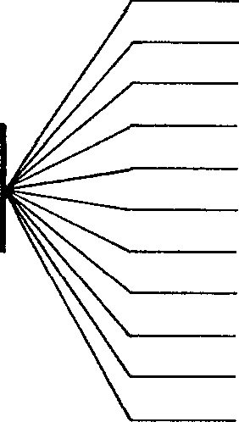
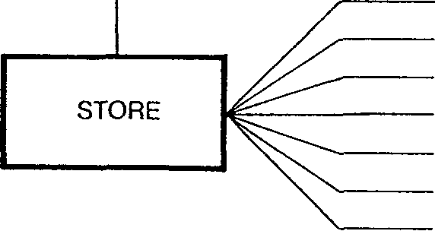
normal------------
no. of results > Hi no. of results < Lo no. of results No Go no. of results Go max. value min. value peak to peak value value > Hi value < Lo value No Go value Go
no. of results > Hi no. of results < Lo no. of results No Go no. of results Go
max.--------------
min. ---------------
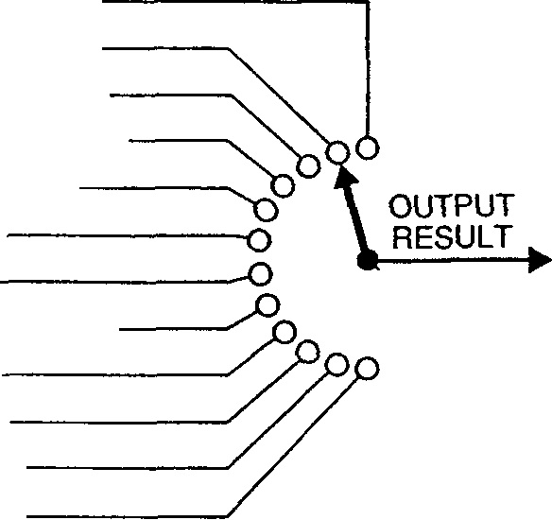
peak to peak value
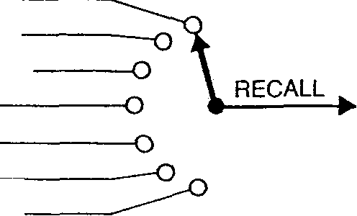
Fig 4.9 Limits Program
Measurements for the Limits program can be taken using either the SAMPLE or TRACK controls. However, if the program is configured for window mode, several measurements are required before an output is displayed. In this instance, a sample count down is displayed, in response to the SAMPLE control, which finally replaces n — 1 with the result. The process then repeats itself for another n measurements
GAM/7081/Part 1/2
4.15
Program Definition
To access the Limits program, press program, limits, ENTER.
The program mode is set by pressing one of the controls shown below followed by ENTER.
Continuous Sampling
Window Sampling
V— J I V\, lv-V/-n=j I«\,fhjI I n (Truen
Enter the sample size, high and low limits, if required.
To define the output, press one of the controls shown below followed by ENTER. THE NUMBER OF RESULTS
"I
THE VALUE OF THE RESULTS
>Hi <Lo No-Go Go
NORMAL OUTPUT
Max
Min
P-P
>Hi <Lo No-Go Go
ni ^ nn
(—^ i—^ii—^ г
AUTO j I T j ( A j |
-CXP 5x9 j
Results equal to Hi or Lo Limit are treated as in limit (Go).
To activate the program, press the program control.
READY appears in the display and the compute annunciator lights.
Readings can be taken by pressing the SAMPLE or TRACK control.
To deactivate the program, press compute.
Recall
To recall the results stored in the program memory, press program, limits, RECALL.
Press the RECALL control to scroll through the results, which are displayed in the following order:-
Number of results > Hi Number of results < Lo Number of results No Go Number of results Go Maximum value Minimum value Peak to peak value
To return to the normal measurement mode, press program.
4.16
GAM/7081/Part 1/2
6.6 Time program
The Time program is a measurement control function and not a processing function. Its main object is to enable the unit to take automatic measurements under clock control. The compute annunciator does not light when the Time program is in use.
Two modes are available for the program:
Real Time Elapsed Time
When in the real time mode, the begin and end times for the program must be set to a time of day, e.g. BEGIN 11,55,31.6,01, END 11,58,31.6,01.
In the elapsed time mode, the begin time indicates the time between the moment the user presses the SAMPLE control and the moment the voltmeter makes the first measurement. The end time indicates the period over which the unit will continue to take measurements.
In both modes, the interval time denotes the time between individual measurements
ACTIVATE SAMPLE KEY
____A.
BEGIN 10.30H
REAL TIME
MEASUREMENTS
INTERVAL 30s
BEGIN
INTERVAL
END
10,30,00.0,00 00,00,30.0,00 17,15,00.0,00
END 17.15h
ACTIVATE SAMPLE KEY
ELAPSED TIME
MEASUREMENTS
BEGIN 10m
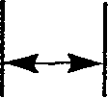
INTERVAL 15s
BEGIN
INTERVAL
END
00,10,00.0,00 00,00,15.0,00 02,10,00.0,00
END 2h10m
Fig 4.10 Time Program
The values should be entered in hours, minutes, seconds, tenths of seconds and elapsed days format.
The TRACK control cannot be used with this program.
GAM/7081/Part 1/2
4.17
Program Definition
To access the Time program, press program, time, ENTER.
The program mode is set by pressing one of the controls shown below followed by ENTER.
Real
Elapsed
I ^l 1 I II ^1 ^1 ^
V= I W I jw.* —I IO.FILTJ I П I ITruen
Define the values for the begin, interval, end and time of day. Follow each time setting by pressing the ENTER control.
To activate the program, press the program control.
ARMED appears in the display.
Press the SAMPLE control to begin measurements.
Time of Day
It is possible to set the Time of day in 7081 using the Time program as time of day appears after the begin, interval and end times. Therefore, if begin, interval and end are to be 'unchanged' but time of day is to be altered, the following procedure should be adopted:
1. Press program, time, ENTER.
2. Press the V------control, to denote real time, followed by ENTER.
3. Press ENTER three times.
4. Define the time of day required in hours, minutes format, e.g. 11,15, followed by pressing the ENTER control.
5. To activate the setting, press the program control.
4.18
GAM/7081/Part 1/2
7 HELP Control
The HELP control can be used at any time during program definition to display the options available. Refer to Table 4.1 for a list of the messages displayed.
Table 4.1 Help Messages
Display Message | Occurence/Use | Definition
Select 0 -»5 EN RE PRO | HELP control pressed immediately after program control | Press control 0 to 5, ENTER, RECALL or program
0 -» RECALL + MEMORY | To set Limits window, high or low, Scale с or m, Ratio N, Digital Filter window or Statistics window | Press controls 0 to 9, •/ EXP,+/-, ENTER, CLEAR, RECALL or memory
0 ->9 ENT HH,MM,SS-T,DD | To set Time Begin, Interval or End | Press controls 0 to 9, followed by ENTER, in hours, minutes, seconds, tenths of seconds, days format
0 ->9 ENTER HH, MM | To set Time now | Press controls 0 to 9, followed by ENTER, in hours, minutes format
SELECT 0 -+ +/- ENTER | To set Limits output | Press control 0 to 9, */EXP or +/- followed by ENTER
SELECTO-CENTER | To set Statistics output | Press control 0 to 5, followed by ENTER
SELECTOR ENTER | To set Ratio mode | Press control 0 to 7, followed by ENTER
S ELECT 0->2 ENTER | To set Digital Filter mode | Press control 0 to 2, followed by ENTER
SELECT 0-^1 ENTER | To set Statistics, Limits or Time mode | Press control 0 to 1, followed by ENTER
RECALL PROGRAM | After results displayed | Press RECALL to access next result or program to exit from results sequence.
GAM/7081/Part 1/2
4.19
8 Clearing Programs
Once the programs have been set up, they can be turned on or off, as required, by pressing the compute control. Also, any results stored in the program memory can be cleared by pressing program followed by the CLR RSLTS control. The programs remain unaffected.
If all the defined programs are no longer required, they can be cleared by pressing program and then CLEAR. To clear individual programs, for example the Ratio program, press program, ratio, CLEAR. Any other defined programs will remain intact.
9 Computing History
The contents of the history file can be passed through any of the programs by setting up the programs required and then pressing the COMP HIST control. For example, in order to ratio a number of results against a constant the following procedure could be adopted:
1. Clear the history file by pressing the CLR HIST control.
2. Set up the voltmeter to measure, for example, volts dc, 7x9, auto and press the SAMPLE control to measure the required number of inputs.
3. Set up the Ratio program for Main/TV and activate the program, ensuring that the required value for N is entered
4. Press the COMP HIST control.
5. The results displayed will be equal to: measured voltages/constant(AO The processed results are placed in the history file.
4.20
GAM/7081/Part 1/2
Appendix 1 Operating System Error Messages
The following messages should never be seen as they indicate an internal fault: @ F, REL S, REL M, REL L, REL U, GET U, @ S, @ W, @ P. If one does appear (the unit may be under either local or remote control), the following procedure should be adherred to:
1. Power-off the 7081.
2. Power-on and press the initialise control.
3. If the fault persists, power-off and hold the initialise control depressed whilst powering-on.
4. If this also fails to clear the fault, contact Solartron giving details of the error message and the exact circumstances of its occurrence.
GAM/7081/Part 1/2
Al.l
Index
Accessories, 2 Terminal Input Lead, 1.5 Accessories, 3 Terminal Input Lead, 1.6 Accessories, 5 Terminal Input Lead, 1.7 Accessories, General, 1.5 Accessories, Ratio Plug, 1.6 ARMED, 3.7
Calibration Transfer, 4.3
Calibration, General, 1.4
Capabilities, 1.2
Clear, 3.5
Clear History, 3.5
Clear Results, 3.5
Clearing, Programs, 4.20
Compute History, 3.5, 4.20
Compute, 3.4
Controls, Front Panel, 3.2
Controls, Shifted Level, 3.5
Digital Filter, General, 3.4, 4.8 Digital Filter, Program Definition, 4.10 DISPLAY OFF, 4.2 Displays, Alpha-Numeric, 3.7 Displays, Annunciators, 3.6
Error Messages, A1.1
Facilities, 1.2 Fuses, 2.2
GPIB, 1.3
GPIB, Interface Selectors, 3.6
Help Messages, 4.18
Help, 3.5
History File, General, 1.3, 3.3
Initialisation, 3.4 INITIALISED, 4.2 Input Select, 3.5 Interfaces, General, 1.3
Limits, General, 4.15 Limits, Program Definition, Limits, Recall, 4.16 Local Operation, 3.4
4.16
Measurement Capabilities, 1.2 Measurement, General, 3.2 Memory, 1.3,3.4 Messages, Help, 4.18
Messages, Local, 3.7 Messages, Operating System Error, Messages, Self Test, 4.3 Multi-Channel Capabilities, 1.4 Multi-Channel Connector Pin Assignments, 1.4
NULL ON, 3.4 Null, General, 3.3 Nulling, 4.5
Al.l
Operation, General, 4.4 Operation, Measurement, Overload Indicators, 3.8
4.4
Power-Up, 4.2 Processing, Clearing Programs, Processing, Computing History, Processing, Digital Filter, 4.8 Processing, General, 1.3,4.5 Processing, Limits Program, 4.15 Processing, Ratio Program, Processing, Scale Program, Processing, Time Program, Program, 3.4
4.20 4.20
4.5 4.11 4.17
Ranging, 3.3
Ratio Plug, 1.6
Ratio, General, 1.2
Ratio, Program Definition, 4.7
Ratio, Program, 4.6
READY, 3.7
Rear Panel Controls, 3.6
Recall, Limits Program, 4.16
Recall, Statistics Program, 4.14
RESUMED, 4.2
RS232, 1.3
Sample, 3.3
Scale Length, 3.3
Scale, General, 4.11
Scale, Program Definition, 4.11
Self Test, 3.4,4.3
Special Functions, 3.3
SRQ, 3.4
Statistics Program, Processing, 4.12
Statistics, Computing History, 4.12
Statistics, General, 4.12
Statistics, Program Definition, 4.12
Statistics, Recall, 4.14
Storage, 1.3
PD/7081/Part 1/2
Talk/Listen, 3.6
Time of Day, 4.18 .
Time, Elapsed, 4.17
Time, General, 4.17
Time, Program Definition, 4.18
Time, Real, 4.17
Track, 3.3
Triggering, 3.3
Voltage Selection, 2.2
WAIT@F, 4.22 Warm-up Procedure, 2.3
./Exp, 3.5
AMK/7081/Part 1/3
Cl| solartron
Instruments
7081
Precision Digital Voltmeter
OPERATING MANUAL
Part 2
Solartron Instruments Ltd is a division of the Solartron Group Ltd. Any reference to Schlumberger or Schlumberger Instruments (the name of the company until November 1993) implies no liability on the part of Schlumberger.
Solartron Instruments Ltd
Victoria Road, Famborough, Issue 5 : June 1985
Hampshire GU14 7PW. UK. Solartron Part No.: 70810011
19©93
Solartron Instruments Ltd
Victoria Road, Farnborough Hampshire GU14 7PW England. Telephone 0252 376666. Fax: 0252 544981
Solartron Instruments
WittekindstraBe 12
45470 Miilheim/Ruhr, Germany
Tel: 0208 31026
Fax: 0208 31441
Solartron Instruments
12 Lorong Bakar Batu #07-07/11 Singapore 1334, Republic of Singapore Telephone: 7466344. Fax: 7475186 Telex: RS 25315 SLBSYS
For details of our agents in other countries,
Solartron Instruments
11321 Richmond Avenue, Suite M102 Houston, Texas, 77082-2615 USA Tel: (713) 558 2587 Fax:(713)558 8954
Solartron Instruments
50 Ave Jean Jaures
BP 620-06, 92542 Montrouge, Cedex, France
Telephone: (1)47 46 67 00
Fax: (1)47 46 67 27
Solartron Instruments Liaison Office
Room 58357, Jin Jiang Club
191 Chang Le Road, Shanghai 200020
Peoples Republic of China
Telephone: 21 4728753 Fax: 21 4728753
Telex: 33012 BTHJC CN (Room 58357)
contact our Farnborough, UK, office.
Solartron Instruments pursue a policy of continuous development and product improvement. The specification in this document may therefore be changed without notice.
7081 WITHIN A SYSTEM
The need for a precision measurement module in a data acquisition, or other processor-controlled, system is readily satisfied by the 7081 voltmeter. All front-panel-selectable facilities (with the exception of the Input Select switch) are fully programmable. The instrument can thus be remotely controlled by electrical commands. An interface - the user has a choice of two international standards - accepts command data from, generates the control signals required by, and outputs data to, the external system. The output information can be simple measurements, processed measurement data, or data accessed from the 7081 history file.
In a simple system, involving the use of just one other device, e.g. a keyboard terminal, the measurement processing and data storage/manipulation facilities of the voltmeter offer considerable sophistication and obviate the need for the terminal to be intelligent. On the other hand, by choosing 7081 for inclusion in a complex, multi-device system such as a fully automated test facility, the instrument's ability to manipulate data can be exploited to complement the computational power of the System Controller. The latter will thus be freed for other tasks, such as servicing the needs of other devices within the system.
The 7081 contains two interfaces either of which can be used on its own, or a system can be configured which combines the facilities that they offer:
1. A two-wire Serial Interface, conforming to the RS232/CCITT V24 standard.
2. A bit-parallel, byte-serial Interface, conforming to IEEE 488(1978) - the GP-IB Interface.
Chapter 1 of this part contains an introduction to interfacing whilst Chapters 2 and 4 provide a brief outline of the two standards and how 7081 utilises them within a system. Chapter 3 is devoted to an explanation of the command languague and error messages.
G AM/7081/Part 2/2
Contents Part 2
Chapter 1 General Information
1  2 3 4 5 | Introduction Combined System RS232C(V24) IEEE 488/1978 (GP-IB) Command Language | Page No. 1.2 1.2 1.2 1.3 1.6
Chapter 2 | Operation over the GP-IB
1 2 3 4 5 6 7 8 9 10 11 | Introduction  Commanding Remote and Local  Commanding Measurements  Message Protocols  Invalid Characters  Input and Output  GP-IB Functions  Lock Front Panel Command  Interrogation Characters  Processed Measurement  Programming Examples | 2.2  2.2  2.2  2.6  2.6  2.7  2.7  2.9  2.9  2.10  2.10
Chapter 3 | Command Language
1  2 3  4 | Introduction  Commands  Command Execution Order  Error Messages | 3.2 3.2 3.4,9 3.50
Chapter 4 | RS232 Operation
l  2 3 4 5 6 | Introduction  Hardware and Terminology Transmission Speeds Command Language Input and Output Programming Examples | 4.2 4.2 4.2 4.3 4.3 4.4
Appendix 1 | Examples of Output Formats | Al.l
Appendix 2 | Adopted Settings | A2.1
Index
GAM/7081/Part 2/2
Chapter 1 General Information
Contents
 |  | Page No.
1 | Introduction | 1.2
2 | Combined System | 1.2
3 | RS232C (V24) | 1.2
4 | IEEE 488/1978 (GP-IB) | 1.3
5 | Command Language | 1.6
G AM/7081/Part 2/2 1-1
I Introduction
The 7081 interfaces function as bi-directional data transfer devices. Information is received, at an interface, as coded electrical commands and the voltmeter responds by sending either measurements or other data as commanded by the system controller.
Two interfacing standards are available:
1. A serial interface conforming to RS232C.
2. A bit-parallel, byte-serial interface conforming to IEEE 488/1978.
Selection is made simply by connecting 7081 to the system via the appropriateRS232C or IEEE socket at the rear of the unit. The RS232C baud rate is set up by internal switches and the IEEE device address by rear panel switches.
Combined System
The 7081 is capable of operation within a combined system using both RS232C and IEEE compatible equipment e.g. the voltmeter might be configured within a full IEEE system and yet also be connected, via a separate rear panel connector, to an RS232C terminal.
In a system containing more than one controller, only one can be controller-in-charge at any one time. The other(s) must remain in the idle state until control is handed over. Initially, the controller-in-charge is the first controller to send instructions on the bus.
RS232C (V24)
RS232C defines a standard interface between data terminal equipment (DTE) and data communication equipment (DCE) employing serial binary data interchange. In this instance, the 7081 acts as a DCE; the DTE might typically be a teleprinter, such as the Texas ASR 743.
L
1
Scope of RS232
I
1  DTE 1 (ASR 743) 1  1 1 |  | INTERFACE
1
1
INTERFACE | 1 DCE j (7081)
J
Fig 1.1 RS232C Linking
GAM/7081/Part 2/2
3.1 Interface Details
The interface standard, definable by its mechanical and electrical characteristics, specifies fourteen interchange circuit configurations for data transmission. The 7081 RS232C interface is classified as Type E and has the pin/signal assignment listed in Table 1.1.
Table 1.1 PinlSignal Assignment.
Pin No | Signal
1 | Protective Ground
2 | Transmitted Data
3 | Received Data
5 | Clear to Send
6 | Data Set Ready
7 | Signal Ground
8 | Received Line Signal Detector
20 | Data Terminal Ready
All the RS232C control signals (pins 5, 6, 7, 8 and 20) are internally commoned within 7081, thus the voltmeter transmits and receives data over what is effectively a twin-wire system.
4 IEEE 488/1978 (GP-IB)
The IEEE 488 interfacing standard, or GP-IB as it is also known, defines a bi-directional bus structure for the interconnection of programmable instruments in byte-serial, bit-parallel interfacing systems. The.cables, connectors and control protocols used are rigidly defined to ensure unambiguous interdevice communication. The limitations on a system are:
1. A maximum of 15 devices can be interconnected by a single bus.
2. The total bus length should not be greater than 20m or number of devices x2m, whichever is the shorter.
3. Transmission rate should not exceed 1 Megabaud.
4. All bus data should be digital.
4.1 Devices
Of the 15 devices on the GP-IB, only one is designated controller-in-charge. This device exercises overall bus control and is capable of both receiving and sending data. The remaining devices can be designated as follows:
Listener-able to receive messages Talker-able to send messages Talker/Listener Combined-e.g. 7081
The controller can address other devices and command them to listen, address one device to talk, and wait whilst a message is sent. Message routes are set up by the controller but it need not take part in the data interchange.
4.2 Cabling
The GP-IB is a standard cable linking the individual instruments into a coherent system. It contains 16 signal wires and 8 earth returns. The cable connectors consist of a plug/socket piggy-back arrangement, so that additional cables can be connected maintaining the parallel bus structure.
G AM/708 l/Part 2/2
The 16 signal wires form the communication highway and comprise:
8 data wires - digital input/output (DIO)
5 management wires - interface control signals
3 handshake wires - transfer of data control
Management
The management lines are used for bus supervision. The signal ATN (Attention) is asserted by the controller whenever it places an address or command message byte on the bus. ATN is used in conjunction with EOI (end or identify) when the controller is carrying out a device poll. The EOI line can also be driven by a talker to indicate the end of a message.
 | ,,,. | iff | y_o
DEVICE A  Able to talk, listen, and control. Controller |  | iff
DEVICE A  Able to talk, listen, and control. Controller | *:,& Г ? | • :'- ';■■'• | :
DEVICE A  Able to talk, listen, and control. Controller |  | » | » | >»_^
DEVICE A  Able to talk, listen, and control. Controller |  |  | ( | >»_^
 |  |  | ( | >»_^ | \ Data Bus J (8 lines)
DEVICE В  Able to talk and listen. . |  |  | ( | >»_^
DEVICE В  Able to talk and listen. . |  | » | »
DEVICE В  Able to talk and listen. . |  | С | \
(e.g. Digital Voltmeter) |  | С | \ |  | 3 Wire Handshake
(e.g. Digital Voltmeter) |  | С |  |  | System
DEVICE С  Only able to listen. |  | С
DEVICE С  Only able to listen. |  | 1 | >
DEVICE С  Only able to listen. | ^. | ^{N}\___
(e.g. Signal Generator) | ( | ^{N}\___ |  |  | General Interface
(e.g. Signal Generator) | ( | Г |  |  | Management Bus (5 lines)
DEVICE D  Only able to talk. | ™*
DEVICE D  Only able to talk. |  | ■ | ;
DEVICE D  Only able to talk. |  | »
DEVICE D  Only able to talk. |  | --------------it |  | L
DEVICE D  Only able to talk. |  | --------------_и |  | L
(e.g. Tape Reader) |  |  |  | ПЛХ/
 |  |  | МПГП
 |  | ..
 |  | . |pQ
 |  | SRQ
 |  | ..... RFM
EOI
Fig 1.2 GP-1В Structure
G AM/7081/Part 2/2
To alert the controller to the fact that service is required, e.g. data for transfer, a device asserts SRQ. The controller then conducts a device poll to determine which device requires service.
The remaining two lines are largely self-explanatory. IFC (Interface Clear) is used by the controller to initialise the interface to a predetermined state. REN (Remote Enable) is used by the controller to enable an addressed device/devices to accept remote control.
4.4
Handshake
Message data is transferred under the control of a 3-wire handshake, which can be arranged to run at the speed of the slowest bus device concerned with the interchange. The talker indicates that a byte is present by asserting DAV (Data Valid), then waits for all devices to indicate that the data has been accepted. The listeners do this by releasing the NDAC (Not Data Accepted) line. Data may only be sent if all devices are ready to receive. This is indicated by the releasing of the NRFD (Not Ready for Data) line by every device as it becomes ready for another data byte.
ATN
FIRST DATA BYTE
SECOND DATA BYTE
DIO 1-8 _____
(COMPOSITE)
DAV
VALID
NOT VALID NOT VALID
1
VALID
r
SOME READY ALL READY
NRFD
NONE READY
NONE READY
ALL SOME SOME ACCEPTED ACCEPTED ACCEPTED ALLACCEPTED
NDAC
NONE ACCEPTED •
NONE ACCEPTED
Fig 1.3 Handshake Routine Timing
GAM/7081/Part 2/2
1.5
4.5 Address and Talk/Listen Selection
For normal operation on the GP-IB (using a controller) set the selector switch on the rear panel as indicated in Figure 1.4.
i---------LISTENIONLY
_ADDRESS_ p^----------TALK ONLY
ADDRESS: As required 12 4 8 16
LISTEN ONLY: OFF TALK ONLY: OFF
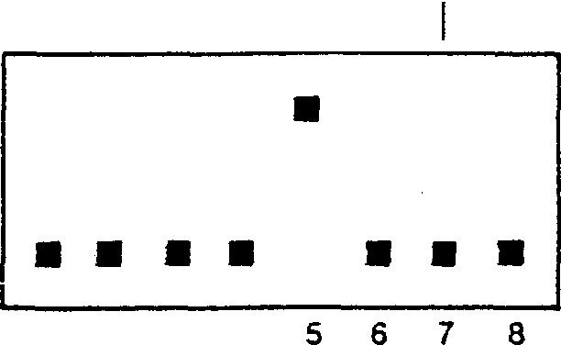
ON
12 3 4
OFF
Rg 1.4 GP-IB Selector Switches
For operation without a controller, e.g. if a printer only is connected to 7081, the TALK ONLY mode should be selected. To achieve this, set TALK ONLY to ON.
Note:The voltmeter only looks at the selector switch settings at power-up or initialise.
Command Language
The command language for both interfaces is formed of English language words, decimal numbers and a set of punctuation symbols. It incorporates, where applicable, the recommended practices set out in the 1981 draft "CODE AND FORMAT CONVENTIONS FOR USE WITH IEEE STANDARD 488 (1978)". The form and type of words (see Chapter 3) are based on those specified in the IEEE standard 416 (1978) commonly known as atlAs.
1.6
PD/7081/Part 2/3
Chapter 2 Operation over the GP-IB
Contents
 |  | Page No.
1 | Introduction | 2.2
2 | Commanding Remote and Local | 2.2
3 | Commanding Measurements | 2.2
4 | Message Protocols | 2.6
5 | Invalid Characters | 2.6
6 | Input and Output | 2.7
7 | GP-IB Functions | 2.7
8 | Lock Front Panel Command | 2.9
9 | Interrogation Characters | 2.9
10 | Processed Measurement | 2.10
11 | Programming Examples | 2.10
G AM/7081/Part 2/2 2.1
This chapter describes the use of 7081 within a GP-IB system.
1 Introduction
All 7081 facilities can be accessed and controlled remotely via the GP-IB using a suitable controller. These facilities consist of all those offered at the front panel plus some additional ones.
The 7081 will accept commands from the controller, initiate measurements and send results back to the controller when requested. In addition the 7081 can be programmed to interrupt the controller when a measurement or an error occurs, thereby allowing the controller to conduct other tasks until interrupted and so increase system efficiency.
Connection to the GP-IB is made using the IEEE 488/GP-IB Interface socket on the rear panel. The 7081 address and Talk/Listen status are selected using the adjacent switch.
2 Commanding Remote and Local
Depending upon the interface switch settings and certain GP-IB commanded parameters, 7081 can be switched between local and remote operation either manually, or by electrical commands. With full IEEE 488/1978 implementation, i.e. GP-IB ON and 7081 not in TALK ONLY:
1. On power-up the instrument is in local operation without Local Lockout.
2. With REN (Remote Enable) asserted and after the listen address has been received from the GP-IB controller, 7081 will be in remote.
3. Local Lockout disables the local control preventing any attempt to return to local via the front panel. The RS232 interface is also disabled by this command.
4. If the instrument, in the remote state, receives the GP-IB command GO TO LOCAL, or REN is unasserted, 7081 enters the local state.
The remainder of this description covers the operation of 7081 in remote.
3 Commanding Measurements
With 7081 under remote control, front panel selection of function, range, scale length etc. is not possible. Therefore, the controller must command all the settings and instruct the voltmeter to take a measurement. Instructions are sent in the form of a message string, using the appropriate commands followed by a number or word which clearly defines the setting. For example, to command 7081 to operate on the 100 range, the command is RANge= 100; if Autorange is required the command is RANge=Auto.
Other parameters are commanded in a similar fashion; measurement function is, for example MODe=VDC; displayed scale length is NInes=n where n=3 to 8. Thus:
MODe=VDC: RANge=Auto: NInes=6
commands the voltmeter to select Vdc, Autorange, 6x9's displayed.
2.2
G AM/7081/Part 2/2
The Measure command is used to instruct the voltmeter to take a measurement. The command can take several forms:
1. MEAsure, Single or MEAsure, 1
Both these commands are equivalent and cause a measurement to be made on the present settings. The measurement is preceded by a sample delay appropriate to those settings or a user defined delay, if required.
COMMAND ENTERED
MEASUREMENT
SAMPLE DELAY
2. MEAsure, Continuous
This command causes successive measurements to be taken at the fastest possible rate for the integration time selected. There is a sample delay before measurements begin, but, once measurements have begun, there is no inter measurement delay. Sample delays are only implemented if there is a measurement setting change (mode or range).
COMMAND ENTERED
MEASUREMENTS
SAMPLE DELAY
3. MEAsure, 6
Six measurements are produced on the present settings. There is a sample delay between each measurement.
COMMAND ENTERED
MEASUREMENTS
^—--------------^---------------SAMPLE DELAYS-
PD/7081/Part 2/3
2.3
4. MEAsure, CLock controlled
Single measurements are generated at defined times, the total number of measurements taken depending on the time values set up via the Begin, Interval, End and Clock commands.
COMMAND ENTERED
MEASUREMENTS
BEGIN 10m
A_ INTERVAL = 30s _J_ PLUS SAMPLE DELAY
BEGIN = 00,10 INTERVAL = 00,00,30 END = 00,13 CLOCK = ELAPSED
_J
END 13m
SAMPLE DELAY'
When operating 7081 with a multi-channel scanner, such as Solartron Minate (7010), channel measurements can be taken using the commands given below.
5. MEAsure, CHannel, 4,1,5
A single measurement is performed on each of the channels specified. Channel pull-in and drop-out delays may be specified under the Channel command and are in addition to the sample delays. The voltmeter is left on the last channel selected.
COMMAND ENTERED
 | ▲1 |  | CHANNEL 1
 | 1 SAMPLE I 1 DELAY | |  | CHANNEL 2
 |  |  | CHANNEL3
 | J |  | CHANNEL4
ч | SAMPLE ! DELAY  r 1 | _{ж} | CHANNEL 5
SAMPLE DELAY
2.4
GAM/7081/Part 2/2
6. MEAsure, 2, CHannel, 1, To, 3
A single measurement is made of each specified channel and then the process is repeated until the specified number of channel scans, i.e. 2, has taken place.
COMMAND ENTERED
Sample Delay
Sample
Delay
Sample Delay
I Sample I Delay
Sample
Delay
CHANNEL 1
CHANNEL 2
CHANNEL 3
Sample Delay
7. MEAsure, CLock controlled, CHannel, 1, To, 3
In this command each event commanded by the clock control is a channel scan.
COMMAND ENTERED
BEGIN 10m
Sample Delay
Sample Delay
-+-
I Interval = 15m
I plus
¹ Sample Delay
Sample Delay
Sample Delay
BEGIN = 00,10 INTERVAL = 00,15 END = 00,45 CLOCK = ELAPSED
CHANNEL 1
CHANNEL 2
CHANNEL 3
Sample Delay
8. TRigger
This command initiates a measurement event which has been 'armed', i.e.
MEAsure, 9, ARM
ARM may be used with facilities 3, 4, 5, 6 and 7, and has the meaning "waiting for trigger". If no facility has been armed, TRigger assumes the meaning MEAsure Single.
GAM/7081/Part2/2
2.5
It is not always possible to determine how much output will be generated as a result of a Measure command, e.g.
If an interval time for clock controlled measurements is shorter that the event takes to be performed, fewer readings than expected will be obtained. In this case, the following command could be used:
MEAsure, CLock: MEAsure?
As Measure commands are actioned sequentially, the reply to MEAsure? only appears after the clock control has finished.
MEAsure, Continuous can be stopped using the MEAsure, STop command, however, although no more measurements are produced, there may be results 'in the pipeline¹. If no more output is required, STOp should be used as this command clears both the input and output queues.
Message Protocols
For 7081 to accept the controller's message and act upon its instructions, certain conditions must be met:
1. The voltmeter must receive the message.
2. The message must be recognisable as being a command.
3. A terminator must follow the message.
Condition 1 is satisfied by the GP-IB controller asserting REN and sending MLA (My Listen Address), i.e. addressing 7081 as a Listener.
Condition 2 in the GP-IB system calls for the unassertion of ATN (Attention), the signal which identifies the information as a Device Dependent Message.
Condition 3. Command messages, of any type and irrespective of their origin, are received by the interface and stored in a queue. Up to 76 characters can be accepted as a single command string. The 7081 will only action the command string on receipt of:
LF Line Feed character
or
EOI with any character
Invalid Characters
As a general rule, 7081 will ignore commands etc. not included in the command language. If required however, the interface can be programmed to output an error message over the GP-IB or assert SRQ if it receives an invalid command or an invalid command argument.
PD/7081/Part 2/3
6 Input and Output
If the controller attempts to input messages to the 7081 at a faster rate than the unit can implement them, the 7081 will slow down the handshake routine thereby slowing the controller's ability to input messages.
The output of 7081 will queue, in general, up to three messages before ceasing operation, i.e. measurements, processing, etc., if the connected devices do not take the output. Once the queued output has been taken, 7081 will continue where it left off. The voltmeter will still accept up to three input messages, if the output is queued.
Note: A message is defined, in this context, as an input line terminated by a Carriage Return, Line Feed or EOI.
The following commands are relevant to output control:
1. OUTPUT - allows generated data to be routed only to the interfaces desired. If both RS232 and GP-IB are on, output occurs at the rate of the slowest device to ensure that both outputs remain synchronised.
2. FORMAT - controls the format of the measurement results output.
3. CAPITALS LOCK - particularly useful with primitive controllers.
4. DELIMIT - defines the 'end of line' character.
5. ERROR - if the GP-IB output is on and ERror = Verbose, error reporting messages will also appear over the bus.
6. SRQ - enables a Service Request to be generated on Ready, Output Available, Error, etc.
These commands, together with specific program commands, enable powerful editing of information transmitted to the output and into the history file.
7 GP-IB Functions
Two messages, Service Request and Parallel Poll Configure, are actioned only within the GP-IB. They enable: 7081 to request service from the GP-IB controller by means of the SRQ line; the unit's DIO lines to be configured, i.e. coded, for Parallel Poll interrogation by the controller.
7.1 Parallel Poll
In a system containing more than one controlled device it is essential that the controller should be able to identify which instrument is requesting service when SRQ is asserted. It obtains this information by conducting a Parallel Poll.
The systems interface is configured for parallel poll in accordance with sub-set PP1 of the IEEE 488/1978 standard.
The 7081 interface allows for the voltmeter to be allocated a unique data wire (DIO 1 through 8) as its parallel poll code wire.
In the multi-device system under consideration, if an interrupt occurs as a result of SRQ, the controller must initiate a parallel poll using the GP-IB IDENTIFY (IDY) command.
PD/7081/Part 2/3
In configuring for parallel poll, the controller allocates each instrument one of the eight DIO wires as its code wire. When the IDY command is obeyed, the data sent back to the controller is a representation of the 8 lines indicating which devices are responding, i.e.
0 0 0 0 0 0 0 1
indicates that the device allocated DIO 1 is requesting attention.
To complete its response to the SRQ interrupt, the controller must interrogate (Serial Poll) the device requesting service, by sending SPE as described below.
7.2 Parallel Poll Sharing
Where the number of controlled devices exceeds eight (the number of DIO lines available), it is not possible to allocate each device an individual DIO wire for polling purposes. Thus, if may be necessary for two devices to share a common line. A parallel poll will establish which DIO line has been set, then serial polling will ascertain which of the two devices has requested service, and what service is required.
7.3
Serial Poll
When the controller conducts a Serial Poll it sends SPE (Serial Poll Enable) along with a talk address to 7081 which responds by outputting the value of its serial poll byte.
It is recommended that, for maximum value in a computer-controlled system, the Serial Poll instruction is used as part of a user-program subroutine.
7.4 Serial Poll Byte
Voltmeter status is coded in an 8-bit register in the interface as the Serial Poll Byte, which is made up as follows:
8 | 7 | 6 | 5 | 4 | 3 | 2 | 1
Request for service ' 1 = 7081 generating SRQ
1 = Abnormal/0 = normal -
1 = Busy/0 = ready -
1 = Output available -User (manual)--------
Abnormality Code-------------------------------
00 = Command Interpretation Error
01 = Command Execution Error
10 = Calibration Fault
11 = Input Message too long (>76 chars).
V_
Fig 2.1 Serial Poll Byte
2.8
GAM/7081/Part 2/2
The 7081 requests service by setting the rqs bit true and asserting the SRQ line. The user's software must include the means of detecting, and reacting to SRQ. The SRQ (and rqs) facility is controlled by the SRQ command, where SRq=OFF inhibits SRQ; Error, Output, User and Ready define what will cause an SRQ.
Output is an 'enable' for SRQ when data, control information, error messages are available at the GP-IB interface; bit 4 of the serial poll byte is set, 7081 asserts SRQ and sets bit 7 true.
User enables the front panel SRQ control; bit 3 of the serial poll byte is set, 7081 asserts SRQ and sets bit 7 true.
Ready enables SRQ when the unit is not busy; bit 5 of the serial poll byte is set to zero, 7081 asserts SRQ and sets bit 7 true. SRQ will only be asserted when all of the instrument is ready.
7.5 Error Indication
The value of the serial poll byte will be modified if SRQ is generated as a result of the interface receiving an invalid message. Although the voltmeter itself ignores the setting commanded by the invalid message, the error is detected by the interface and SRQ is asserted. At the same time, the error type is coded in bits 1 and 2 of the serial poll byte and rqs is set true. In the 7081 interface, the possible codes are:
00 = Command Interpretation Error
01 = Command Execution Error
10 = Calibration Fault
11 = Input Message too long (> 76 chars.)
8 Lock Front Panel Command
When 7081 is functioning under remote control, it is possible, under certain conditions, for an operator to resume local control by pressing the front panel Local key. For controllers which do not implement Local Lockout, this can be prevented by inhibiting the keyboard with the command: LOck front panel=ON. The front panel controls are enabled by: LOck front panel=OFF.
9 Interrogation Characters
It is desirable to have a means whereby the commanded settings can be verified. 708l's settings can be accessed individually, by means of the query character, e.g.:
MODe? - interrogates the measurement function RANge? - interrogates the selected range
to which the unit will respond with a status reply.
GAM/7081/Part 2/2
10 Processed Measurement
The processing commands are sent as command strings in exactly the same way as those commanding unprocessed measurement. Thus, for program definition, the message:
RATio, MOde=Main/N, N=5.6, ON
can be sent. This defines the Ratio program to mode main/N with a value of 5.6 for N. The command also turns the program on.
10.1 History Dump
If the user wishes to access information stored within the instrument, the Dump command should be used. This command initiates output of the unit history file contents.
The Dump command is also useful in determining how many results a program has produced. For example, if the Limits program is configured to output only no go results, the number of results out of range will be indeterminate. The readings could be stored in the history file and upon completion, the command DUmp? could be used to indicate the number of readings to dump.
10.2 Program Exit
The 7081 can be commanded to perform a mixture of unprocessed and processed measurements. Exit from processed measurement is commanded by COmpute, OFF, i.e. the instrument reverts to unprocessed measurement. COmpute, ON causes 7081 to resume processed measurement.
11 Programming Examples - HP9835A
In the following examples of controlling the 7081 via the GP-IB, the system controller is assumed to be a HP9835A calculator. AH command messages are, therefore, in the operating code and format of that device.
Example 1 Single measurement under remote control
10 DIM B$[80] This instruction is internal to the controller. It defines
a string variable, B$, of length 80 characters.
20 RESET 716 Clears the interface to a pre-defined state and 7081 to
its power-up (resumed) conditions.
30 OUTPUT 716; "INITIALISE" Initialises the 7081.
35 WAIT 3()(K) Wait for 7081 to complete initialisation. (Value in
milliseconds.)
40 OUTPUT 716; "OUTPUT, GP-IB, ON: FORMAT = ENGINEERING,EXPANDED"
This command line turns on the GP-IB output and defines the format of the output.
50OUTPUT716;"MODE = VAC:RANGE=100:NINES=7"
Defines the mode, range and scale length for 7081 to use.
60 OUTPUT 716; "MEASURE, SINGLE"
Instructs 7081 to perform a single measurement.
2.10
GAM/7081/Part 2/2
70 ENTER 716; В$
These two commands store the result in B$ within the controller and then access the store and print the result.
80 PRINT B$
90 STOP Stop is a local message to the controller, terminating
the program.
To execute the program, press the controller RUN button.
Example 2 Using the Ratio program
10 DIM N$ [90] Internal string definition.
20 RESET 716 As in Example 1.
30 OUTPUT 716; "INITIALISE"
35 WAIT 3000
40 OUTPUT 716; "OUTPUT, GP-IB, ON: FORMAT = DVM, COMPRESSED"
This command line turns on the GP-IB output and defines the format of the output.
50 OUTPUT 716; "RATIO, MODE = MAIN/N, N=6, ON"
Defines the Ratio program for 7081.
60 OUTPUT 716; "MEASURE, 15" Instructs 7081 to take 15 measurements and process
them.
70 FOR I = 1 TO 15 Enters into the controller and prints each of the 15
results. 80 ENTER 716; N$
90 PRINT N$
100 NEXT I
110 STOP Program terminator.
Fifteen results are output, when this program is run, indicating the ratio of the main input terminals to the value N=6.
GAM/7()81/Part2/2
2.11
Example 3 This example uses the Statistics program to obtain the average of a set of results, and then scales these averages.
10 DIM C$ [70]
20 RESET 716
30 OUTPUT 716; "INITIALISE"
35 WAIT 3000
40 OUTPUT 716; "OUTPUT, GP-IB, ON: FORMAT^ENGINEERING, EXPANDED"
50 OUTPUT 716; "STATISTICS, MODE = WINDOW, WINDOW SIZE= 10, OUTPUT=AVERAGE, ON" Defines the Statistics program for 7081.
60 FOR I = 1 TO 10 This command sequence produces 10 averages,
multiplies each one by 3 and adds 2. The average is then displayed at the output folio wed by the result of the scale equation.
70 OUTPUT 716; "MEASURE, 10"
80 ENTER 716; C$
90 PRINT C$
100 LET X = VAL(C$)
110LETY = 3*X+2
120 PRINT Y
130 NEXT I
140 PRINT "COMPLETE"
150 STOP
2.12
G AM/7081/Part 2/2
Example 4 Using the Scaie and Limits programs
10 DIM A$[70],B$[70]
20 RESET 716
30 OUTPUT 716; "INITIALISE"
35 WAIT 3000
40 OUTPUT 716; "OUTPUT,GP-IB, ON: FORMAT=DVM, EXPANDED"
50 OUTPUT 716; "MODE= VAC" Sets the 7081 measurement function to volts ac.
60 OUTPUT 716; "SCALE,M=2, C=4,ON"
Defines the Scale program.
70 OUTPUT 716; "MEASURED" Initiates and prints 4 results
80 FOR I = 1 TO 4
90 ENTER 716; A$
100 PRINT A$
110 NEXT I
120 OUTPUT 716; "LIMITS, MODE=WINDOW, HI LIMIT = 10, LO LIMIT = 2, WINDOW SIZE = 4, OUTPUT = NUMBER GO, ON"
Defines the Limits program
130 FOR J = 1 TO 4 Initiates and prints 4 results, which are passed
through both the Scale and Limits programs
140 OUTPUT 716; "MEASURE.4"
150 ENTER 716; B$
160 PRINT B$
170 NEXT J
180 PRINT "COMPLETE"
190 STOP
GAM/7081/Part 2/2
2.13
11.1 Clock Controlled Measurements
The following four example programs show the different techniques that can be used when initiating clock controlled measurements. The basic programming techniques could also be applied to other commands.
Exampie 1 This program sets up the clock and takes measurements which are then output and displayed at the controller. To implement the program the user must know in advance how many results will be produced as this number is used for the FOR . .. NEXT loop.
10 DIM B$[80] Defines a string variable, B$, of length 80 characters.
This command is internal to the controller.
20 RESET 716 Clears the interface to a pre-defined state and 7081 to
its power-up (resumed) conditions.
30 OUTPUT 716; "INITIALISE" Initialises the 7081.
40 WAIT 3000 Defines a waiting time to enable the 7081 to complete
initialisation.
50 REMOTE 716 Puts the 7081 into the remote state.
60 LOCAL LOCKO UT 7 Disables the 7081 'local' control.
70 OUTPUT 716; "OUTPUT,GP-IB, ON: FORMAT = EXPANDED"
Turns on the voltmeter GP-1B output and sets the result format to expanded.
80 OUTPUT 716; "NINES = 5" Defines the 7081 scale length and integration time. At
power-up the voltmeter adopts mode = Vdc, range = Auto so these commands do not have to be specified.
90 OUTPUT 716; "BEGIN = 0,0,30" Sets up the start time for the clock to 30 seconds after
clock control activation.
91 OUTPUT 716; "INTERVAL = 0,0,30"
Defines the interval between measurements as 30 seconds.
92 OUTPUT 716; "END = 0,5,30:CLOCK=ELAPSED"
Sets up the end time as five minutes, 30 seconds after the start and defines the clock time as elapsed time as opposed to real time.
100 OUTPUT 716; "MEASURE, CLOCK CONTROLLED"
Activates measurements under the control of the clock set up in lines 90, 91 and 92.
110 FOR 1=1 TO 11 This FOR . . . NEXT loop reads a measurement from
the voltmeter into the string variable defined in line
120 ENTER 716;B$ 10, prints out the result and then passes on to the next
measurement.
130 PRINT B$
140 NEXT I
150 STO P Terminates the program
2.14
GAM/7()81/Part2/2
Example 2 In the event that the number of results a program will produce is not known, the following technique could be used. The query MEASURE? is used to inform the controller when the 7081 has ceased measuring.
10 DIM B$ [80] Defines a string variable, B$, of length 80 characters.
This command is internal to the controller.
20 RESET 716 Clears the interface to a pre-defined state and 7081 to
its power-up (resumed) conditions.
30 OUTPUT 716; "INITIALISE" Initialises the 7081.
40 WAIT 3000 Defines a waiting time to enable the 7081 to complete
initialisation.
50 REMOTE 716 Puts the 7081 into the remote state.
60 LOCAL LOCKOUT 7 Disables the 7081 'local' control.
70 OUTPUT 716; "OUTPUT, GP-IB, ON: FORMAT = EXPANDED"
Turns on the voltmeter GP-IB output and sets the result format to expanded.
80 OUTPUT 716; "NINES = 5" Defines the 7081 scale length and integration time. At
power-up the voltmeter adopts mode = Vdc, range = Auto so these commands do not have to be specified.
90 OUTPUT 716; "BEGIN = 0,0,30"
Sets up the start time for the clock to 30 seconds after clock control activation.
100 OUTPUT 716; "INTERVAL = 0,0,30"
Defines the interval between measurements as 30 seconds.
110OUTPUT716; "END = 0,5,30: CLOCK = ELAPSED"
Sets up the end time as five minutes, 30 seconds after the start and defines the clock time as elapsed time as opposed to real time.
120 OUTPUT 716; "MEASURE, CLOCK CONTROLLED "
Activates measurements under the control of the clock set up in lines 90, 100 and 110.
130OUTPUT716; "MEASURE?" Queries the state of the measurements, i.e., whenthe
end time has been reached the unit will cease measuring and MEASURE? will produce the reply MEASURE = STOP.
140 ENTER 716; B$ Enters each measurement into B$
150 IF UPC$ (B$) = "MEASURE = STOP" THEN 180
When 7081 outputs MEASURE = STOP into BS the program will jump to the terminator.
160 PRINT B$ Prints out each measurement placed in B$ except
MEASURE = STOP.
170 GO TO 140 Goes onto the next measurement.
180 STOP Program terminator.
G AM/7081/Part 2/2
2.15
Example 3 In this program, 7081 uses its Serial Poll Byte to signal to the controller when it has data for output. The controller performs a background routine and 7081 interrupts this routine when it has completed its measurements. To use a program of this type the controller must be able to conduct both a parallel and a serial poll.
10 DIM A$ [ 100J Defines a string variable, A$, of length 100
characters.
20 S=0! SERIAL POLL HOLDING REG
Defines the serial poll register and sets it to zero.
30 P=0! PARALLEL POLL HOLDING REG
Defines the parallel poll register and sets it to zero.
40 Waiting = 0! BACKGROUND WAITING FOR SIGNAL FLAG
Sets the Waiting flag, for the background routine, to zero.
50 Signal = 0! INTERRUPT ACKNOWLEDGE FLAG
Sets the Interrupt Acknowledge flag, for the background routine, to zero.
60 Rqs = 6! SERPOL BIT— REQUEST FOR SERVICE
Defines the Serial Poll Request for Service bit.
70 Out = 3! SERPOL BIT — OUTPUT AVAIABLE
Defines the Serial Poll Output available bit.
80 RESET 716 Clears the interface to a predefined state and 7081 to
its power-up (resumed) conditions.
90 OUTPUT 716; "INITIALISE" Initialises the 7081.
100 WAIT 3000 Defines a waiting time to enable the 7081 to complete
initialisation.
110 GOSUB Setremote Switches the program to the 'Setremote' subroutine.
120 ON INT #7 GOSUB Intserve! DEFINE INTERRUPT SERVICE ROUTINE
When the 7081 interrupts the controller the program switches to the 'Intserve' subroutine.
130 CONTROL MASK 7; 128! UNMASK GP-IB INTERRUPT
Unmasks the GP-IB Interrupt bit.
140 CARD ENABLE 7! ENABLE INTERRUPT
Enables the interrupt card in the controller.
150 OUTPUT 716; "OUTPUT, GP-IB, ON: FORMAT = EXPANDED"
Turns on the voltmeter GP-IB output and sets the result format to expanded.
160 OUTPUT 716; "SRQ, OUTPUT AVAILABLE, ON"
Enables the voltmeter service request bit and defines it to be asserted when the 7081 has output available at the interface.
2.16
GAM/7081/Part 2/2
170 OUTPUT 716; "NINES = 5" Defines the 7081 scale length and integration time. At
power-up the voltmeter adopts mode = Vdc, range = Auto so these commands do not have to be specified.
180 OUTPUT 716; "BEGIN = 0,0,10"
Sets up the start time for the clock to 10 seconds after a trigger.
190 OUTPUT 716; "INTERVAL = 0,0,05"
Defines the interval between measurements as 5 seconds.
200 OUTPUT 716; "END = 0,1,30: CLOCK=ELAPSED"
Sets the end time as one minute, 30 seconds after the start and defines the clock time as elapsed time as opposed to real time.
210 OUTPUT 716; "MEASURE, CLOCK CONTROLLED"
Activates measurements under the control of the clock set up in lines 180, 190 and 200.
220 OUTPUT 716; "MEASURE?" Queries the state of the measurements, i. e. when the
end time has been reached the unit will cease measuring and MEASURE? will receive the reply MEASURE=STOP.
230 Run:! Defines a program label to return to after a
subroutine.
240 GOSUB Waitsignal Switches the program to the 'Waitsignal' subroutine.
250 IF UPC$(A$) = "MEASURE=STOP" THEN GOTO Stop
When 7081 outputs MEASURE-STOP into A$ the program will jump to the line labelled Stop.
260 GOTO Run Returns the program to the line labelled Run.
270 Stop:! Defines a program label.
280 DISP "END" Prompts the controller to display 'END'
290 STOP Program terminator
300! These lines just supply gaps in the
310! program between the main body of the
320! program and the subroutines.
330 Waitsignal: Waiting = 1 ! SET WAITING FLAG
This line supplies both a label for the 'Waitsignal' subroutine, i.e. marks the beginning, and sets the Waiting flag to 1.
340 Idle = 0 Sets the controller Idle flag to zero.
350 Repeatwait:! REPEAT Defines a program label to return to.
360 Idle = Idle + 1 Increments the Idle flag.
GAM/7081/Part 2/2
2.17
370 DISP "STATUS: WAITING FOR INTERRUPT"; Idle
Prompts the controller to display 'Status: Waiting for Interrupt' followed by the value of the Idle flag.
380 IF Signal = 0 THEN GOTO Repeatwait! REPEAT UNTIL SIGNAL SET
Switches the program back to the line labelled 'Repeatwait' unless the Interrupt Acknowledge flag has the value 1.
390 Signal = 0 Resets the Interrupt Acknowledge flag.
400 PRINT" " Prompts the controller to print out a blank line.
410 RETURN Switches the program back to the line after the .
subroutine was called, i.e. line 250.
420! INTERRUPT SERVICE ROUTINE
This line serves no programming function. It simply serves as a title used to describe the subroutine which follows.
430 Intserve:! Label line which marks the beginning of the Interrupt
Service routine.
440 Int = Int + 1 Defines the number of the Interrupt.
450 PRINT "INTERRUPT #"; Int Prompts the controller to print out 'Interrupt #'
followed by the number of the interrupt.
460 PPOLL CONFIGURE 716; "00001011"! BIT 3, SENSE TRUE
Assigns Bit 3 sense true to the 7081.
470 P = P POLL 7! CONDUCT POLL
Causes the controller to perform a parallel poll.
480 GOSUB Remotelocal Switches the program to the 'RemotelocaV
subroutine.
490 IF BIT (P,3) <> 1 THEN GOTO Endpol! 7081 REQUESTING SERVICE?
Switches the program to the end of the polling sequence if bit 3 is not true during a parallel poll.
500 STATUS 716;S The controller conducts a serial poll.
510 IF BIT (S,Rqs) <> 1 THEN GOTO Endpol
Switches the program to the end of the polling sequence if the Request for Service bit is not set to I during a serial poll.
520 IF BIT (S, Out) <> 1 THEN GOTO Endtry! OUTPUT AVAILABLE?
Switches the program to the end of the polling sequence if the Output Available bit is not set to I during a serial poll.
530 PRINT "OUTPUT AVAILABLE:'*;
Prompts the controller to print out 'Output Available'.
2.18 GAM/7()81/Part2/2
540 ENTER 716; A$ Enters each measurement into A$.
550 P RI NT A$ Prints out each measurement placed in A$.
560 Signal = 1! SIGNAL BACKGROUND
Sets the Interrupt Acknowledge flag to 1 to indicate that the interrupt has been attended to.
570 Endtry:! Line lable signifying the end of an interrupt.
580 IF Waiting = OTHEN GOTO Endwait! IF BACKGROUND WAITING
Switches the program to the line labelled Endwait if the 'Waiting for Signal' flag is reset.
590 Waiting = 0! THEN CLEAR WAITING FLAG
Reset the Waiting flag if set.
600 Endwait:! Line label signifying Waiting flag reset.
610 Endpol:! Line label signifying end of polling sequence.
620 PPOLL UNCONFIGURE 716 Unconfigures the parallel poll previously set up.
630 GOSUB Remotelocal Switches the program to the "Remotelocal"
subroutine.
640 CARD ENABLE 7! RE-ENABLE INTERRUPT
Re-enables the interrupt card in the controller.
650 RETURN Switches the program back to the line after the
subroutine was called, i.e. line 130.
660 Setremote:! Line label marking the beginning of the 'Setremote'
subroutine.
670 Remote = 1! SET REMOTE FLAG
Sets the 'Remote'flag to 1.
680 REMOTE 716 Puts the 7081 into the remote state.
690 LOCAL LOCKOUT 7 Disables the 7081 'local' control
700 RETURN Switches the program back to the line after the
subroutine was called, i.e. line 120 and 780.
710 Setlocal:! Line label marking the beginning of the 'Setlocal'
subroutine.
720 Remote = 0! CLEAR REMOTE FLAG
Resets the 'Remote' flag to zero.
730 LOCAL 7 Puts the 7081 into the local state.
740 RETURN Switches the program back to the line after the
subroutine was called, i.e. line 800.
GAM/7081/Part 2/2 2.19
750 Remotelocal:! Line label marking the beginning of the ' Remotelocal'
subroutine. This routine is needed because the HP9835A returns devices to local during a parallel poll.
760 IF Remote = OTHEN GOTO Elseremote! IF STATE WAS REMOTE
Switches the program to the line labelled 'Elseremote' if the 7081 was previously in local.
770 GOSUB Setremote! THEN RETURN TO REMOTE
Switches the program to the 'Setremote' subroutine if the 7081 was previously in remote.
780 GOTO Endremote Switches the program to the line labelled 'Endremote'
790 Elseremote: GOSUB Setlocal! ELSE RETURN TO LOCAL
Line labelled 'Elseremote' which switches the program to the 'Setlocal' subroutine.
800 Endremote:! Line label signifying the end of the 'Remotelocal'
subroutine.
810 RETU RN Switches the program back to the line after the
subroutine was called, i.e. line 490.
Example 4 In this program, 7081 signals the controller via the Serial Poll Byte, that it has completed the measurements. The measurements are then sent through the Limits program to find the peak to peak value. When 7081 has completed this computation it signals to the controller via its SRQ, READY command. To use a program of this type the controller must be able to conduct both a parallel and a serial poll.
Interrupts for SRQ on Abnormal, Output Available and User are also contained in the program but they are not used.
10 DIM AS [100] Defines a string variable, A$, of length 100
characters.
20 S=0! SERIAL POLL HOLDING REG
Defines the serial poll register and sets it to zero.
30 P=0! PARALLEL POLL HOLDING REG
Defines the parallel poll register and sets it to zero.
40 Waiting = 0! BACKGROUND WAITING FOR SIGNAL FLAG
Sets the Waiting flag, for the background routine, to zero.
50 Signal = 0! INTERRUPT ACKNOWLEDGE FLAG
Sets the Interrupt Acknowledge flag to zero.
60 Rqs = 6! SERPOL BIT— REQUEST FOR SERVICE
Defines the Serial Poll Request for Service bit.
70 Abn = 5! SERPOL BIT— ABNORMAL
Defines the Serial Poll Abnormal bit.
2.20
GAM/7081/Part 2/2
80 Abnmask = 3! SERPOL ABNORMAL CODE MASK
Defines the Serial Poll Abnormal Code Mask bit.
90 Rdy = 4! SERPOL BIT— READY (0= READY)
Defines the Serial Poll Ready bit.
100 Out = 3! SERPOL BIT — OUTPUT AVAILABLE
Defines the Serial Poll Output A vailable bit.
110 Usr = 2! SERPOL BIT — USER/FRONT PANEL
Defines the Serial Poll User bit.
120 RESET 716 Clears the interface to a pre-defined state and 7081 to
its power-up (resumed) conditions.
130 OUTPUT 716; "INITIALISE" Initialises the 7081
140 WAIT 3000 Defines a waiting time to enable the 7081 to complete
initialisation.
150 GOSUB Setremote Switches the program to the 'Setremote' subroutine.
160 ON INT #7 GOSUB Intserve! DEFINE INTERRUPT SERVICE ROUTINE
When the 7081 interrupts the controller the program switches to the 'Intserve' subroutine.
170 CONTROL MASK 7; 128! UNMASK GP-IB INTERRUPT
Unmasks the GP-IB Interrupt bit.
180 CARD ENABLE 7! ENABLE INTERRUPT
Enables the interrupt card in the controller.
190 OUTPUT 716; "HISTORY, EXPAND"
Sets the 7081 History file to expanded format, i.e. 500 fully formatted readings.
200 OUTPUT 716; "NINES = 5" Defines the 7081 scale length and integration time. At
power-up the voltmeter adopts mode = Vdc, range = Auto so these commands do not have to be specified.
210 OUTPUT 716; "BEGIN = 0,0,10"
Sets up the start time of the clock to 10 seconds after activation of clock control.
220 OUTPUT 716; "INTERVAL = 0,0,10"
Defines the interval between measurements as 10 seconds.
230 OUTPUT 716; "END = 0,1,30: CLOCK = ELAPSED"
Sets the end time as one minute, 30 seconds after the start and defines the clock time as elapsed time as opposed to real time.
240 OUTPUT 716; "MEASURE, CLOCK CONTROLLED "
Activates measurements under the control of the clock set up in lines 210, 220 and 230.
GAM/7081/Part 2/2 ²-21
250 OUTPUT 716; "SRQ, READY, ON"
Enables the voltmeter Service Request bit and defines it to be asserted when 7081 is ready, i.e. not busy.
260 GOSUB Waitsignal Switches the program to the 'Waitsignal' subroutine.
270 OUTPUT 716; "SRQ,OFF" Disables the voltmeter Service Request bit.
280 OUTPUT 716; "LIMITS, ON" Turns on the 7081 Limits program
290 OUTPUT 716; "COMPUTE, HISTORY"
Sends the contents of the History file, i.e. the clock controlled measurements, through the Limits program.
300 OUTPUT 716; " SRQ, READY, ON"
Enables the voltmeter Service Request bit and defines it to be asserted when 7081 is ready, i.e. not busy.
310 GOSUB Waitsignal Switches the program to the 'Waitsignal' subroutine.
320 OUTPUT 716; "SRQ, OFF: OUTPUT, GP-IB, ON"
Disables the voltmeter Service Request bit and turns the GP-IB output on.
330 OUTPUT 716; "LIMITS, PEAK TO PEAK?"
Asks for the peak to peak value from the Limits program.
340 ENTER 716; A$ Enters the result into A$.
350 PRINT A$ Prints out the result from A$.
355 DISP "EXAMPLE COMPLETE"
Prompts the controller to display 'Example complete.'
360 STOP Program terminator.
370 Waitsignal: Waiting = 1! SET WAITING FLAG
77z/5 line supplies both a label for the ' Waitsignal' subroutine, i.e. marks the beginning, and sets the Waiting flag to 1.
380 Idle = 0 Sets the controller Idle flag to zero.
390 Repeatwait: ! REPEAT Defines a program label to return to.
400 Idle = Idle + 1 Increments the Idle flag.
410 DISP "STATUS : WAITING FOR INTERRUPT" ; Idle
Prompts the controller to display 'Status: Waiting for Interrupt' followed by the value of the Idle flag.
420 IF Signal = 0 THEN GOTO Repeatwait! REPEAT UNTIL SIGNAL SET
Switches the program back to the line labelled 'Repeatwait' unless the Interrupt Acknowledge flag has the value 1.
2.22
GAM/708 I/Part 2/2
430 Signal = 0 Resets the Interrupt Acknowledge flag.
440 PRINT" " Prompts the controller to print out a blank line.
450 RETU RN Switches the program back to the line after the
subroutine was called i.e. lines 270 and320.
460! INTERRUPT SERVICE ROUTNE
This line serves no programming function. It simply serves as a title used to describe the subroutine which follows. The Interrupt Service routine in this program is general purpose as it shows how to access all of the main 7081 SRQ features.
470 Intserve : ! Label line which marks the beginning of the Interrupt
Service routine.
480 Int = Int + 1 Defines the number of the Interrupt.
490 PRINT "INTERRUPT*" ; Int Prompts the controller to print out 'Interrupt #'
followed by the number of the interrupt.
500 PPOLL CONFIGURE 716; "00001011" ! BIT 3, SENSE TRUE
Assigns Bit 3 sense true to the 7081.
510 P = P POLL (7)! CONDUCT POLL
Causes the controller to perform a parallel poll.
520 GOSUB Remotelocal Switches the program to the 'RemotelocaT
subroutine.
530 IF BIT (P,3) <> 1 THEN GOTO Endpol! 7081 REQUESTING SERVICE?
Switches the program to the end of the polling sequence if bit 3 is not true during a parallel poll.
540 STATUS 716; S The controller conducts a serial poll.
550 IF BIT (S,Rqs)<> 1 THEN GOTO Endpol
Switches the program to the end of the polling sequence if the Request for Service bit is not set to 1 during a serial poll.
560 IF BIT (S,Abn)<> 1 THEN GOTO Tryrdy! CASE ABNORMAL:
Switches the program to the SRQ on Ready sequence if the Abnormal bit is not set to I during a serial poll.
570 Abncode = BINAND (S, Abnmask)
Performs a binary AND of the Serial Poll Byte and the Abnormal Code Mask bit enabling the reading of the Abnormality Code bits.
580 ON Abncode + 1 GOTO Comint, Comex, Cal, lovf
On Abnormality Code + 1 the program switches to the lines labelled 'Comint', 'Conmex', 'Cal' or'lovf.
590 Comint: PRINT "ABNORMAL SET ••• COMMAND SYNTAX ERROR"
Prompts the controller to print out 'Abnormal Set •kir-k Command Syntax Error'.
GAM/7081/Part2/2
600 GOTO Try rdy Switches the program to the line labelled ' Tryrdy'.
610 Comex: PRINT "ABNORMAL SET ••• COMMAND EXECUTION ERROR"
Prompts the controller to print out 'Abnormal Set ■k-k-k Command Execution Error.'
620 GOTO Tryrdy Switches the program to the line labelled' Tryrdy'.
630 Cal: PRINT "ABNORMAL SET ••• CALIBRATION FAULT"
Prompts the controller to print out 'Abnormal Set •k-k-k Calibration Fault'.
640 GOTO Tryrdy Switches the program to the line labelled ' Tryrdy'.
650 lovf: PRINT "ABNORMAL SET •** INPUT BUFFER OVERFLOW"
Prompts the controller to print out 'Abnormal Set ■k-k-k Input Buffer Overflow'.
660 Tryrdy:! Line label signifying the beginning of the Service
Request on Ready sequence.
670 IF BIT (S,Rdy)=l THEN GOTO Tryout
Switches the program to the SRQ on Output
A vailable sequence if the Ready bit is set to 1 during a
serial poll.
680 PRINT "READY" Prompts the controller to print out 'Ready'.
660 Tryout:! Line label signifying the beginning of the SRQ on
Output A vailable sequence.
700 IF BIT (S,Out) <>1 THEN GOTO Tryusr! OUTPUT AVAILABLE?
Switches the program to the SRQ on User sequence if the Output A vailable bit is not set to 1 during a serial poll.
710 PRINT "OUTPUT AVAILABLE"
Prompts the controller to print out 'Output Available'.
720 ENTER 716; A$ Enters each measurement into A$.
730 PRINT A$ Prints out each measurement placed in A$.
740 Tryusr:! Line label signifying the beginning of the Service
Request on User sequence.
750 IF BIT (S,Usr) <>1 THEN GOTO Endtry ! USER?
Switches the program to the end of the SRQ sequence if the User bit is not set to I during a serial poll.
760 PRINT "USER SRQ" Prompts the controller to print out 'User SRQ'.
770 Endtry:! Line label signifying the end of the Interrupt
sequence.
2.24
GAM/7081/Part 2/2
780 IF Waiting = 0! THEN GOTO Endwait! IF BACKGROUND WAITING
Switches the program to the line labelled Endwait if the 'Waiting for Signal' flag is reset.
790 Waiting = 0! THEN CLEAR WAITING FLAG
Resets the Waiting flag if set.
800 Signal = 1! SIGNAL BACKGROUND
Sets the Interrupt Acknowledge flag to I to indicate that the interrupt has been attended to.
810 Endwait:! Line label signifying Waiting flag reset.
820 Endpol:! Line label signifying end of polling sequence.
830 PPOLL UNCONFIGURE 716 Unconfigures the parallel poll previously set up.
840 GOSUB Remotelocal Switches the program to the 'Remotelocal'
subroutine.
850 CARD ENABLE 7! RE-ENABLE INTERRUPT
Re-enables the interrupt card in the controller.
860 RETURN Switches the program back to the line after the
subroutine was called, i.e. line 170.
870 Setremote : ! Line label marking the beginning of the 'Setremote'
subroutine.
880 Remote = 1! SET REMOTE FLAG
Sets the 'Remote'flag to 1.
890 REMOTE 716 Puts the 7081 into the remote state.
900 LOCAL LOCKOUT 7 Disables the 7081 'local' key.
910 RETURN Switches the program back to the line after the
subroutine was called, i.e. lines 160 and 990.
920 Setlocal:! Line label marking the beginning of the 'SetlocaV
subroutine.
930 Remote = 0! CLEAR REMOTE FLAG
Resets the Remote flag to zero.
940 LOC A L 7 Puts 7081 into the local state.
950 RETU RN Switches the program back to the line after the
subroutine was called, i.e. line 1010.
960 Remotelocal:! Line label marking the beginning of the 'Remotelocal'
subroutine. This routine is needed because the HP9835A returns devices to local during a parallel poll.
970 IF Remote = OTHEN GOTO Elseremote ! IF STATE WAS REMOTE
Switches the program to the line labelled Elseremote if the 7081 was previously in local.
GAM/7081/Part2/2 2.25
980 GOSUB Setremote! THEN RETURN TO REMOTE
Switches the program to the 'Setremote' subroutine if the 7081 was previously in remote.
990 GOTO Endremote ! Switches the program to the line labelled Endremote.
1000 Elseremote: GOSUB Setlocal! ELSE RETURN TO LOCAL
Line labelled 'Elseremote' which switches the program to the 'Setlocal' subroutine.
1010 Endremote:! Line label signifying the end of the ' Remotelocal'
subroutine.
1020 RETURN Switches the program back to the line after the
subroutine was called, i.e. lines 530 and 850.
2.26
GAM/7081/Part 2/2
Chapter 3 Command Language
Contents
Page No.
1 Introduction 3.2
2 Commands 3.2
3 Command Execution Order 3.49
4 Error Messages 3.50
GAM/7()8I/Part2/2
3.1
This chapter is intended to familiarise the user with the commands used and error messages produced when the voltmeter is configured under remote control.
1 Introduction
The command language is for use with both the GP-IB and RS232 interfaces, and is made up of English language words, decimal numbers and a set of punctuation symbols.
The language symbols are defined in Table 3.1. Table 3.1 Language Symbol Definitions
Symbols Definition
MEAsure Upper case characters indicate the required minimum abbreviation.
space May be used anywhere to improve command readability.
? Causes the current status of the command to be output.
: Used in multicommand lines to separate the commands,
e.g. MODe = VDQRANge = 100.
, Used to separate command words.
= May be used instead of',' except where the context would be confused,
e.g. SCale,M=2=C=4 will produce an error.
2 Commands
The command words available, with their page numbers, are given in Table 3.2.
Each command is represented by a syntax diagram. The symbols used in the diagrams are explained in Table 3.3.
3.2
GAM/7081/Part2/2
Table 3.2 Command Words
Command | Page No. | Command | Page No.
BEEp | 3.4 | INTerval | 3.26
BEGin | 3.5 | Limits | 3.27
CALIBRATE | 3.6 | LOck front panel | 3.30
CAPitals lock | 3.7 | MEAsure | 3.31
CHannel | 3.8 | MEMory | 3.33
CLock | 3.9 | MODe | 3.34
COmpute | 3.10 | Nines | 3.35
DAte | 3.11 | NU1I | 3.36
DELAy | 3.12 | Output | 3.37
DELImit | 3.13 | Pad count | 3.38
DIGital filter | 3.14 | RANge | 3.39
Display | 3.16 | RATio | 3..40
DRift | 3.17 | SCale | 3.41
DUmp | 3.18 | SRq | 3.42
ENd | 3.19 | STATistics | 3.43
ERror | 3.20 | STOp | 3.45
FORmat | 3.21 | TEst | 3.46
HElp | 3.23 | Time | 3.47
History | 3.24 | TRigger | 3.48
INItialise | 3.25
Table 3.3 Sytax Diagram Symbols
Symbols
Definition
( )

Ovals are used to represent command words/abbreviations that must be entered by the user. Alternatives are shown inside the same symbol.
Circles represent separators. Alternatives are shown inside the same symbol.
Rectangles contain values or elements that are to be defined or that are shown in their own diagram.
Lines and arrows indicate authorised paths and are used to show the acceptable sequences(s) of elements in the syntax diagram.
Each command line should be terminated with either Carriage Return (RS232) or, Line Feed or EOI(GP-IB).
GAM/7()81/Part2/2
ВЕЕр
Enables a tone which can be used to draw the user's attention to a command and/or result.
( BEEp )—----------------------------------------»-
Fig 3.1 Beep Command
3.4
GAM/7()81/Part2/2
BEGin
Used to set the start time for clock controlled measurements.
( BEGin )-»1-Ц^)
-0-
Seconds б to 59
Hours 0to23
6
o
Minutes 0to59
Tenths of
seconds
0to9
6
■C^T)------<=>-!
No. 0to98
Fig 3.2 Begin Command
The time should be entered in hours, minutes, seconds, tenths of seconds format. A day value can also be entered; this value indicates 'elapsed' days to the activation of clock control.
The Begin command is used in conjunction with the Interval, End and Clock commands. To initiate clock controlled measurements the Measure, Clock controlled command should be used.
Examples
BEGin = 10,30 BEGin = 15,45,Day=4
BEGin?
- starts clock controlled measurements at 10.30
- starts clock controlled measurements at 3.45pm in 4 days time
- produces a reply of the form: Begin = 15,45,11.5,Day=04
GAM/7081/Part2/2
3.5
CALIBRATE
Used to calibrate the unit against known standards.
CALIBRATE
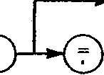
d>
< VDC >Ч?)-Г<
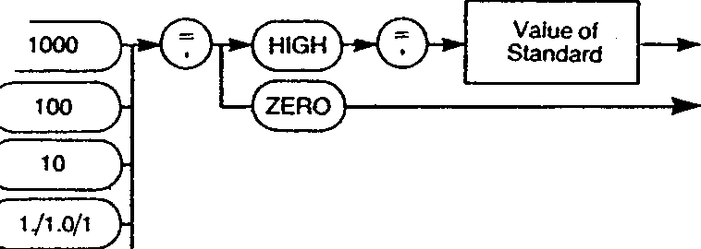
0.1/-' У
vac )-»-(Т)-_{г}—(^ooo )|>Q-»(high)*^»
100
3
<Z3
♦( 171.0/1 }
Value of Standard
-*S KOHM V*"Vy"T*"C
■»( loop )₁>(j)->(high)>(?}»
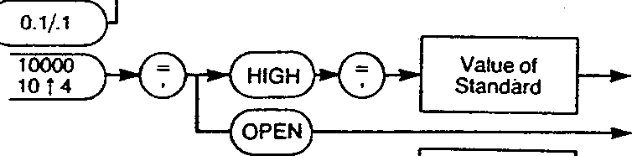
♦( 1/10/1 )■
■*■( 0.1/1 у
Value of Standard
-►■{reference)—*^r)----------*( high )—Kj)"*"
Value of Standard
-»( ZENER^)-
<I>
64 TO 127
Fig 3.3 Calibrate Command
The Calibrate command is only valid when the 7081 front panel key is turned to the CAL position.
Examples
CALIBRATE, VDC=10,HIGH= 10.000012
high point calibration using a standard of known value equal to 10.000012 volts.
CALIBRATE?
- produces a status reply of the form:
Calibrate = Fail 1
Fail 2
Fail3
OK Refer to the 7081 Maintenance Manual for an explanation of these messages.
3.6
GAM/7081/Part 2/2
CAPitals lock
Used to set the output format to capitals only.
С
CAPitals lock
y-o
-Ton \
<°^>
Fig 3.4 Capitals Lock Command
This command can be set to on or off. If CAPS lock is on, all output messages have lower case characters converted to upper case and any commas or colons replaced by spaces.
Example
CAPitals lock = OFF
default condition.
GAM/7081/Part 2/2
CHannel
Used to select a specific Minate channel.
С
CHannel
■0-
y-o
Channel No. 0Ю127
►Г Pull-in delay j-----т—~*\V}
—*-Q Drop-
out delay
О
Value 0 to 9999
-o
Fig 3.5 Channel Command
This command selects a channel, for measurement purposes, and sets any pull-in or drop-out delays that may be required. Only one pull-in and one drop-out delay is available for all channels.
Examples
CHannel=40
selects channel 40.
CHannel=12,Pull-in delay = 10,Drop-out delay = 5
- selects channel 12 and sets a pull-in delay of 10ms and a drop-out delay of 5ms.
CHannel?
- produces a reply of the form:
Channel=12, Pull-in Delay = 10ms, Drop-out Delay = 5ms.
GAM/7081/Part 2/2
CLock
Sets the mode of the clock control parameters.
( CLock У-
■©■
■&
■/ REAI \
•( Elapsed V
Fig 3.6 Clock Command
This command is used in conjunction with the Begin, Interval and End commands. When Clock is set to real, the Begin and End values must be set to a time of day. When Clock is set to elapsed, the Begin time should be set to the value required between the moment a measurement is 'triggered' and the moment the first measurement is taken. The End value should indicate the period over which the voltmeter will continue to take measurements and the Interval value the time between individual measurements.
Examples
CLock=REAI CLock=Elapsed
Begin, Interval and End times related to real time.
Begin, Interval and End times related to the time elapsed since activation.
CLock?
- produces a reply of the form:
Begin = 12,34,56.7,Day=01 Interval = 00,00,30.0,Day=00 End = 12,54,56.7,Day=02 Clock = Real
GAM/7081/Part 2/2
COmpute
This command is associated with the unit's programs.
(cOmputeV
<D-
&
< ^{OFF} >
\ ON }-
■-Г History V
^ RESET )-
Rg 3.7 Compute Command
Compute is automatically turned on, if a program is enabled, or off, if no programs are left on. The command can also be used to process the contents of the History file or reset the program running variables.
Examples
COmpute = ON
COmpute = OFF COmpute = History
COmpute = RESET
- passes measurements through any activated programs in the chaining order.
- measurements are not processed by the programs.
- passes the contents of the History file through any activated programs in the chaining order and returns the processed results to the History file.
- resets all the program running variables whether activated or not.
COmpute';
produces a reply of the form:
Compute = OFF Ratio = OFF Digital Filter = OFF Scale = OFF Statisitics = OFF Limits = OFF
3.10
GAM/7081/Part2/2
DAte
Enables setting of the calendar date into the unit.
С DAte \
■O
■&
Month (1to12)
Day of month (1to31)
6
6
Year (80 to 9999)
Fig 3.8 Date Command
Examples
DAte=21,6,1983 DAte?
- enters the date 21,6,1983 into the unit.
- produces a reply of the form: Date = 21,6,1983
PD/7081/Part 2/3
3.11
DELAy
Defines the trigger delay.
Q DELAy "У
■&
■©-
-f User 3t*^L)—
Delay value 0 to 9999
—*-( Normal V
Rg 3.9 Delay Command
This delay can be set to normal or a user defined time, entered in milliseconds, up to a maximum of 9999ms. If the delay is set to normal, the unit selects its own delay before carrying out a measurement.
Examples
DELAy=User,400 DELAy?
trigger delay user defined at 400ms.
produces a reply of the form:
Delay = Normal or
Delay = User,400ms.
3.12
GAM/7081/Part 2/2
DELImit
Defines the end of line character.
( DELImit V
■€>
\~ CRLF \
{j3R END + LF)-
СЮ-
( END + CR~y
{^ END ~У
string of three characters delimited with quotes
Fig 3.19 Delimit Command
Note: END is defined as:
(a) assert EOI with the last character on the GP-IB.
(b) output ETX as the last character on RS232.
Example
DELImit=END+CR
- sets the end of line character to END+CR
GAM/7081/Part 2/2
3.13
DIGital filter
Enables selection and definition of the Digital Filter program.
С
DIGital filter
>
■d>
■&
-<
<
ON
>
OFF
>
■c
RESET
>
MOde
У-&
■c
Continuous averaging
>
Simple averaging
>ng)-
' WAIking window\_ averaging J~
,7<
SAmple size Window size
Ж!>
►Г МЕМогу ~У
No.1 to 1E18-
■O-
* IfMode = Walking window, the maximum window size is 16. If values greater than 16 are entered, the program will default to 16. No error message is produced to indicate that this has occurred and the response to DIGital filler? will give the value entered not the value used by the program.
Fig 3.11 Digital Filter Command
This command can be used to set up all the program's parameters at once or just one parameter.
The program has three modes of operation:
Continuous averaging Simple averaging Walking window averaging
In continuous averaging, an updated result is output for every input whereas, in simple averaging, one average result is produced for each sample size. The sample size has a maximum value of 1E18.
In walking window averaging, the sample window used to produce the result consists of the last n readings where n is the defined sample size. Once the sample size has been fulfilled an average result is produced for every new input. The maximum sample size is 16.
The program adopts a default setting on initialise of walking window averaging with a sample size of 10.
3.14
GAM/7081/Part 2/2
Examples
DIGital filter,MOde = WAlking window, Window size = 10,ON
- sets up the program to walking window mode with a window size of 10. This command also turns the program on.
DIGital filter,MOde = Simple averaging
- changes the program mode to simple averaging.
DIGital filter? - produces a reply of the form:
Digital Filter = OFF
Mode = Walking Window Average
Window Size = lO.OOOOOOOE+00
GAM/7081/Part 2/2
3.15
DISplay
Affects the voltmeter front panel display.
( Display )------КЭ"
•С
OFF
>
■С
ON
>
•/ Gp-ib address У
<_
Time
>
String of up to 40 characters delimited with quotes
Fig 3.12 Display Command
If a controller uses quotes (") for delimiting character strings, the quotes of the display command can be sent as their ASCII numeric value, the sending string being made up of these character values and the string itself, e.g.
OUTPUT 716; "DISPLAY,"&chr$(34)&"Hello"&chr$(34)
Examples
DISplay=Time DISplay,"1.23456789"
- causes time of day to be continually displayed until displaced by other display information.
- causes 1.23456789 to appear in the display until displaced by other display information.
3.16
GAM/7081/Part2/2
DRift
Enables or disables the automatic drift correct measurement.
( DRift У~
-&
<D-
< ^{off} >
►( ON "У
»{ Now V
Fig 3.13 Drift Command
A drift correct measurement is performed approximately once every 15 minutes and is also automatically invoked when the nines parameter is increased above 5 x 9. The measurement is performed at the number of nines integration selected or 6 x 9 whichever is the greater.
Examples
DRift = Now DRift = OFF
DRift?
- enables an immediate drift correct.
- disables automatic drift correct. (A drift correct measurement will still be performed if the nines parameter is increased above 5x9).
- produces a reply of the form: Drift Correct = ON.
GAM/7081/Part2/2
3.17
DUmp
Enables the output of the contents of the specified History file locations.
f DUmp Y
■©■
■©■
►( Forward V
"/ Reverse V
No. 1 to 1500
-r^XJEyO
•0-
No. 1 to 1500
Fig 3.13 Dump Command
The History contents are preserved after a Dump command. Forward direction defines the oldest record as history record number 1; reverse direction defines the newest record as history record number 1.
Examples
DUmp
DUmp=l.To,20.25
- outputs all the history records in the direction last specified. The default direction is forward. If no history exists, an error message is output.
DUmp=Reverse,20,To,25,30,To,26
outputs history records 1 to 20 and 25.
outputs history records 20 to 25, 30 to 26 relative to the newest record.
DUmp?
- produces a reply of the form:
Dump Direction = Forward, nnnn
where nnnn is the number of records present.
18
GAM/7()81/Part2/2
ENd
Used to set the end time for clock controlled measurements.
( ENd У~
■&
■©-
Hours 0to23
■o-
Minutes 0to59
 | —»■ | Seconds 0to59
¹
С
 | ' ' |  |  | —»■ | т  sec | enths of
 |  |  |  | —»■ | т  sec | onds 0 to 9 | r
1 |  |  |  | '_ | С |  | r
 |  |  |  |  |  | No. 0to98
/^{r} ~\ | i----------KD |  | ' |  |  | No. 0to98
*\ Day j |  |  |  |  |  | No. 0to98
Fig 3.15 End Command
The time should be entered in hours, minutes, seconds, tenths of second format. A day value can also be entered : this value indicates 'elapsed' days since the start of clock control.
The End command is used in conjunction with the Begin, Interval and Clock commands. To initiate clock controlled measurements the Measure, Clock controlled command should be used.
Examples
ENd= 15,45, Day=2
ENd?
- ends clock controlled measurements at 3.45pm. 2 days after the start.
- produces a reply of the form: End= 15,45,11.5,Day=02
G AM/7081/Part 2/2
3.19
ERror
Defines the type of error messages that are produced.
f ERror \
■©■
_{fc}, Brief \
"^ Compressed f
■c
Y Verbose \ Expanded
>
Fig 3.15 Error Command
The messages displayed are as shown in Table 3.4. For a full explanation of the error messages refer to the end of this chapter.
Table 3.4 Error Messages
Command | Brief Message | Verbose
SCale,M=2,C=2 | OK | Command Syntax OK.
DUmp | E50 | No History Present.
SCale,M=2=C=2 | E4 | Invalid Separator Before Char No. 10 ThisPart:2 =
Example
ERror = Verbose
- error messages are produced, instead of error numbers, on RS232 and at the GP-IB output if on.
3.20
GAM/7081/Part 2/2
FOrmat
Defines the nature of the voltmeter output.
■©■
ENgineering
Binary
О
6
Compressed V
-»-f Expanded
Fig 3.17 Format Command
Three format settings are available: DVM, Engineering and Binary, all of which can be selected as Compressed or Expanded
DVM
- the decimal point occupies a fixed position in the output and the number is arranged to give a positional indication of magnitude, e.g.
-0.11234567 -1123.45678 -11234.56
Engineering
If DVM, Expanded is selected, the units, time, day, channel and history file number (as applicable) will also be output, i.e.-l.52345 VdcTime = 12,34,56.7,Day=01 Channel 123 Hist No:0123.
the number occupies a fixed position but the decimal point may occupy one of three positions. The exponent, which is always shown, is allowed to change in intervals of three, e.g.
-112.3456E-06 1.12345E+09
-11.2345678E-06
Engineering, Expanded produces an output of the form: 156.3445E+09 VdcTime = 12,34,56.7, Day=00 Channel 123 Hist No:0034
Binary
the IEEE 488 recommended format for binary real numbers is used. Binary, Expanded gives a representation of the time, day, channel and history file number.
For further details on the formats available refer to Appendix 1 at the end of the manual.
GAM/7081/Part2/2
3.21
Examples
FOrmat=Dvm,EXpanded - measurements displayed in DVM form with
time, day, channel and history file number included.
FOrmat? - produces a reply of the form:
Format=Expanded, DVM:Caps Lock = OFF
3.22
GAM/7081/Part 2/2
HEIp
Explains the last error message, i.e. displays the verbose reply.
( HEip у
Fig 3.18 Help Command
GAM/7()81/Part 2/2
3.23
History
Used to define the size and nature of the History file.
( History У~
■o
-d>
-*C Size y^vD⁻*"
<
f CLear \
No. 1 to 1500
Fixed
>
<
ROIIaround CONtinuous^
•»-( COMpressed ■*-f Expanded
6
Fig 3.19 History Command
In order to display the History file contents in expanded form, both History and Format must be set to Expanded. If Format is set to Compressed, the History file contents will be stored in expanded format but output in compressed format.
Note: History size values >500 are not considered an error even if History is set to Expanded. In this instance, the file will default to 500.
Examples
HIstory,FIxed,SIze=100
HIstory,ROllaround, COMpressed, SIze= 1500
History,EXpanded History?
- In fixed, the History file is not overwritten, hence the next 100 results are saved. The voltmeter continues measuring after the History file is full but no further results are stored.
- In rollaround the last n readings are maintained in the file where n is the history size specified. In compressed, only the numeric values of up to a maximum of 1500 results are stored.
- In expanded, full result information of up to a maximum of 500 results are stored.
- produces a reply of the form: History .Compressed, Roll, Size=500.
3.24
PD/7081/Part 2/3
INItialise
Causes the unit to return to the initialised state.
f INItialiseV
Rg 3.2 Initialise Command The GP-IB status and handshake are not preserved during an initialise execution.
GAM/7081/Part 2/2
3.25
INTerval
Used to set the interval time for clock controlled measurements.
( INTerval \
■d>
■©■
Hours 0to23
О
Minutes 0Ю59
Seconds 0to59
< ^{pa}v )—KD-
Tenths of seconds 0 to 9
No. 0to98
Rg 3.21 Interval Command
The time should be entered in hours, minutes, seconds, tenths of seconds format. A day value can also be entered: this value indicates 'elapsed' days.
The Interval command is used in conjunction with the Begin, End and Clock commands. To initialise clock controlled measurements the Measure, Clock controlled command should be used.
Examples
INTervaI=0,8,Day=0 INTerval?
- sets the interval time to 8 minutes.
- produces a reply of the form: Interval =00,08,00.0,Day=00
3.26
GAM/7081/Part 2/2
Limits
Enables selection and definition of the Limits program
С
Limits
>
■e-
Ф
-d
''NUMBER Higfi\
NHigh
NUMBER Low NLow
У
NUMBER No go N No go Г
4
NUMBER Go NGo
MAXimum
>
—*•( Peak to peak
MINimum
>
<
High limit J—i-----*\~)~
r©-
Low limit
SAmple size \_ Window size J
MOde
■c
OFF y-
■( ON )-
{jRESET V
■&
—*f MEMory \
No. + 1E18 io -1E18
No. 1 Ю1Е18
MEMory V
-»( OUTpu7~)—»■(=)-
)-----*-f 7 J------1------^{COntinuous^
к
Window
Output (see Fig. 3.23)
Rg 3.22 Limits Command
GAM/7()81/Part2/2
3.27
Output
•С
NORmal
>
Y NUMBER High Л "\ N High J-
Y NUMBER Low \_ Л^ N Low Г
^f NUMBER No go Л ~*\ N No go JT
<
NUMBER Go NGo
>
■c
MAXimum
>
■c
MINimum
>
-*/ Peak to peak V
-*-f High results J-->f LOw results V
<
*i NO Go results
>
<
*i GO results
>
Rg 3.23 Limits Output Command
3.28
GAM/7081/Part2/2
The Limits command can be used to set up all of the program functions at one time, a particular function of the program or query a result.
Two program modes are available:
Continuous sampling Window sampling
In continuous sampling, the results are constantly updated and an output result is displayed for every input.
In window sampling, one result is produced for each sample size. The maximum sample size is IE18.
The output of the program may be configured to be any of the following:-
Normal (reading passed on unaltered)
Number high (number above high limit)
Number low (number below low limit)
Number no go (number out of limits)
Number go (number within limits)
Max. value
Min. value
Peak to peak value
High results (only high results output)
Low results (only low results output)
No go results (only out of limits results output)
Go results (only within limits results output)
The 7081 stores the number of high, low, go and no go results, the max., min., and peak to peak values in the program memory. These results can be recalled at any time during the program's life by entering a query command, e.g.
Limits,MAXimum?
Examples
LImits,MOde=WIndow, SAmple size=10,High limit=6, Low limit=3,OUTput=GO results,ON
LImits,OUTput=MAXimum, ON
Limits,Peak to peak?
Limits?
GAM/7081/Part2/2
- sets up the program for window sampling with a sample size of 10, high limit of 6, low limit of 3, output results within limits. The command also turns the program on.
- sets the program output to maximum and turns the program on.
- produces a reply of the form: PTOP= 1.0000000E+00
- produces a reply of the form:
Limits = ON
Mode = Window Sampling
Output = Max.
Hi Limit = 6.0000000E+00
Lo Limit = 3.0000000E+00
Sample Size = 10.0000000E+00
LOck front panel
Enables or disables the front panel controls.
( LOck front \_ V_____panel J~
Ф
^ ON У
►^ OFF У
Fig 3.24 Lock Front Panel Command The front panel controls are enabled at power-up. Examples
LOck front panel = ON - front panel controls disabled.
LOck front panel = OFF - front panel controls enabled.
3.30
GAM/7081/Part 2/2
MEAsure
Used to initiate the taking of measurements.
Г MEAsure )-----1—►T 7 Л
<2>
No. of times 1 to 9999
CLock controlled
>
О
■ZcHannelV
■o
'{'arm \
<
W Continuous
>
>( Single )-
STop "V
No. I to 127
6
No. 0 to 127
T о
—*-T ARM \
To
>
О
Fig 3.25 Measure Command
Five main settings are available for the command: Clock controlled, Continuous, Single, Stop and a specified number from 1 to 9999. The channel can also be specified. If the word 'ARM' is used in the command, the voltmeter will wait for a trigger signal before proceeding with the measurements.
Examples
MEAsure,CONtinuous MEAsure,STop
initiates measurements at the fastest possible rate.
this command can be used to stop continuous measurements. After the command has been entered, one result will appear and then the measuring will cease. If this command is used to stop any of the other measure commands, the unit will only cease measuring after the previous command has been implemented. e.g. MEAsure,25
MEAsure,STop
The unit will take 25 measurements and then stop.
GAM/7081/Part 2/2
3.31
MEAsure,Single - initiates a single measurement.
MEAsure,CHannel, 15,To,23,9 - initiates measurements on channels 15 to 23, and 9.
MEAsure,25 - initiates 25 measurements.
MEAsure,CLock controlled, CHanneI,23,To,45
- initiates measurements, under clock control, of channels 23 to 45, i.e. each event under clock control is a scan of channels.
MEAsure,5,ARM - initiates 5 measurements on receipt of a trigger
signal.
MEAsure? - produces a reply of the form:
Measure = Stop
or
Measure = Continuous
3.32
GAM/7081/Part2/2
MEMory
Used to store items in or recall items from the memory.
Г MEMory V
<z>
■0-
No. -lE18to+1E1f
Examples
MEMory
MEMory,3.56
MEMory?
Fig 3.26 Memory Command
- stores the last numeric output.
- stores 3.56 in the memory.
- recalls the memory contents, i.e. Memory Contents = 3.5600000E+00
GAM/7081/Part2/2
3.33
MODe
Enables selection of the measurement function.
f MODe \
<!>
■Q-
»f TRueohms V
■>C kohm "y
VAC + DC + Filter VDC + AC + Filter VAC + VDC + Filter VDC +• VAC + Filter
-c
VAC
>
■/VAC + Filter \
■c
VDC
>
VAC + VDC VDC + VAC VAC + DC VDC + AC
Y REFerence \ only
>
*( TESTOvdc V ►TTESTIOvdcy
<
TEST Kohm
>
^ TESTAc^)-
Rg 3.27 Mode Command At power-up and initialise 7081 adopts Mode=VDC. Examples
MODe=VAC MODe=TRue ohms MODe?
- selects the ac voltage function.
- selects the true resistance function.
- produces a reply of the form:
Mode = VDC [Front]
where [Front] identifies the input terminals enabled.
3.34
GAM/7081/Part 2/2
Nines
Enables setting of the scale length to any value from 3 to 8 X 9 inclusive.
f Nines V
-G>
■©-
No. ЗЮ8
Examples
NInes=7 Nines?
Rg 3.28 Nines Command
- sets a scale length = 7x9
- produces a reply of the form: Nines = 3 x 9's
GAM/7081/Part 2/2
3.35
NUU
Enables or disables the present null values, or enables a new null measurement.
( NUil У-
<z>
<!>
< ^{OFF} >
■{ ON }-
-f New V
Examples
NUH,New
NUll,ON NU11?
Fig 3.29 Null Command
- initiates a new null measurement. If RANge = Auto, all ranges for the unit mode are nulled. Each nullable mode has its own null value set.
- enables the present null value set.
- produces a reply of the form: Null=ON
3.36
GAM/7081/Part2/2
Output
Enables selection of the unit output.
С Output ^)—*\f)-
-f Rs232 V
—»•( OFF ~У
•©-
—*S Gp-ib V
—*-f Display J-------*\~У~
String of up to 60
characters delimited
with quotes
^ OFF У~
^C
ON
-( OFF У
-<
ON \ Normal у
—»/ Monitor V
-o
Fig 3.30 Output Command
The RS232 and GP-IB interfaces, and the voltmeter display can be turned on or off. The voltmeter display can also be set to Normal or Monitor: with Monitor selected the display gives an indication of everything going out to the interfaces, e.g. error messages.
If the controller uses quotes (") for delimiting character strings, the quotes of the output command can be sent as their ASCII numeric value, the sending string being made up of these character values and the string itself e.g.
OUTPUT 716; "OUTPUT," & chrs$(34) & "Hello" & chrs$ (34)
Examples
Output, Rs232, ON - turns the RS232 output on.
Output,Display=Normal - sets the voltmeter display to normal operation.
Output,OFF - turns all interface outputs off.
GAM/7081/Part 2/2
3.37
Pad count
Used to set the number of nulls (0 to 9) after a Carriage Return and before a Line Feed at the RS232 output.
(pad count)-------*\ 0"
No. 0to9
Rg 3.31 Pad Count Command
Example
Pad count = 0
- no nulls inserted.
3.38
GAM/7081/Part 2/2
\
RANge
Used to set the range used for taking measurements.
( RANge )-
<E>
■0-
*C Auto j-
J 10000 \_ \ 10 14 J~
►Г 1000 \
-Г 100 \
►(To 1. 1)-
•GT>
Rg 3.32 Range Command
Not all ranges are available on all measurement functions but no error is reported if a range is selected which is not available on the current function. The unit remembers any attempted range selections for possible future implementation when a suitable function is selected.
Examples
RANge = 10000 RANge = Auto RANge?
- selects the 10000 range
- selects auto ranging
- produces a reply of the form:
Range = 100, Auto
or
Range = 100, Fixed
GAM/7081/Part 2/2
3.39
л
RATio
Enables selection and definition of the Ratio program.
( RATio ) I *(?)
<!>
< ^{OFF} >
>( ON )■
■^ MOde ^—*V0~
>*d>
No. -1E18to + 1E18
-Г МЕМогу \
IvIAIN/REF Dff ^ M/RDB
Di
REF/MAIN R/MDB
Ш\_
MAIN/REF . M/R
>
Y REF/MAIN \_ \ R/M У"
/MAIN/NDB Л M/N DB
>
N/MAIN DB \ N/M DB У
-С
MAIN/N Л M/N У
N/MAIN N/M
>
* 77ie processed results should not exceed these bounds.
Fig 3.33 Ratio Command
The Ratio command can be used to set up all of the program functions at one time or a particular function of the program.
'Main' refers to the voltmeter input terminals (front or rear panel) and 'Reference' to the reference or ratio terminals (rear panel). N is a user defined constant.
The program default setting, which is adopted at initialise, is Main/Reference.
Examples
RATio,MOde=Main/Ref DB, ON
- provides results of the ratio of the main input terminals to the reference terminals and gives the values in dBs.
О
RATio, MOde=Main/N,N=5.6, ON
RATio?
provides results of the ratio of the main input terminals to a constant N (5.6).
produces a reply of the form:
Ratio = OFF Mode = Main/N N=5.6000000E+00
3.40
GAM/7081/Part 2/2
SCale
Enables selection and definition of the Scale program.
С SCale \
■d>
•&
*( ON )~
< °^{FF} У
—*"f M ~)------f\y) I »ГмЕМогуЛ
,4i>
No. -1Е18Ю+1Е18
О
TTie processed results should not exceed these bounds.
Fig 3.34 Scale Command
The Scale program provides:
у = mx + с
where у is the processed result, x the input measurement, and m and с user defined constants. Both m and с may be taken from memory, thus enabling a previously measured value to be used.
Examples
SCaIe,M=28.1,C=MEMory,ON - turns the program on with M=28.1 and C=the
contents of the memory.
SCale,OFF SCale?
- turns the program off.
- produces a reply of the form:
ScaIe=On
M=28.1000000E+00
C=l.2000000E+00
GAM/7081/Part 2/2
3.41
SRq
Enables or disables service request and allows definition of the requirements for asserting SRq.
( SRq У
<2>
■©-
< °^{FF} >
Error
>
Output available
>
User
>
Ready
>
■0-
■C°!L>
ON
>
О
Пд 3.35 SRQ Command The settings for the SRQ command can be described as follows:
Error
Output available
User Ready
Examples
SRq,User=ON SRq
SRq?
- an SRQ is asserted on an error. Four types of error are handled: Command Interpretation, Command Execution, Calibration Fault, Input Message too long, i.e. >76 characters.
- an SRQ is asserted when the unit has output available. The output can be data, error messages, control information, etc.
- enables the voltmeter front panel SRQ control.
- an SRQ is asserted when the unit is not busy. SRQ will only be asserted when all of the instrument is ready.
- enables the voltmeter front panel SRQ control.
- if SRq,Uscr=ON, this command causes SRQ to be asserted with the user bit set.
- produces a reply of the form:
SRq,Error=OFF,User=ON, Output = OFF,Ready=OFF
3.42
GAM/7081/Part 2/2
STATistics
Enables selection and definition of the Statistics program
( STATistics V
<i>
-0-
■C
ON
>
< ^{0FF} >
6
•c
RESET
>
■c
MOde
У-d>
■C
Continuous
>
К
Window
*" V configure J Ч^У
<
SAmple size \ >f/*="^ Window size у ^vlx"
У
•f MEMory "V
No. 1 to1E18
Number
>n
Average
Variance
>
<
Standard deviation
>
<
Root mean square
К NUmber of _ '
—>4 Average
■c
NORmal
>
samples so far
Variance
<
Standard deviation
0
К
Root mean square
Fig 3.36 Statistics Command
GAM/7081/Part2/2
3.43
The Statistics command can be used to set up all of the program functions at one time, a particular function of the program or query a result.
The program has two modes of operation:
Continuous sampling Window sampling
In continuous sampling, the running variables are constantly updated and an output result produced for every input.
In window sampling, the result is derived from a user defined sample size up to a maximum of 1E18. After the result has been produced, the variables are reset and a new sample collected.
Both modes may be configured to pass on any of the following outputs:
Normal (reading passed on unaltered)
Number so far (number of samples collected so far)
Average
Variance
Standard deviation
Root mean square
All of the outputs, with the exception of'Normal', are stored in the unit's program memory and can be recalled at any time during the program's life by entering a query command, e.g.
STATistics,Root mean square?
Examples
ST ATistics,MOde=COntinuous,OUTput=Variance,On
- selects a mode of continuous sampling with a variance output and turns the program on.
STATistics? - produces a reply of the form:
Statistics=OFF
Mode = Window Sampling
Output=Variance
Sample Size=10.0000000E+00
3.44
G AM/7081/Part 2/2
STOp
Aborts all measurement processes, clears the output queue and also clears any unexecuted input commands.
С STOp)-----------------------»-
Fig 3.37 Stop Command
This command causes operation over the GP-IB to stop at the next character and the RS232 to stop at the next end of line.
If the Stop command is sent immediately after other commands to the voltmeter, some, if not all, of those commands may be ignored. This is because the commands are being aborted before they have been implemented. The Stop command should therefore never be used in a multicommand line.
GAM/7081/Part2/2
3.45
TEst
Causes execution of the internal test sequence.
( TEst )-------------------------►
Rg 3.38 Test Command
3.46
GAM/7()81/Part2/2
Time
Used to set the voltmeter's real time clock.
с
Time
Л_
•0"
■©■
Hours 0to23
~5
Minutes 0to59
Examples
TIme= 15,45 Time?
Fig 3.39 Time Command
- sets the unit's clock to 3.45pm.
- produces a reply of the form: Time = 15,45,30.4
GAM/7081/Part 2/2
3.47
TRigger
Used to activate a function set up under ARM.
(TRigger J-------------------------*-
Fig 3.40 Trigger Command
If no function is armed, TRigger has the same effect as MEAsure,SIngle.
Examples
MEAsure,5,CHanneI,l,5,9,ARM
- defines a series of 5 scans of the channel set specified.
TRigger - executes the series.
3.48
GAM/7081/Part2/2
3 Command Execution Order
The order in which commands are executed does not necessarily follow the command sequence. This allows the user to change parameters such as the format of the output, turn outputs on or off, turn programs on or off, alter program constants, change the mode of the history storage, etc., even though, for example, a clock controlled measurement has begun.
In certain circumstances, operating a non-sequential system requires better user programming, e.g. in the program
MEAsure,15
Output,Gp-ib,ON
DUmp
the Output and history Dump commands are executed before all the results of the Measure command have been generated. To execute the Output and Dump commands after completion of the measurements requires some means of detecting the completion before sending the commands, e.g. SRQ on Ready.
3.1 Command Message Flow
Figure 3.41 shows the functional areas under which commands are grouped and how areas interact with each other.
A-to-D and
Measurement
Control
Keyboard |  |  |  | A-to-D and  Measurement  Control
_ | Command Interpreter |  |  | Processing |  |  | History
GP-IB |  |  |  | Output Manager |  |  | RS232
Input |  |  |  | Output Manager |  |  | RS232
 |  |  |  | Clock |  |  | GP-IB
Fig 3.41 Command Functional Areas
Each functional area receives its own commands in sequence but commands to parallel areas may be executed in parallel. There are three exceptions:
1. The Test command puts the 7081 into a 'stopped¹ state to prevent further input until the self test is complete.
2. The Stop command is actioned almost immediately upon receipt (See page 3.44).
3. Only one Dump command can be actioned at any one time.
Table 3.5 indicates which commands are grouped under which functional areas.
GAM/7081/Part2/2
3.49
Table 3.5 Command Groupings
Functional Area | Commands
A-to-D and Measurement Control | BEGin,CALIBRATE,CHannel,CLock,DELAy,DRift,ENd, INTerval,MEAsure,MODe,NInes,NUH,RANge,TRigger.
Processing | COmpute,DIGitalfilter,LImits,MEMory,RATio,SCaIe, STATistics.
Output Manager | BEEp,CAPitalslock,DELIrnit,DISpIay,DUmp,ERror, FOrmat,HElp,HIstory,INItialise,LOck front panel,Output, Padcount,SRq.
Clock | DAte,TIme.
History via Output Manager | DUmp, History.
RS232 via Output Manager | DELImit,Pad count.
GP-IB via Output Manager | SRq.
4 Error Messages
7081 error messages are output in different forms depending upon the interface used and the command settings of that interface. Provided the display is on, error messages 20 to 50 always appear when they arise. When the display is set to monitor, the first 20 characters of the verbose form of a command are displayed.
4.1 Display
If the voltmeter display is set to Monitor, verbose error messages will always appear. Error numbers never appear in the display but messages 20 to 50 will always appear in their verbose form regardless of the display setting.
4.2 RS232
The RS232 interface can be enabled for either brief or verbose error messages. If brief messages are enabled, the error numbers (E numbers) will appear but messages 20 to 49 will always appear in their verbose form, provided the interface is on, regardless of the error setting.
PD/7081/Part 2/3
{■
г
4.3 GP-IB
No error messages will be output, if error is set to brief, but the serial poll byte abnormality code will be set to a value between 00 and 11 depending upon the type of message generated, i.e.
Command Interpretation Error Code=00
Command Execution Error Code=01
Calibration Fault Code=10
Input Message Too Long (more than 76 chars) Code= 11
The GP-IB will receive verbose messages, if error is set to verbose.
4.4 Message Groups
The messages can be divided up into the following four groups.
Error messages 0 to 19 may be displayed in response to a command input and are grouped under the GP-IB abnormality code settings shown in Table 3.6.
Table 3.6 Errors 0tol9
Brief Message | Verbose Message | GP-IB Abnormality Code
OK | Command Syntax OK | —
El | Command Incomplete Before Char No. This Part: | 00
E2 | Numeric Not Expected Before Char No. This Part: | 00
E3 | 'Word' Unrecognised Before Char No. This Part: | 00
E4 | Invalid Separator Before Char No. This Part: | 00
E5 | Numeric Out of Range Before Char No. This Part: | 00
E6 | Too many Arguments Before Char No. This Part: | 00
E7 | Argument Missing Before Char No. | 00
E8-9 | Reserved For Future Use | —
E10 | Record nnnn Not Present (result of DUmp) | 01
Ell | Null Mode Illegal | 01
E12-19 | Reserved For Future Use | —
PD/7081/Part 2/3
3.51
Error messages 20 to 49 may be displayed in response to a Calibration, Dump, Compute or Null command, or an Initialise or Power-up sequence. Refer to Table 3.7 for a listing of the messages.
Table 3.7 Errors 20 to 49
Brief | Verbose Message | GP-IB
Message |  | Abnormality Code
E20 | Null Too High | 01
E21 | Complete (null sequence) | —
E22 | "Initialised* | —
E23 | CalOK | -
E24 | NVM Fail | 10
E25 | Dump Fail | 10
E26 | Cal Incomplete | 10
E27 | * Resumed* | —
E28 | Cal Ref Out Of Range | 10
E29 | Zero Too Large | 10
E30 | Vref Out Of Range | 10
E31 | Factor Out Of Range | 10
E32 | Cal Not Enabled | 10
E33 | Pass (refers to self test) | —
E34 | Fail, Test OVdc | 01
E35 | Fail, Test lOVdc | 01
E36 | Fail, Test Ohms | 01
E37 | Fail, Test AC | 01
E38 | Insufficient History | 01
E39 | Complete (refers to COmpute,History) | —
E40 | No Programs On | 01
E41-49 | Reserved For Future Use | —
3.52
GAM/7081/Part 2/2
ТаЫеЗ.8 | Errors 50 to 59
Brief Message | Verbose Message | GP-IB Abnormality Code
E50 E51-59 | No History Present Reserved For Future Use | 01
Table 3.9 Errors 60 Onwards
Brief Message
Verbose Message
GP-IB Abnormality Code
E60
Complete (refers to DUmp command)
E61 onwards Reserved For Future Use
4.5 Examples
The following examples show both the brief and verbose responses.
DUmp | OK | Command Syntax OK
 | E50 | No History Present
DUmp,l,To,5 | OK | Command Syntax OK
• | 5.97425 | 5.97425
 | 5.97086 | 5.97086
 | 5.89322 | 5.89322
 | ЕЮ | Record 4 Not Present
 | ЕЮ | Record 5 Not Present
 | Complete | Complete
MEAsure,CHannel,l,To El
MODe=l FiIter,ON SCale,M=2=C=4
E2
E3
E4
Command Incomplete Before Char No. 22 This Part: To
Numeric Not Expected Before Char No. 8 This Part: 1
'Word' Unrecognised Before Char No. 7 This Part: Filter
Invalid Separator Before Char No. 10 This Part: 2=
GAM/7081/Part 2/2
3.53
Chapter 4 RS232 Operation
Contents
 |  | Page No.
1 | Introduction | 4.2
2 | Hardware and Terminology | 4.2
3 | Transmission Speeds | 4.2
4 | Command Language | 4.3
5 | Input and Output | 4.3
6 | Programming Examples | 4.4
GAM/7081/Part 2/2
4.1
This chapter describes the use of 7081 via the RS232 interface.
1 Introduction
The 7081 voltmeter can be connected to any equipment conforming to the RS232 Standard via its RS232 Interface. This chapter details the interface and the voltmeter's RS232 operation.
2 Hardware and Terminology
In RS232 terms, 7081 is designated the Data Communication Equipment (DCE) and its associated terminal the Data Terminal Equipment (DTE). Input commands from the DTE are referred to as Received Data, whilst output signals to the DTE are Transmitted Data. The data is carried, in serial bytes comprising serial bits, on two signal wires.
There are four handshake wires:
Data Terminal Ready - the DTE is ready to send primary data.
Data Set Ready - the DCE is ready to process input data.
Clear to Send - the DCE is ready to send data.
Carrier Detect - the DCE acknowledges receipt of the DTE's signal carrier.
The remaining two lines used are Protective Ground (supply 0V) and Common Return (signal 0V).
3 Transmission Speeds
Most RS232 devices can operate at up to 9600 baud and the 7081 speed must be set to match that of the terminal device. This is achieved via three switches mounted on printed circuit board 3. The possible switch settings are given in Table 4.1. Note that the normal factory setting is 300 baud.
Table 4.1 Baud Rate Switches
Baud Rate | Switch 1 | Switch 2 | Switch 4
110 | ON | ON | ON
150 | OFF | ON | ON
300 | ON | OFF | ON
600 | OFF | OFF | ON
1200 | ON | ON | OFF
2400 | OFF | ON | OFF
4800 | ON | OFF | OFF
9600 | OFF | OFF | OFF
4.2
GAM/7081/Part 2/2
4 Command Language
The command language used for 7081, over the RS232 link, is the same as that used over the GP-IB (see previous chapter for language details) except that, when operating over an RS232 link, the language is device independent and can be simply keyed into the terminal device.
If, while keying in a command message string, the operator makes an error, the mistake is easily rectified by the use of the terminal DELETE or RUB OUT key.
It is possible to turn off the echo to an RS232 terminal, from the voltmeter, by typing CTRL N- To turn the echo back on again enter CTRL O. The echo to the terminal takes account of the Capitals Lock Command, i.e., with CAPitals Iock=ON, all the echoed commands will be in capitals with the commas and colons replaced by spaces.
5 Input and Output
If an associated terminal/computer attempts to input messages to the 7081 at a faster rate than the unit can implement them, 7081 will ignore some of the commands. The voltmeter can queue up to a maximum of three messages before it starts to ignore a percentage of the input.
Owing to the lack of handshake, RS232 output messages may be lost if the terminal/ computer is not ready to receive. The unit will still accept messages if the output is queued.
Note: A message is defined, in this context, as an input line terminated by a Carriage Return, Line Feed or EOI.
The following commands are relevant to output control.
1. OUTPUT — allows generated data to be routed only to those interfaces desired. If both RS232 and GP-IB are on, output occurs at the rate of the slowest device to ensure that both outputs remain synchronised.
2. FORMAT — controls the form of the measurement results output.
3. D ELIMIT—defines the 'end of line' character.
4. ERROR — if the RS232 output is on and ERror = Verbose, error reporting messages will also appear at the output. ERror = Brief will result in error numbers.
5. PAD COUNT — defines the number of nulls inserted before the 'end of line' character.
These commands enable powerful editing of information transmitted to the output and into the history file.
G AM/7081/Part 2/3
6 Programming Examples
The following examples show how the 7081 facilities may be used via RS232 remote control. In all the examples it is assumed that the voltmeter is in the initialised state.
6.1 Measurement Examples
Having switched the voltmeter and associated devices on, the following may be entered.
Example 1
Test
Output, RS232, On
Error = Verbose
Format, DVM, Expanded
Mode = TR
Range = Auto
Nines = 6
Measure, Single
This example takes the unit through a self test and then sets the RS232 Interface output on with verbose error messages. The format of the output display is set to DVM, Expanded. A single true resistance measurement is initiated, with automatic range and scale length of 6x9, and the result displayed at the interface output.
Example 2
Mode = VDC
Nines = 5
Clock, Elapsed
Begin = 0, 0, 30
Interval = 0, 1
End = 0.3
Measure, Clock Controlled
Example 2 changes the measurement function to Vdc and the scale length to 5 x 9. The system clock is then set up and three clock controlled measurements are taken and displayed at the interface output.
Example 3
Mode = VAC Nines = 7 Range = 100 Format = Engineering Measure, Continuous
Stop
In this case, the mode is set to Vac, the scale length to 7 x 9, the range to 100 and the output format to Engineering, Expanded. Continuous measurements are taken and displayed until the Stop command is entered.
4.4
GAM/7081/Part2/2
л
6.2 Processing Examples
Assuming that the voltmeter has been switched on, tested and the interface set up for verbose error messages, the following examples may be entered.
Example 1
Format, DVM, Compressed Ratio, Mode = Main/N, N = 11 Ratio, On Measure,2
Ratio, Off
Example 1 sets up the Ratio program to Main/N with a value of 11 for the constant N. The program is turned on and two measurements are taken and processed. The processed results are then output in DVM, Compressed format and the program turned off.
Example 2
Scale, M = 6, С = 4, On Nines = 5 Measure, 10
Statistics, Mode = Window, Window Size = 10, Output = Average, On Measure, 10
The Scale program is selected and defined, in example 2, and ten measurments taken. The processed results are displayed. The Statistics program is then enabled and defined, ten measurements taken and the average result displayed. As the Scale program has not been turned off, the measurements are processed by both programs.
Example 3
Limits, Mode = Window, Sample Size = 13, Output = Peak to Peak, On Format = DVM, Expanded Measure, 13
Example 3 sets up and defines the Limits program. Thirteen measurements are taken and the processed result displayed in DVM, Expanded format.
Example 4
Digital Filter, Mode = Walking Window, Window Size = 12, On Measure, 23
This example sets up the Digital Filter program and initiates 23 readings. The program window is first filled and then 12 results are displayed.
G AM/7081/Part 2/2
Overload
If an overload occurs and the voltmeter interface output is set for Expanded format, an overload message will appear in the output.
Example 1 shows such an occurrence. The voltmeter replies are shown in parenthesis.
Note: The output errors are set to Brief.
Example 1
Output,RS232,On
(OK)
Error=Brief
(OK)
Format=DVM, Expanded
(OK)
Mode=VAC+VDC+FiIter
(OK)
Range=0.1
(OK)
Nines=5
(OK)
Measure ,3
(OK)
(0.28893 Overload Time = 11,22,11.l,Day=01)
(0.28893 Overload Time = ll,22,13.3,Day=01)
(0.28892 Overload Time = 11,22,15.4,Day=01)
History Dump
When a Dump command is entered into a voltmeter with format set to expanded, the history file number for each result will appear in the output. Any requested file numbers that are not available will be indicated by an error message. Refer to Example 1. The voltmeter replies are again shown in parenthesis.
Example 1
Format.Engineering.Expanded
(Command Syntax OK)
Dump.13.ToJ0
(Command Syntax OK)
(11.00E+00 Go Time=12.15.12.7.Day=03 Channel 001 H
(12.00E+00 Go Time= 12.15.13.4.Day=03 Channel 001 H
(13.00E+00 GoTime= 12,15.14.l.Day=03 Channel 001 H
(14.00E+00 Go Time = 12,15.14.8.Day=03 Channel 001 H
(15.00E+00 Go Time = 12,15,15.5.Day=03 Channel 001 H
(16.00E+00 Go Time= 12,15,16.3,Day=03 Channel 00i H
(17.00E+00 Go Time=12,15,17.0,Day=03 Channel 001 H
(18.00E+00 Go Time= 12,15,17.7,Day=03 Channel 001 H
(19.00E+00 Go Time=12,15,18.4,Day=03 Channel 001 H
(20.00E+00 GoTime= 12,15,19.l,Day=03 Channel 001 H
(21.00E+00 Go Time=12,15,19.8,Day=03 Channel 001 H
(22.00E+00 Go Time= 12,15,21.2,Day=03 Channel 001 H
(15.00E+00 Go Time=12,15,15.5,Day=03 Channel 001 H
(Record 26 Not Present)
(Record 27 Not Present)
(Record 28 Not Present)
(Record 30 Not Present)
(Complete)
stNo
st No
stNo
stNo
stNo
stNo
stNo
stNo
stNo
stNo
stNo
stNo:
stNo
:0013) :0014) 0015) ,0016) 0017) 0018) 0019) 0020) 0021) 0022) 0023) 0024) 0025)
G AM/7081/Part 2/2
Appendix 1 Examples of Output Format
GAM/7081/Part 2/2 A 1.1
character position
'10
a) Measurement Results
<
12
Numeric Field-
DVM, Compressed
0 0 6
0
DVM, Expanded
■0 Engineering, Compressed
E
Engineering, Expanded
E
Other possib e units are
13
14
15
16
1718
19
20
Units Field •
KOHM VRMS
OV GO
BO RE
E|R H
OA
D
LD OlVlRlLD
OV
T
30
111
III
40
Time Field
D
D
У =
50 123456789 60
•«-Channel Field•
H
H
9 70
History record no
N
N
01
Notes: 1/ In DVM format, the decimal point occupies a fixed position and the number therefore gives a positional indication of magnitude. 2/ In Engineering format, the number occupies a fixed position with constant precision for the integration time selected. The exponent, which is always shown, is allowed to change in intervals of three, the decimal point may thus occupy one of three position.
3/ If an overload is present, the overload indication replaces the units field.
4/ The channel field is left blank if channel = 000 is selected (normal voltmeter terminals).
character position
10
12
13
К
16
17
18
1920
9 30
b) Other Outputs
I I I I I I Reply to: Limits, peak to peak?
Reply to: Limits, min?
IV i
Reply to: Begin?
В
E
E
D
Notes: 1/ Program result replies always have the form text/space/
^space/numeric where the number value is in engineering format with a minus sign if the value is negative.
2/ Begin, end and interval times use a fixed numeric format, i.e. text/space/=/space/HH, MM, SS.S, Day = DD.
1 I i M i I I M I M I I I I I I I I I I I 1 I......
5/ In MEAsure, CONtinuous the time field contains the time of completion of each result, other measurement modes record the start time of the measurement. An elapsed time count of the number of days since either the instrument was switched on, or the current clock controlled sequence began is also present. The day of switch on is counted as day 01, the first day of clock controlled measurement is day 00.
6/ The history record number is appended to dumped history records when FORmat = EXpanded. If the history file is stored in compressed format, the dumped results are in engineering format. If FORmat = Expanded but HISTory = COMpressed, the units and channel field
would be blank and the time values al
•40
>5g:
zero.
160
9 70
Binary Compressed
For 3 to 7 nines, single precision is used =
byte0 bytel byte 2 byte3 76543210765'4321,0____________________
sign exponent
Bit 7 of byte 1 = implied bit 23 of the fraction
The exponent bias is 127, therefore the number represented is fraction x 2 (exponent- 127)
fraction
For 8 nines, double precision is used = byte 0 byte 1 byte 2
765432107654321
byte3
byte 4
byte 5
byte 6
byte 7
/•
sign
exponent Bit 4 of byte 1 = implied bit 52 of the fraction
fraction
The exponent bias is 1023, therefore the number represented is fraction x 2 (exponent- 1023)
Binary Expanded
If FOrmat = Binary, Expanded is selected, a binary equivalent of the ASCII expanded information is added to the result string:
byte 4 (or 8) | bytes 5 to 9 (or 9 to 13) | byte 10 (or 14) | bytes 11 and 12 (or 15 and 16)
1  i  ■ | Time in hours, minutes, seconds, tenths of seconds and days. (Binary digits) | CHANNEL (Binary) | HISTORY (Binary)
Mode nibble: 0 = Vdc
1 =Vac
2 = Kohm
3 = Vac + dc
4 = test (0 Vdc)
5 = test (10 Vdc)
6 = test (Kohm)
7 = test (Vac)
8 = ref. terminals only
9 = Vac + filter
10 = Vac+ dc +filter
11 = true Kohm
12 = kVdc probe
Overload nibble: 0 = no overload
1 = main terminals overload
8 = reference terminals overload
9 = both terminals overload No other values are used.
A1.4
GAM/7081/Part 2/2
Appendix 2 Adopted Settings
At power-up (resumed), initialise or Device Clear, the voltmeter adopts known states for its command settings. Table A 2.1 gives a list of these states.
Table A 2.1 7081 Adopted Settings
ITEM | INITIALISED | RESUMED | DEVICE CLEARED
Keyboard  Queued Messages Local  Lock | deleted local  off | deleted local  Not changed | deleted  Not changed (unless REN unasserted) Not changed
GP-IB Input  Queued messages | deleted | deleted | deleted
RS232Input  Queued messages Echo | deleted on | deleted Not changed | deleted Not changed
Clock
Time Date Year | Not changed Not changed Not changed | Not changed Not changed Not changed | Not changed Not changed Not changed
A-to-D
Nines | 6 | 6 | 6
Channel | 0 | 0 | 0
Pull-in Delay Drop-out Delay Trigger Delay Range | 2 2  Normal 1000 Auto | 2 2  Normal 1000 Auto | 2 2  Normal 1000 Auto
Drift Correct | Auto | Auto | Auto
Mode | Vdc | Vdc | Vdc
Arm | off | off | off
Null | off | off | off
Clock Mode | real | Not changed | Not changed
Begin Interval | zeroed zeroed | Not changed Not changed | Not changed Not changed
End | zeroed | Not changed | Not changed
Time control | off | off | off
PD/7081/Part 2/3
A2.1
Table A 2.1 7081 Adopted Settings
ITEM | INITIALISED | RESUMED | DEVICE CLEARED
Processing
Compute | off | off | off
Ratio | off | off | off
Ratio Mode | Main/Ref | Not changed | Not changed
Ratio Constants | zeroed | Not changed | Not changed
Dig filter | off | off | off
Dig filter mode | Walking Window | Not changed | Not changed
Dig filter size | 10 | Not changed | Not changed
Scale | off | off | off
Scale constants | zeroed | Not changed | Not changed
Stats | off | off | off
Stats mode | continuous | Not changed | Not changed
Stats sample size | 10 | Not changed | Not changed
Stats output | normal | Not changed | Not changed
Stats results | reset | reset | reset
Limits | off | off | off
Limits mode | continuous | Not changed | Not changed
Limits sample size | 10 | Not changed | Not changed
Limits high limit | + 1.9E18 | Not changed | Not changed
Limits low limit | -1.9E18 | Not changed | Not changed
Limits output | normal | Not changed | Not changed
Limits results | reset | reset | reset
Output Manager
Error | brief | Not changed | Not changed
Format | compressed, dvm | Not changed | Not changed
History File
Format | compressed, 1500 | Not changed | Not changed
Mode | roll around | Not changed | Not changed
Direction | forward | Not changed | Not changed
Contents | empty | Not changed | Not changed
Display
Queued messages | deleted | deleted | deleted
On/Off | on | Not changed | Not changed
GP-IB Output
Queued messages | deleted | deleted | deleted
On/Off | off | off | off
SRQ enables | off | Not changed | Not changed
RS232 Output
Queued messages | deleted | deleted | deleted
On/Off | off | Not changed | Not changed
A2.2
GAM/7081/Part 2/2
Adapted Settings, A2.1
Combined Systems, 1.2
Commanding Measurements, GPIB, 2.2
Command Input and Output, 2.7
Command Language, General, 3.2
Command Language, Symbol Definition, 3.3
Command Words, General, 3.3
Command, BEEp, 3.4
Command, BEGin, 3.5
Command, CALIBRATE, 3.6
Command, CAPitals Lock, 3.7
Command, CHannel, 2.4, 3.8
Command, CLock, 2.4, 3.9
Command, COmpute, 3.10
Command, DAte, 3.11
Command, DELay, 3.12
Command, DELImit, 3.13
Command, DIGital Filter, 3.14
Command, DISplay, 3.16
Command, DRift, 3.17
Command, DUmp, 3.18
Command, ENd, 3.19
Command, ERror, 3.20
Command, Execution Order, 3.49
Command, FOrmat, 3.21
Command, Groupings, 3.50
Command, HElp, 3.23
Command, History, 3.24
Command, INItialise, 3.25
Command, INTerval, 3.26
Command, Limits. 3.27
Command, LOck( out) Front Panel, 2.9, 3.30
Command, MEAsure, 2.3, 3.31
Command, MEMory, 3.33
Command, Message Flow, 3.49
Command, MODe, 3.34
Command, Nines, 3.35
Command, NU11, 3.36
Command, Output, 3.37
Command, Pad Count, 3.38
Command, RANge, 3.39
Command, RATio, 3.40
Command, SCale, 3.41
Command, SRq, 3.42
Command, STATistics, 3.43
Command, STOp, 3.45
Command, TEst, 3.46
Command, Time, 3.47
Command, TRigger, 2.5,3.48
Compute Off, 2.10
Index
Diagram, Symbol Syntax, 3.3
Error Indication, Serial Poll, 2.9 Error Messages, 0 to 19, 3.51 Error Messages, 20 to 49, 3.52 Error Messages, 50 onwards, 3.53 Error Messages, Display, 3.50 Error Messages, Examples, 3.53
Front Panel, Lock Out, 2.9 Functions, GPIB, 2.7
GPIB Bus Structure, 1.4
GPIB Handshaking, 1.5
GPIB, 3.50
GPIB, Cabling, 1.3
GPIB, Commanding Remote and Local, 2.2
GPIB, Command Language, General, 1.6
GPIB, Devices, 1.3
GPIB, General, 1.3, 2.2
GPIB, Management, 1.4
GPIB, Measurement Command, General, 2.2
GPIB, SRQ, 1.5
GPIB, Switch Selection, 1.6
History Dump, 2.10
IEEE 488/1978 see GPIB, 1.5 Input and Output, Commands, 2.7 Interface, GBIB, 1.3 Interface, RS232, 1.2 Interfaces, General, 1.2 Interrogation Characters, 2.9 Invalid Characters, (GPIB), 2.6
Local, GPIB, 2.2
Message Groups, 3.51 Message Protocols, (GPIB), 2.6 Messages, Error, 0 to 19, 3.51 Messages, Error, 20 to 49, 3.52 Messages, Error, 50 onwards, 3.53 Messages, Error, Display, 3.50 Messages, Error, Examples, 3.53 Mode, Interrogation Character, 2.9
Output Format Examples, A1.2, 1.3
Output Format Examples, Binary Compressed, A1.4
Output Format Examples, Binary Expanded, A1.4
Parallel Poll Sharing, GPIB, 2.8 Parallel Poll, GPIB, 2.7
PD/7081/Part 2/2
Parallel Poll Sharing, GPIB, 2.8 Parallel Poll, GPIB, 2.7 Processed Measurements, 2.10 Program Exit, 2.10 Programming Examples,
Clock Controlled Measurements, 2.14
Ratio Program, 2.11
Scale and Limits Program, 2.13
Single Measurement, 2.10
Statistics Program, 2.12
Range, Interrogation Character, 2.9
Remote, GPIB, 2.2
RS232C, Pin Assignments, 1.3
RS232, 1.2,3.50
RS232, Baud Rate Switches, 4.2
RS232, Command Language RS232,
Input Output, 4.3 RS232, GPIB, 3.50 RS232, General, 1.3,4.2 RS232, History Dump, 4.6 RS232, Overload, 4.6 RS232, Programming Examples,
Measurement, 4.4
Processing, 4.5 RS232 Transmission Speeds, 4.2
Serial Poll Byte, 2.8
Serial Poll Enable, 2.8
Serial Poll, Error Indicator, 2.9
SRQ, General (GPIB), 1.5
SRQ, GPIB, 2.9
Switch Selection, (GPIB), 1.6

